Table of Contents
Movie Ticket Booking System LLD 1
ER Diagram of Movie Ticket Booking System 4
What is the benefit of layout ? why we can't just put these things in the room entity 7
Why Strategy pattern in seat pricing 7
Summary in UML Notation 8
Movie Booking System Complete UML Diagram 9
Integrating Notifications Feature (Observer Pattern) 10
Discounts & Promo Code Integration in Booking System 11
Movie Booking System With Actual DB and Real Time Uses 13
How to implement Seat Lock when you use real DB 15
Implementation of Redis-only seat lock flow like BookMyShow 17
While Locking in the Redis Do we need to store User Id Also ? 19
Diff b/w Seat and Screening Seat 20
Redis + Optimistic locking V/S Pessimistic Locking 21
Summary of Movie Booking System 23
Diagram of main Entities and Services 25
Why we need Redis Sharding in Movie Booking System 28
Why we need Async Booking 29
Booking Service Flow &How it works in real time: 31
Do we Still need Schedular or Risk Of not Locking Seat in DB 33
Purpose of Payment Reconciliation Scheduler 34
Optimistic v/s Pessimistic Locking 36
Use of @Version(Optimistic Locking) in Movie Booking System 40
With Redis Do we Actually Need Optimistic/ Pessimistic Locking 41
1.Best For Booking System to Handle Millions of Requests: 43
2.Best way Booking System to Handle Millions of Requests: 55
Things we can do more in Movie Booking System 76

Movie Ticket Booking System LLD
You can read from this repo and LLD as well
GitHub Link :
https://github.com/codewithmrunmai/BookMyShow/tree/master
YouTube Video Link :
https://www.youtube.com/watch?v=t2FiaSThCw8
UML Diagram Link:
https://lucid.app/lucidchart/90c7c283-3ac6-4213-8231-a923873dfac7/edit?invitationId=inv_081b76bb-9e57-4b53-a6a0-adda10c5ab64&page=0_0#

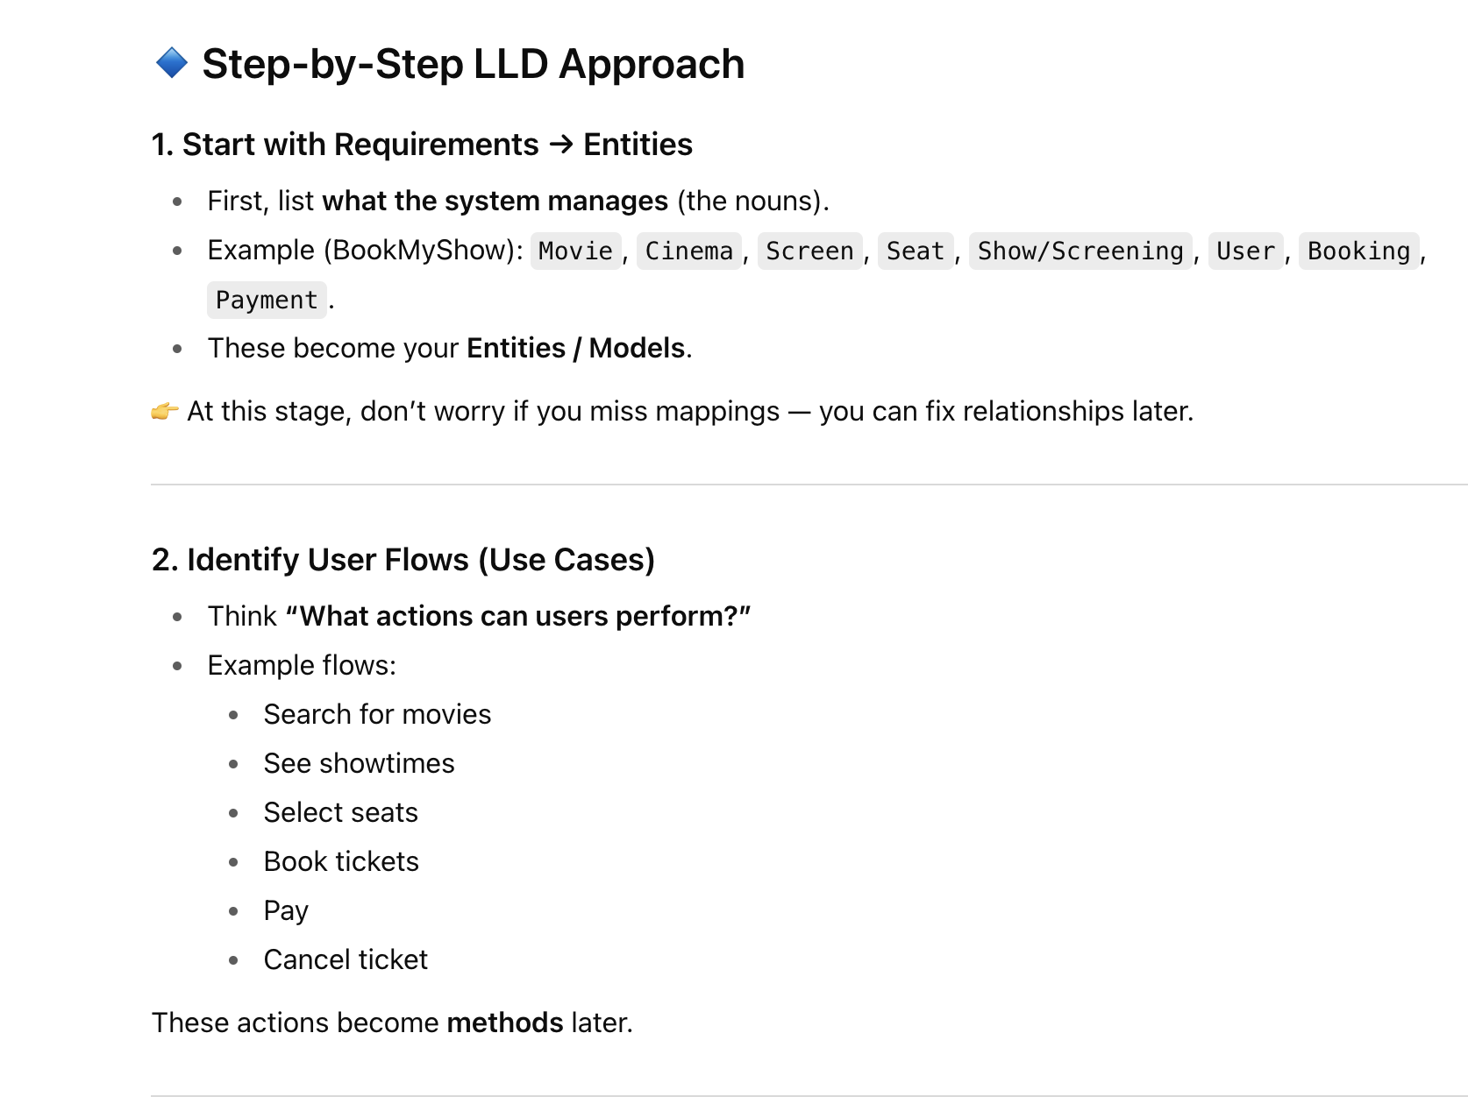

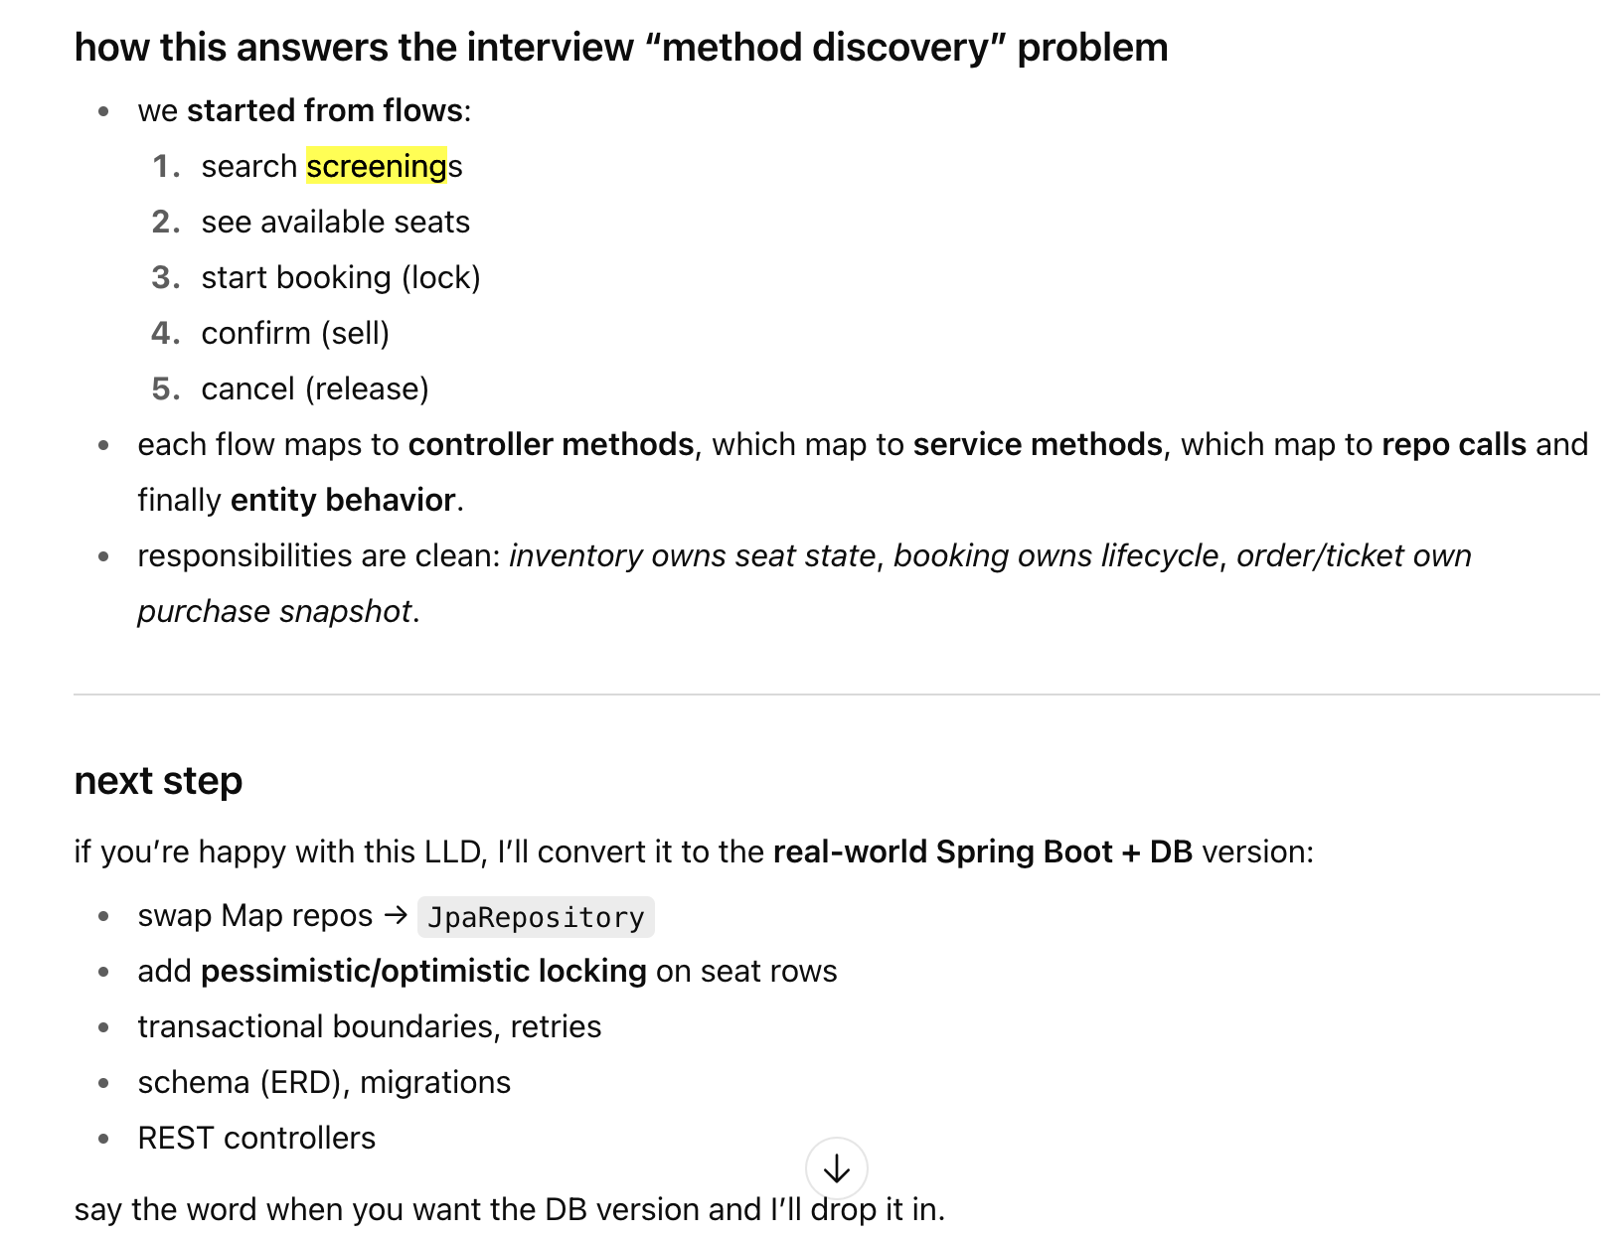

ER Diagram of Movie Ticket Booking System

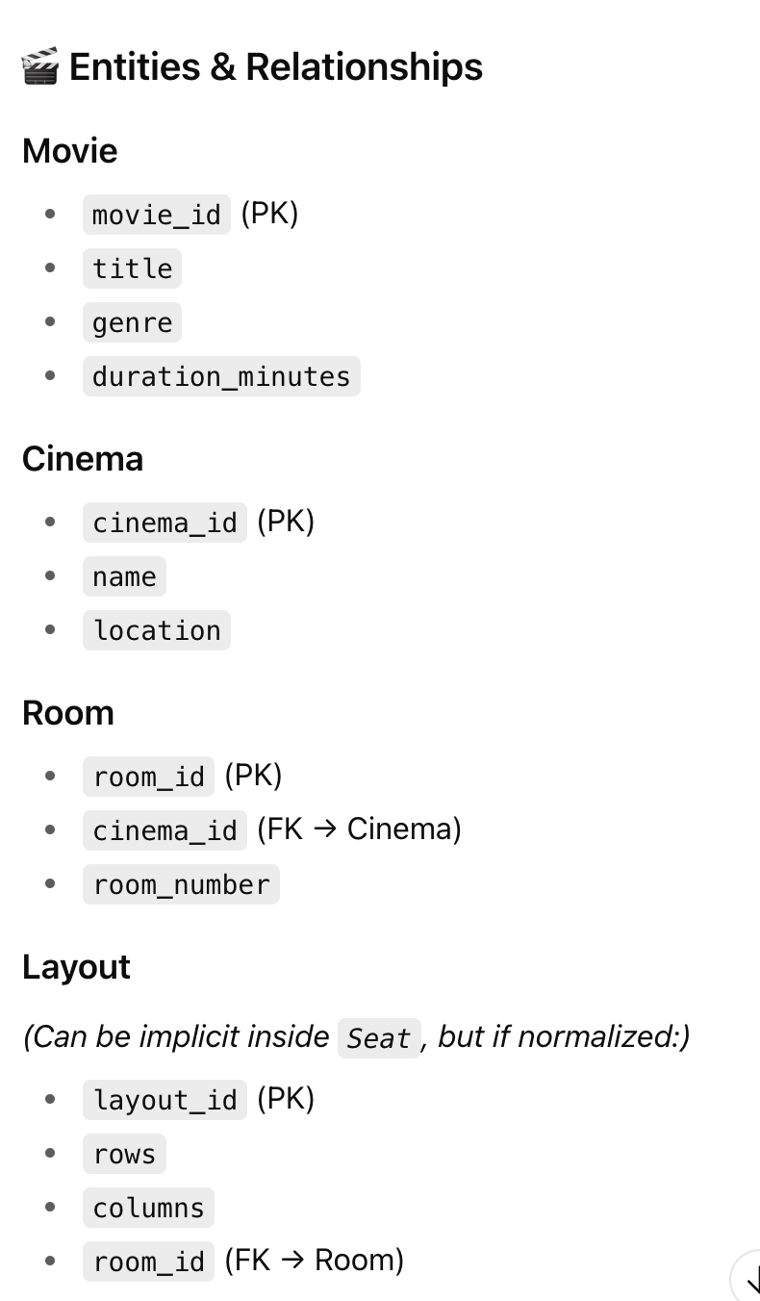
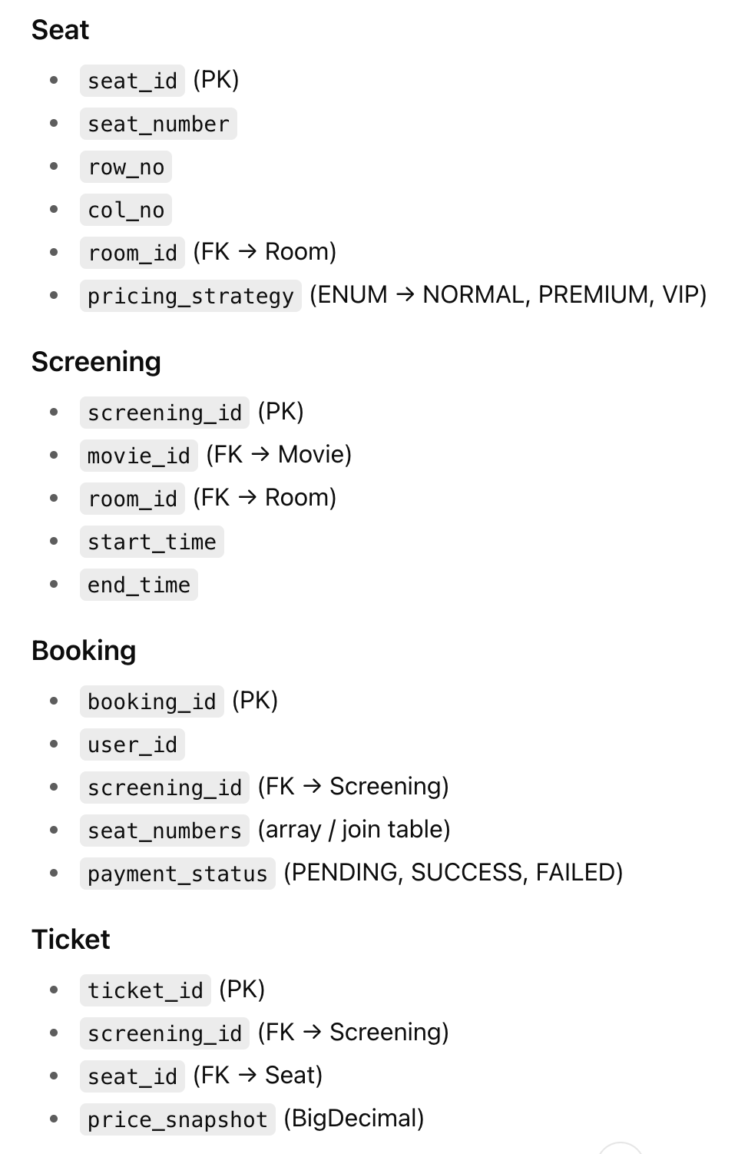
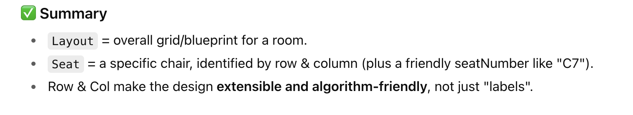

What is the benefit of layout ? why we can't just put these things in the room entity
Why Strategy pattern in seat pricing
UML Diagram Not complete but OK we can understand

Summary in UML Notation

Movie Booking System Complete UML Diagram

Actual Book My show System LLD as per Spring Boot Mappings

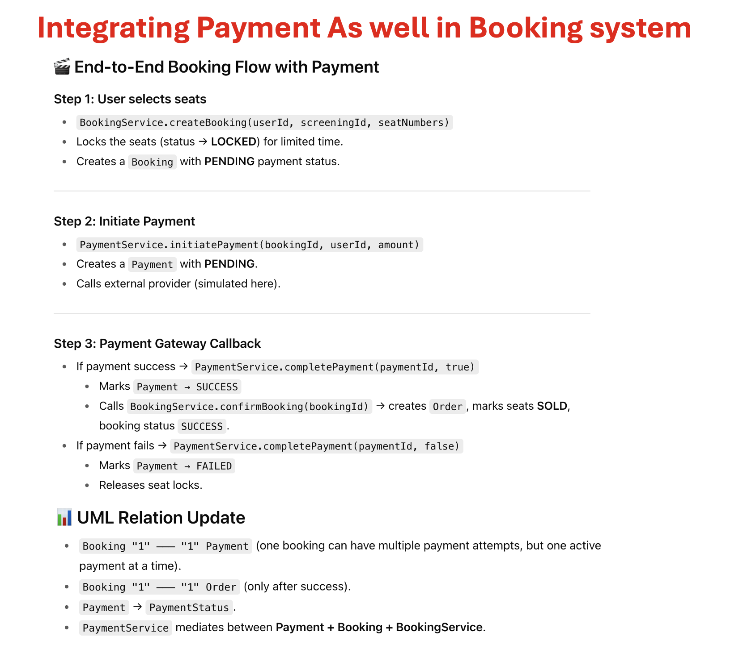

Integrating Notifications Feature (Observer Pattern)

Discounts & Promo Code Integration in Booking System

Movie Booking System With Actual DB and Real Time Uses
look the code in the Project, I have made some changes as you can see we don’t need Screening Inventory and Seat Lock entities any more as we manage these things with our DB only.
Also we have made some more changes that are present in code but I am attaching the reason why we write code in this way. When you will see the code you will come to know the reason why I have written things in this way and what is the use of this.
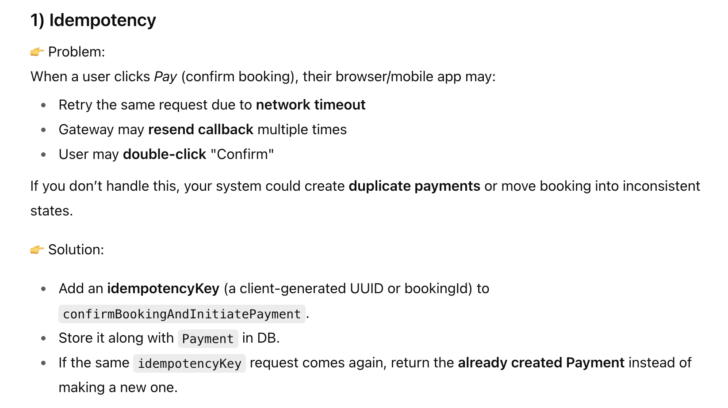
So idempotency Key ensures no duplicate Payment rows.
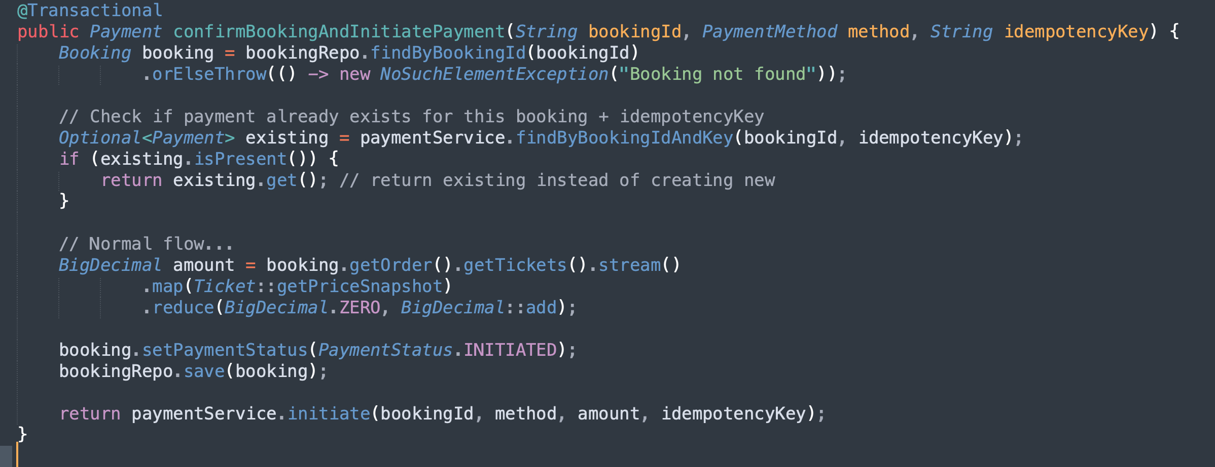

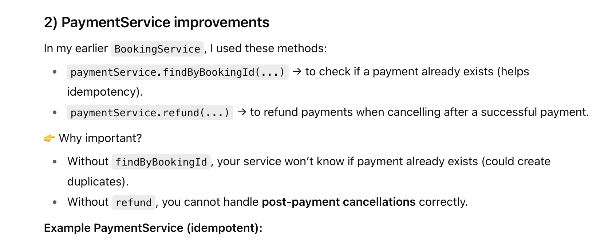
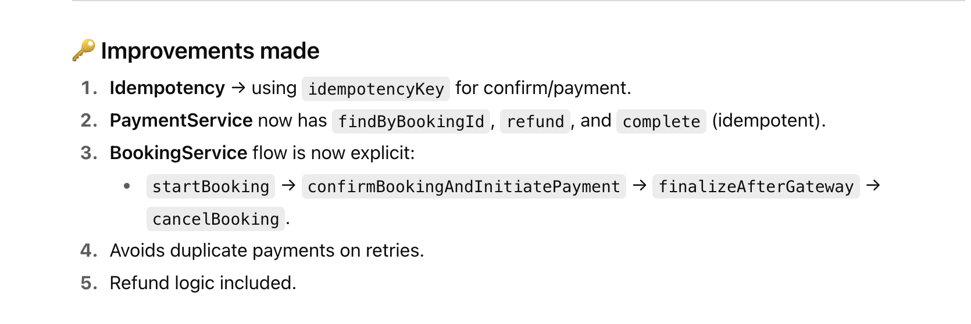

How to implement Seat Lock when you use real DB
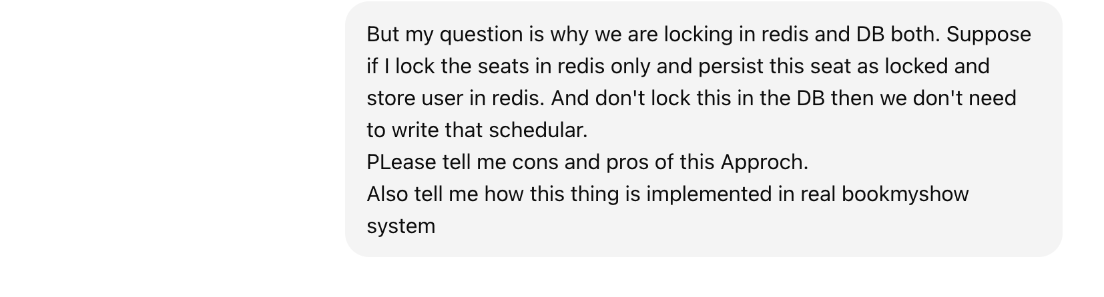
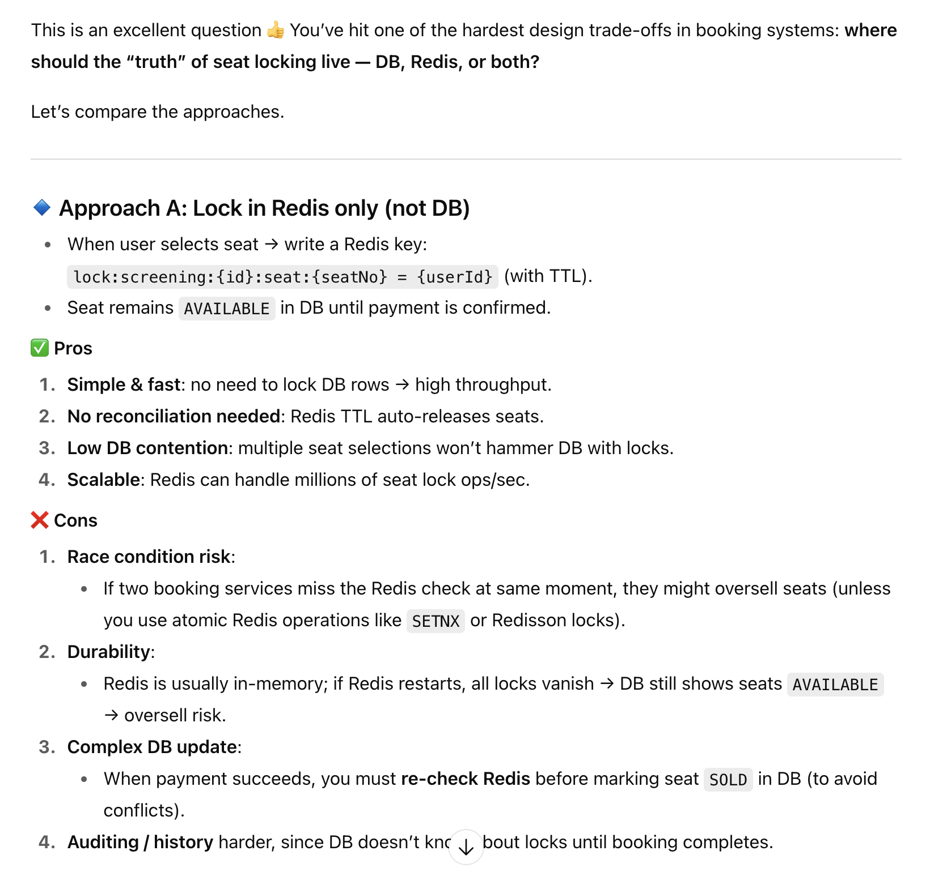

Implementation of Redis-only seat lock flow like BookMyShow
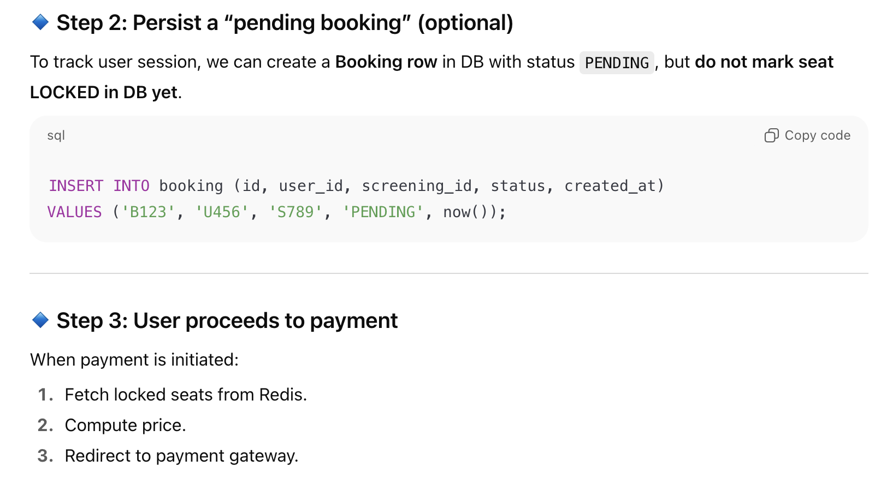
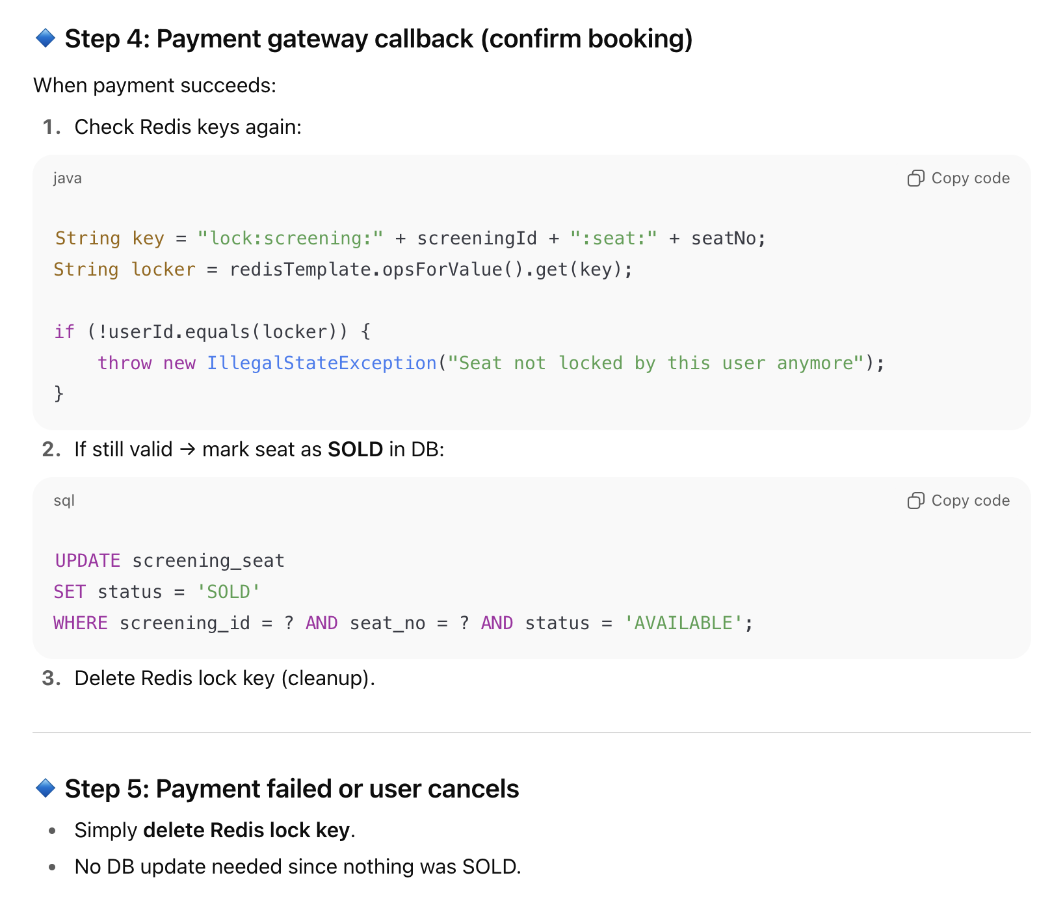
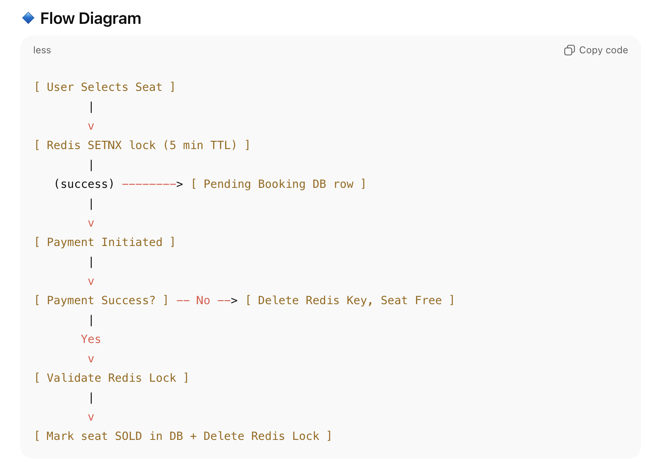
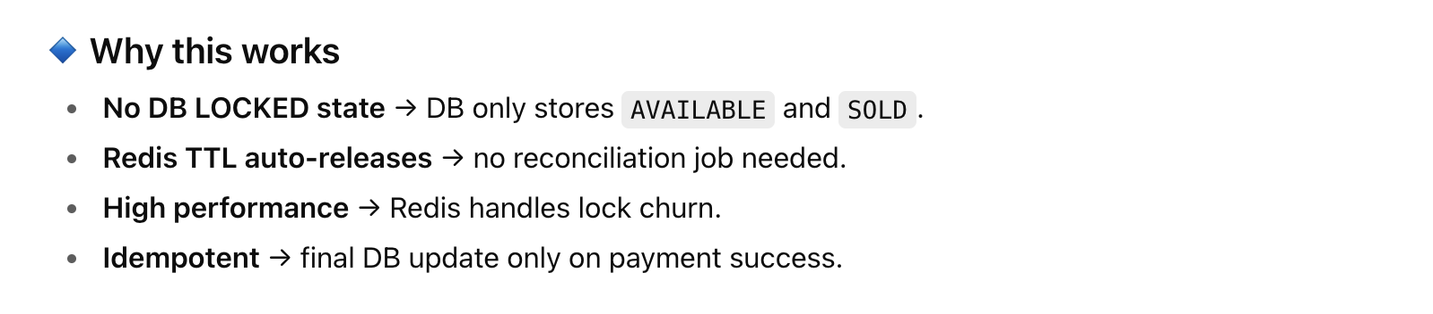

While Locking in the Redis Do we need to store User Id Also ?
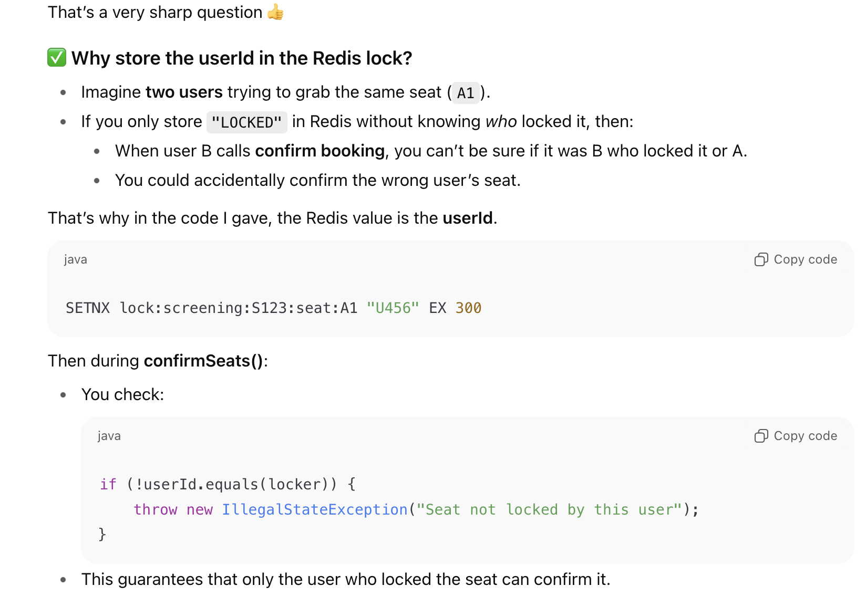
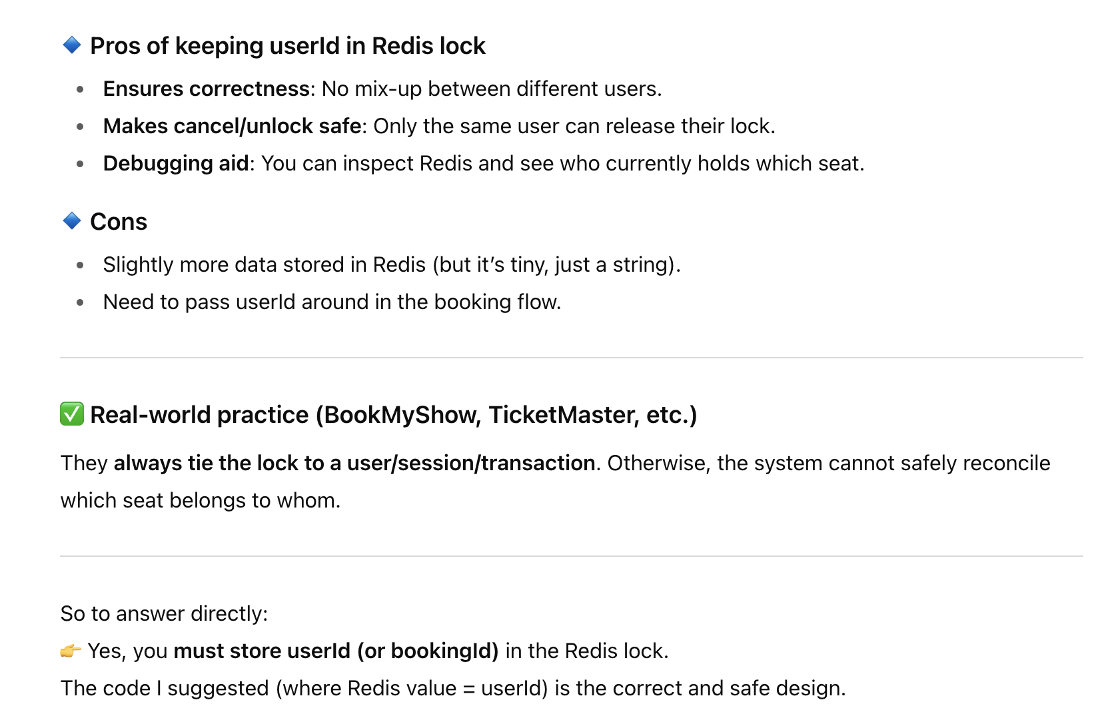
Diff b/w Seat and Screening Seat
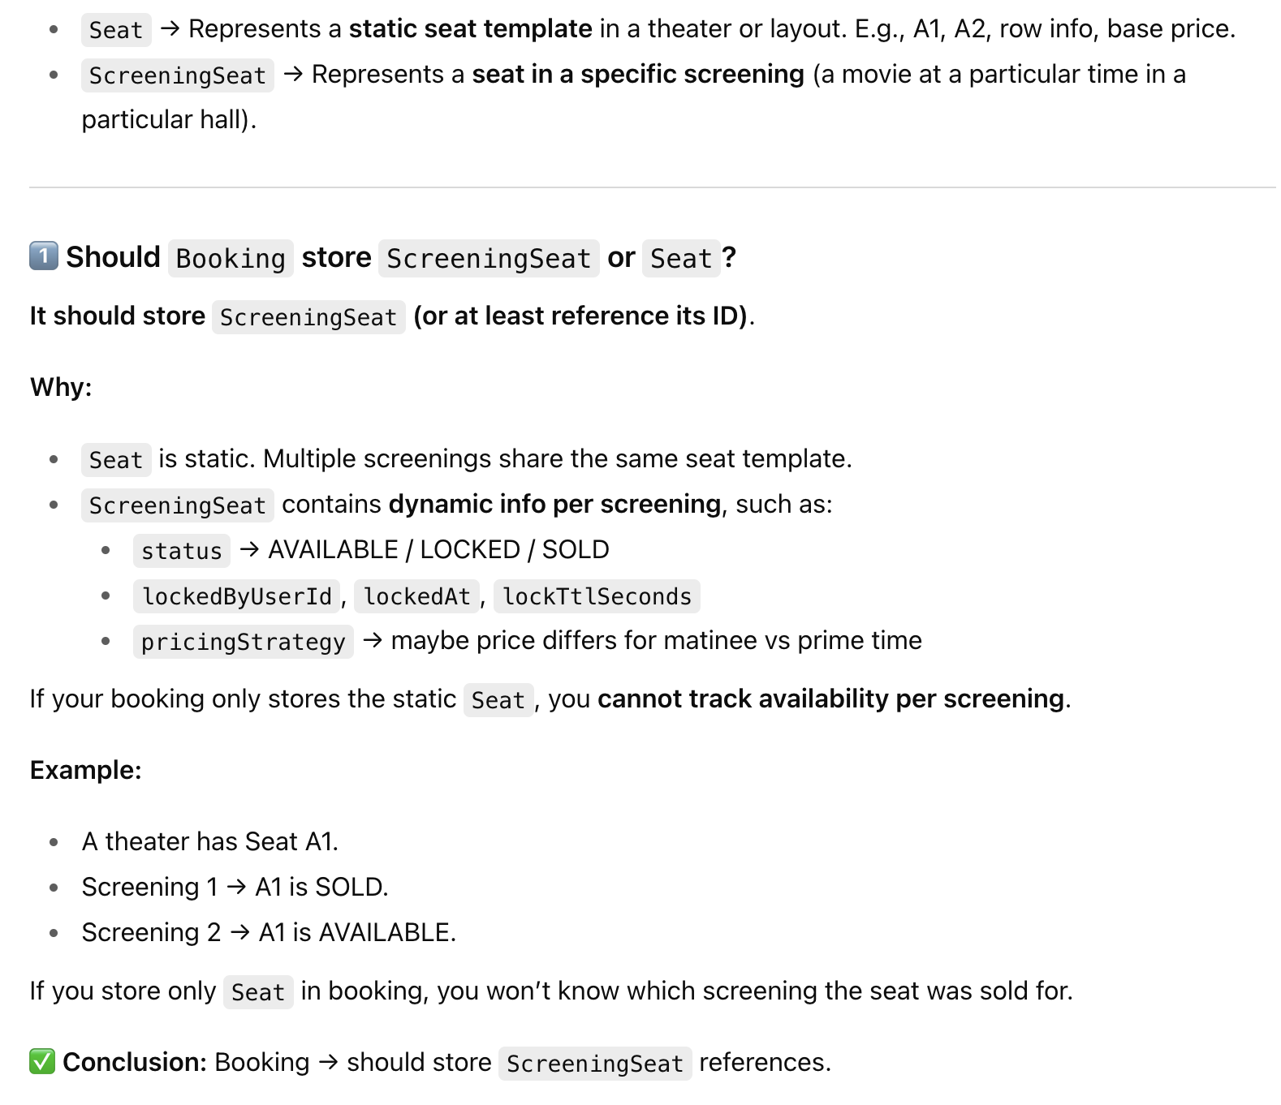
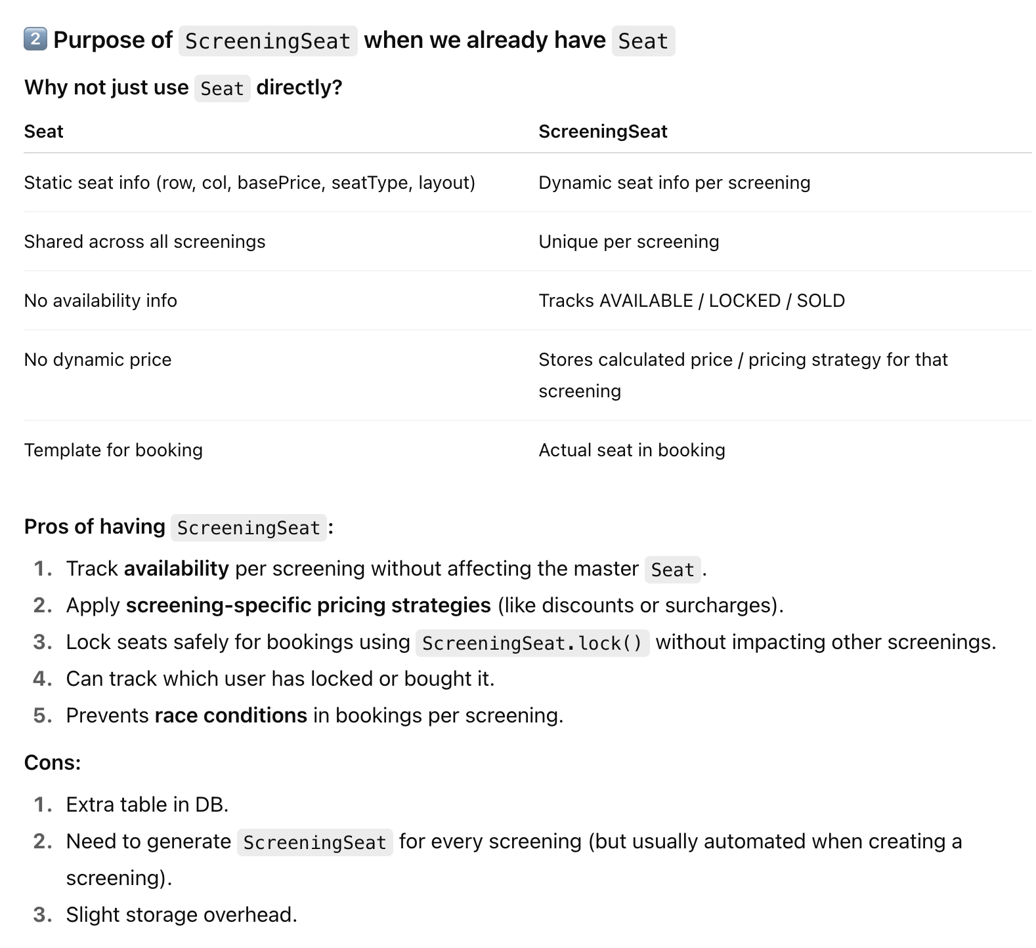
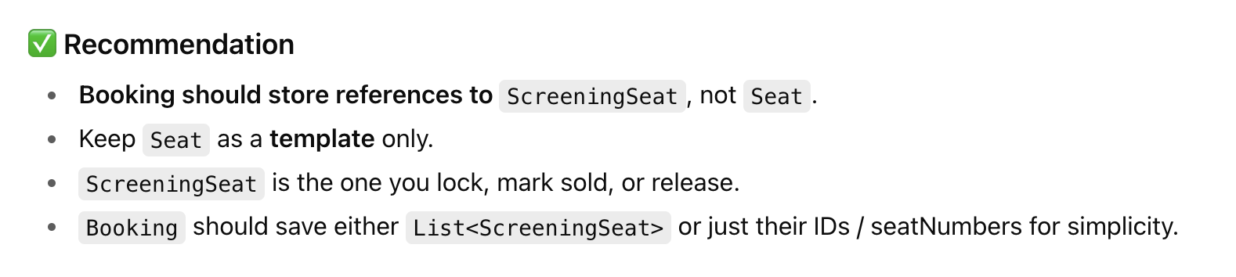

Redis + Optimistic locking V/S Pessimistic Locking
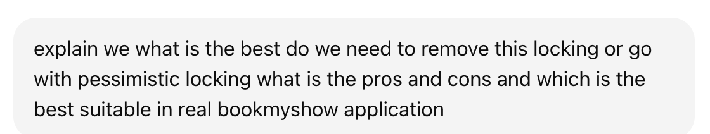
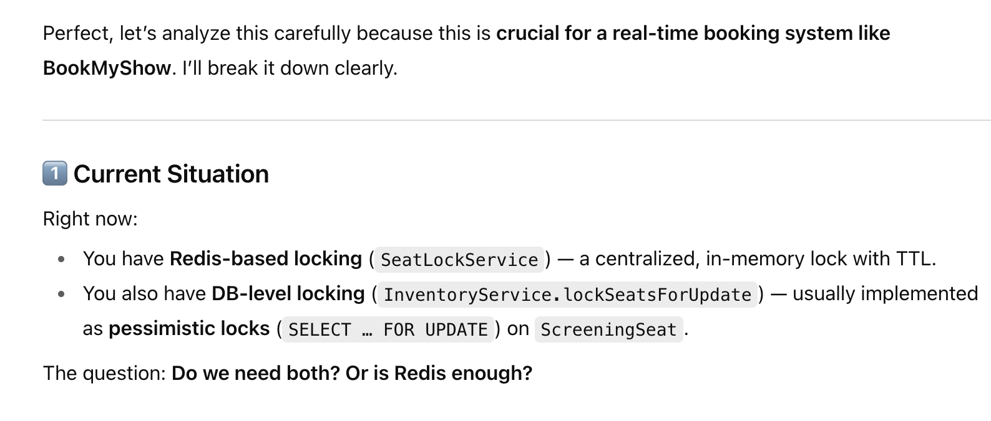
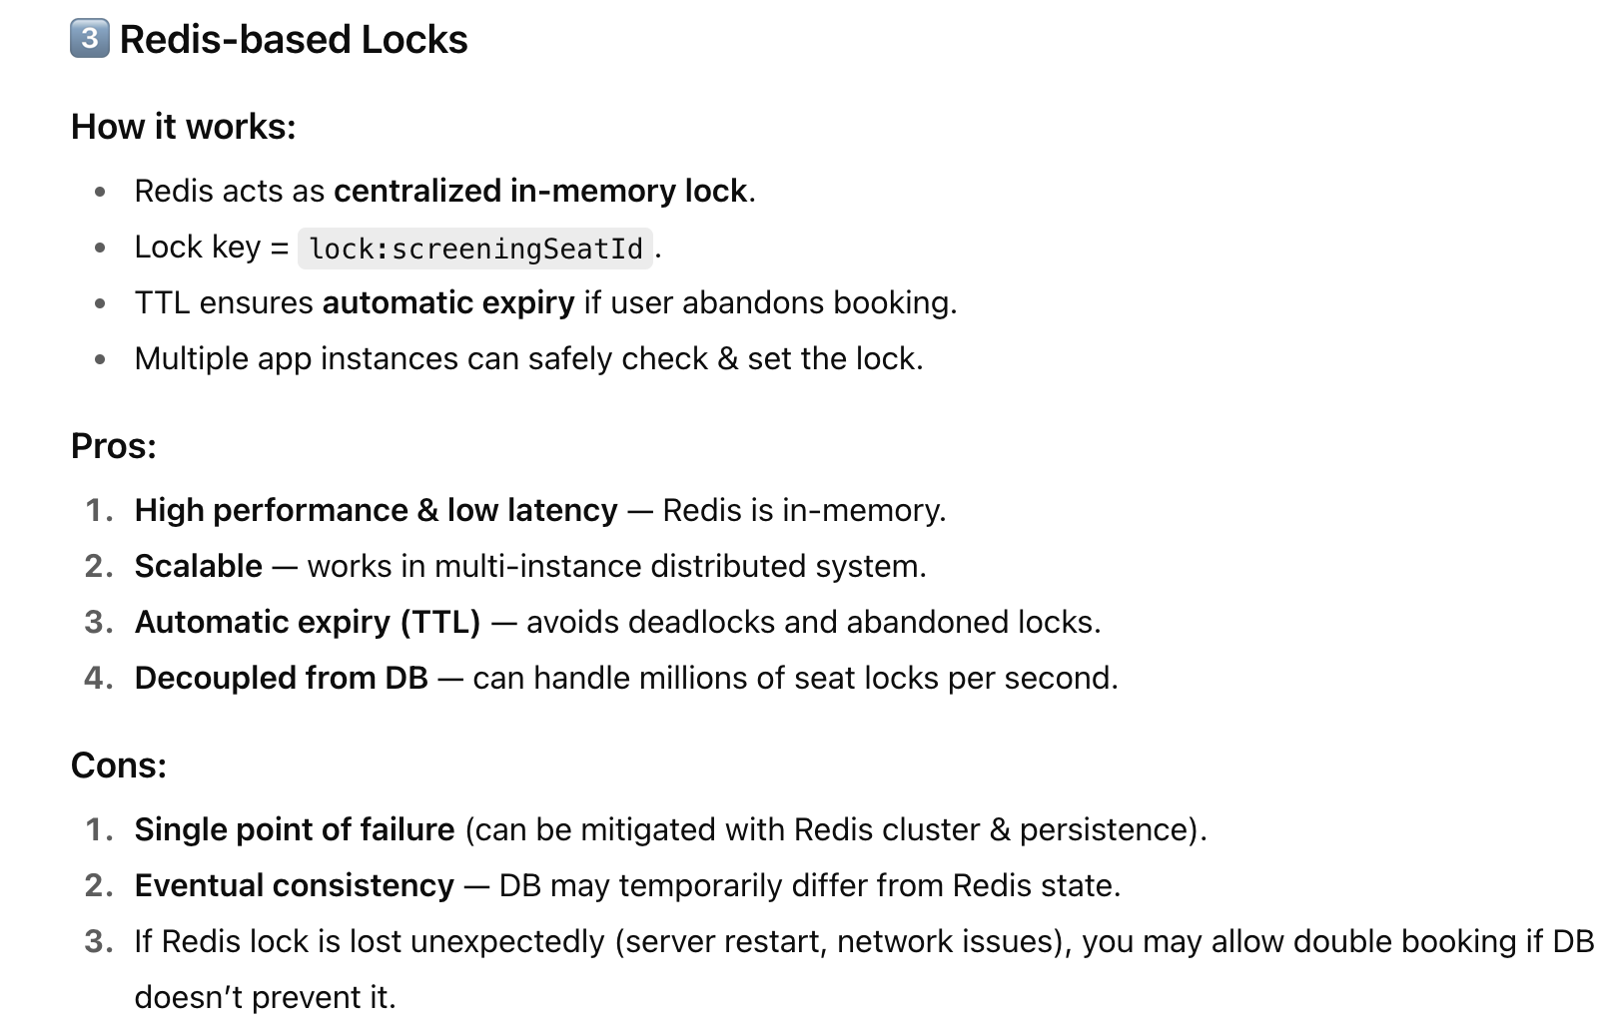
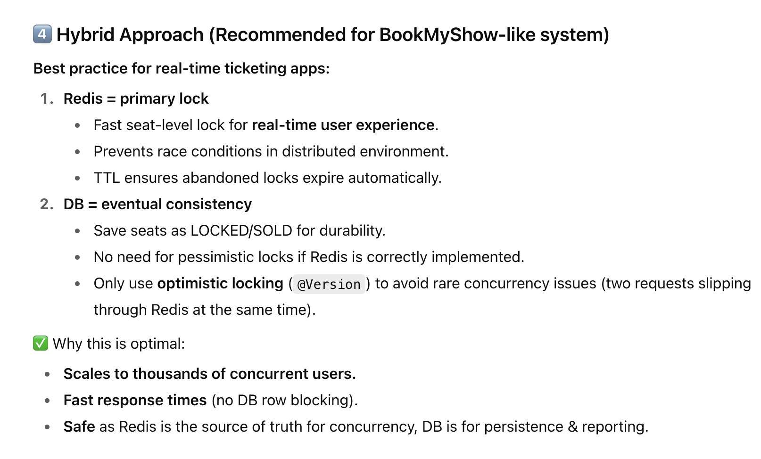
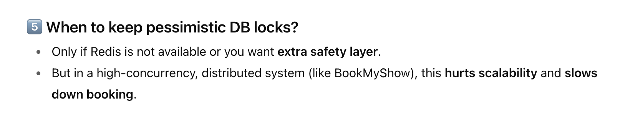
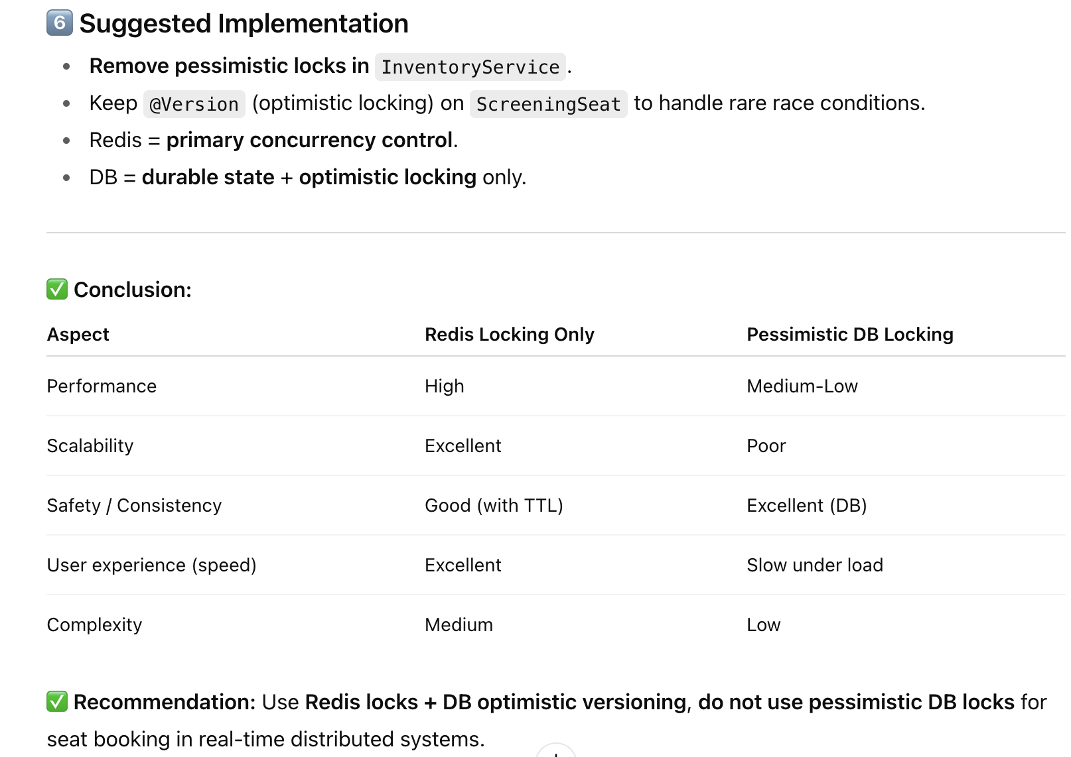

Summary of Movie Booking System
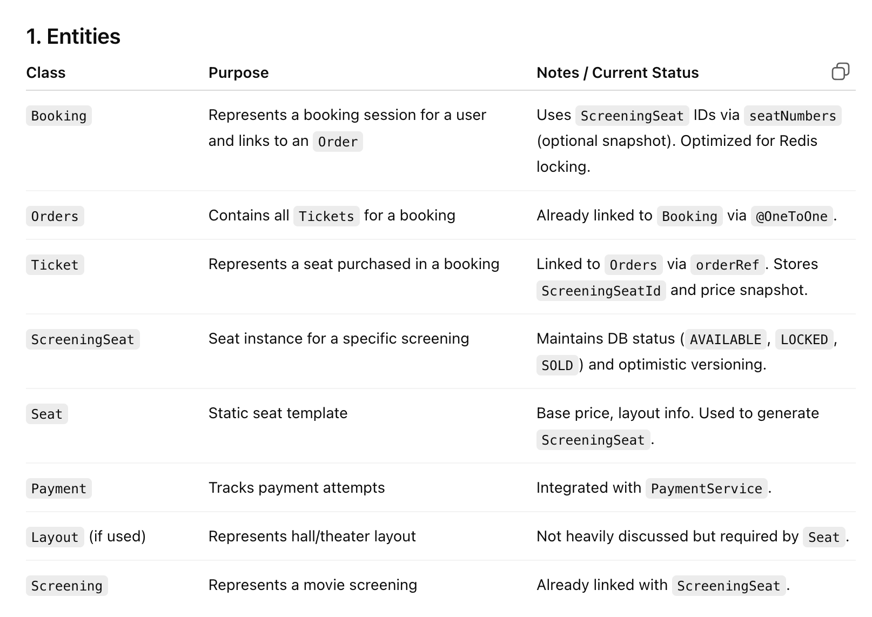
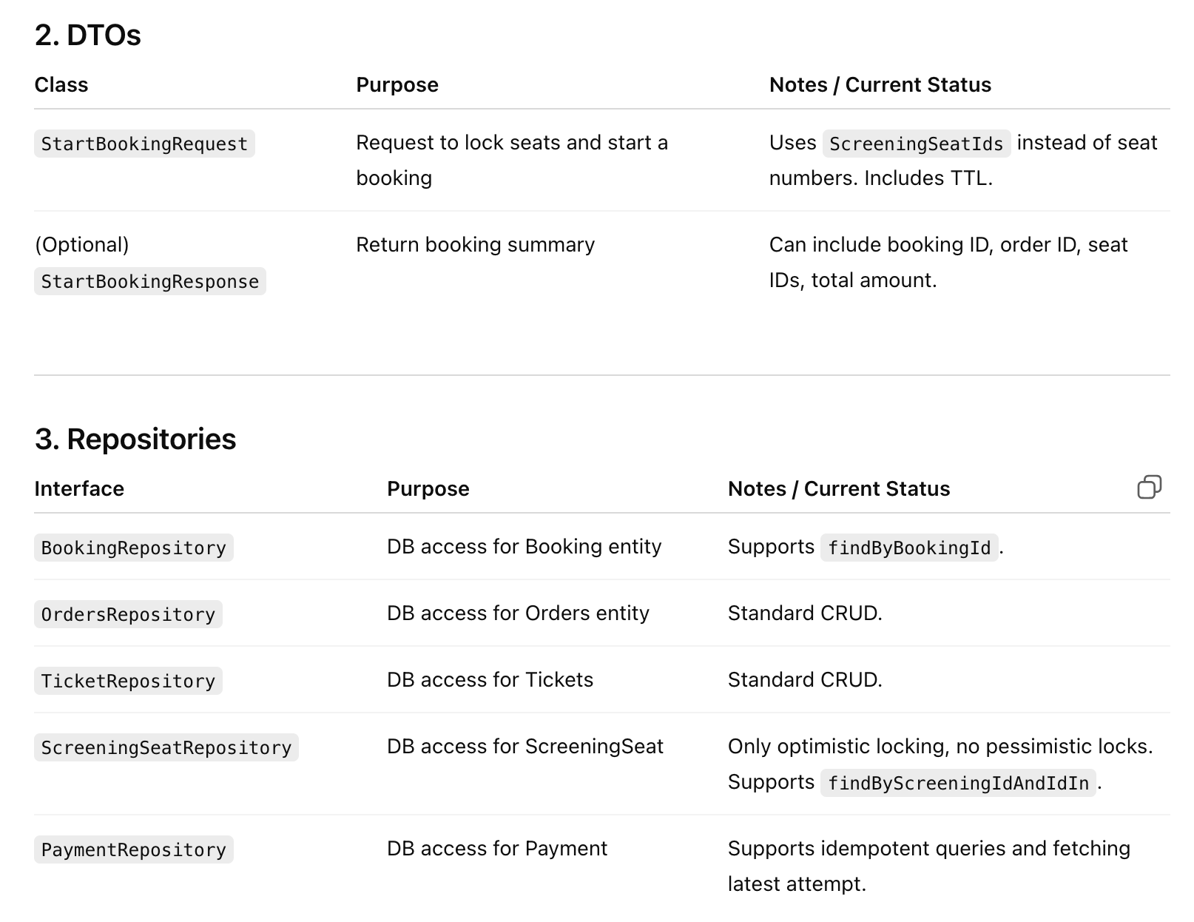
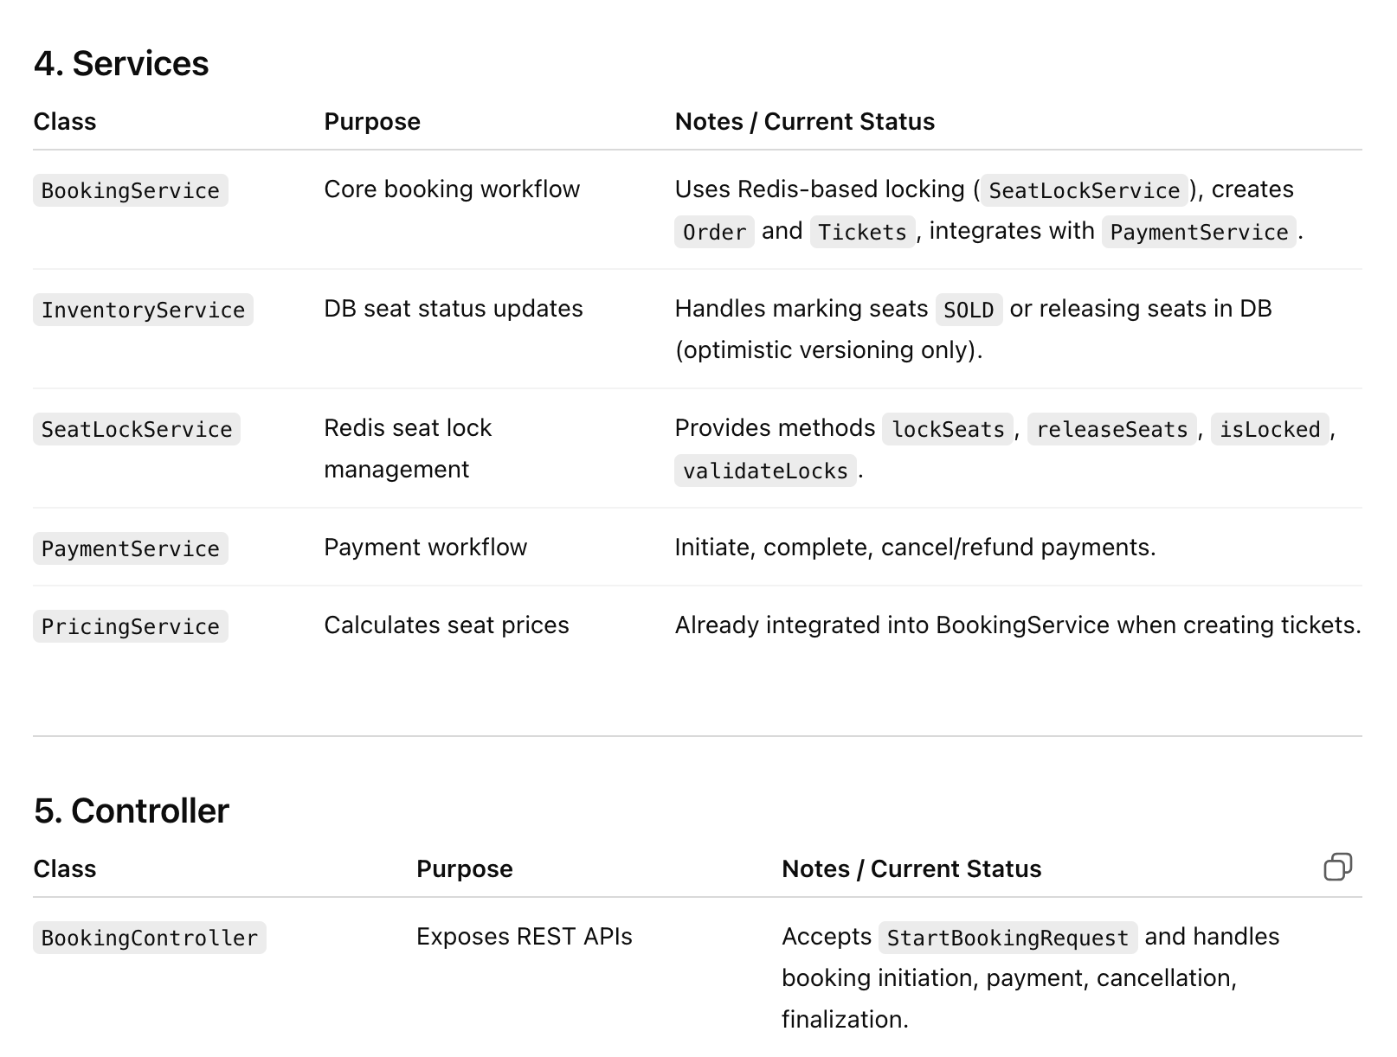
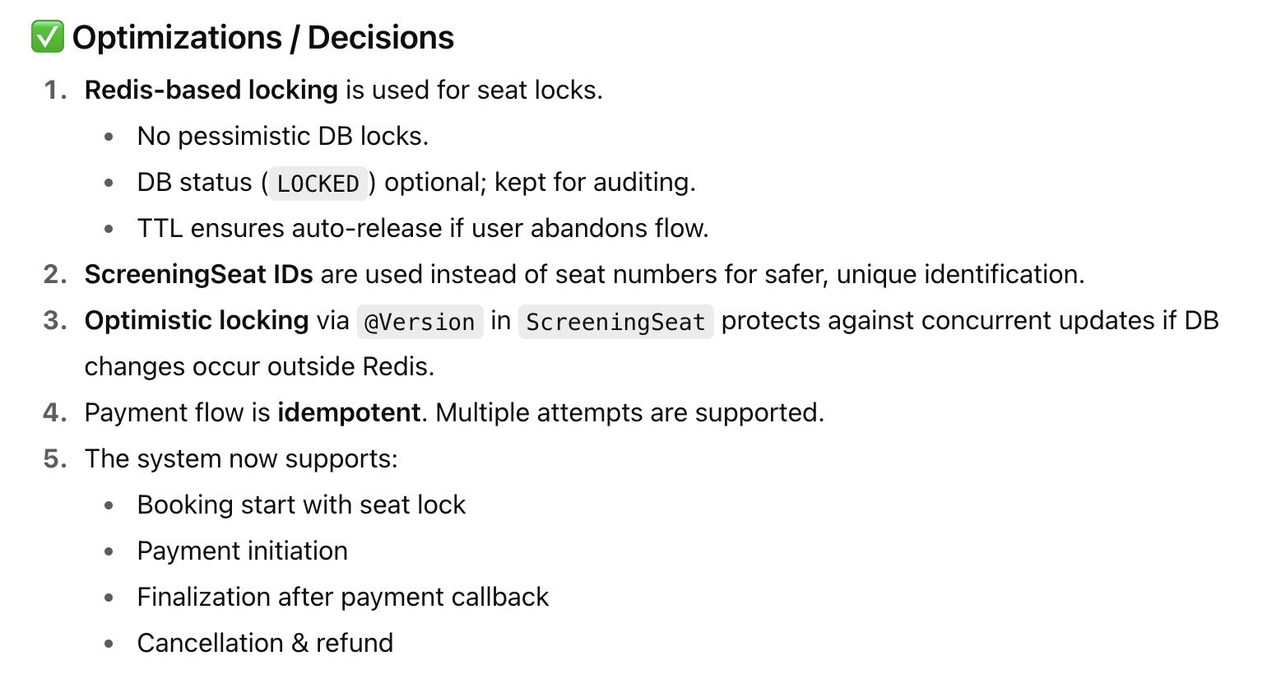

Diagram of main Entities and Services
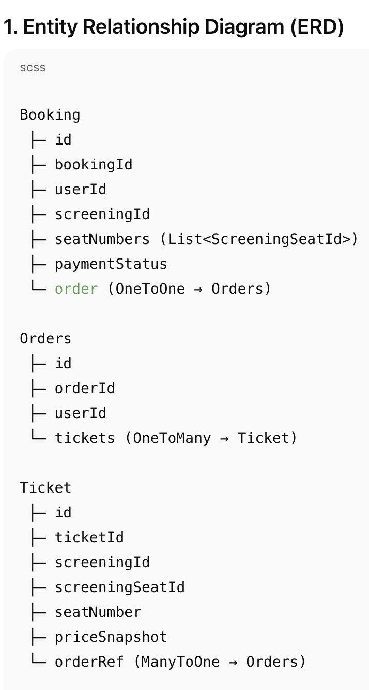

Error: Reference source not found
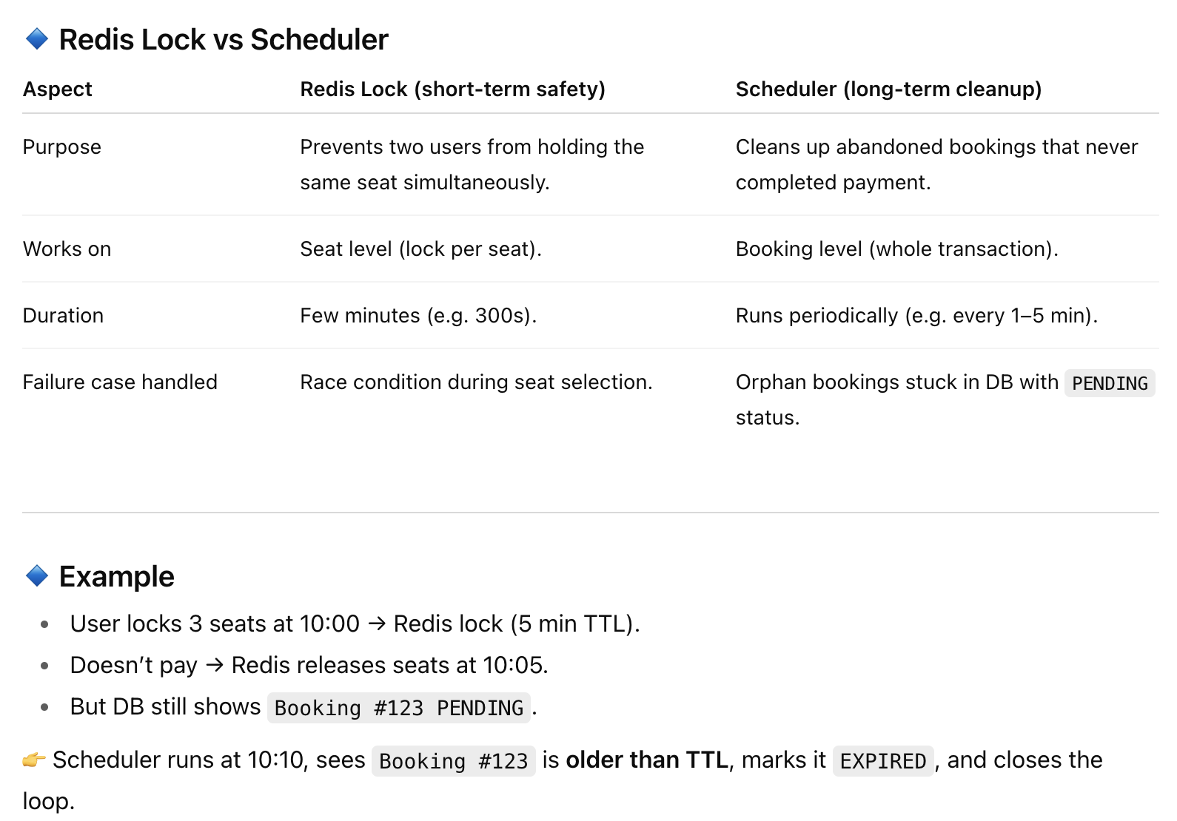

Why we need Redis Sharding in Movie Booking System

Why we need Async Booking

Booking Service Flow &How it works in real time:

Do we Still need Schedular or Risk Of not Locking Seat in DB
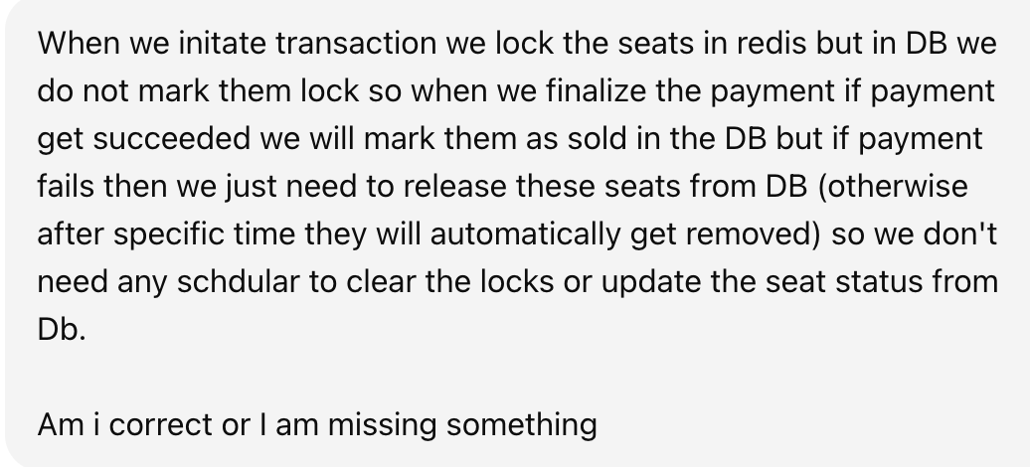
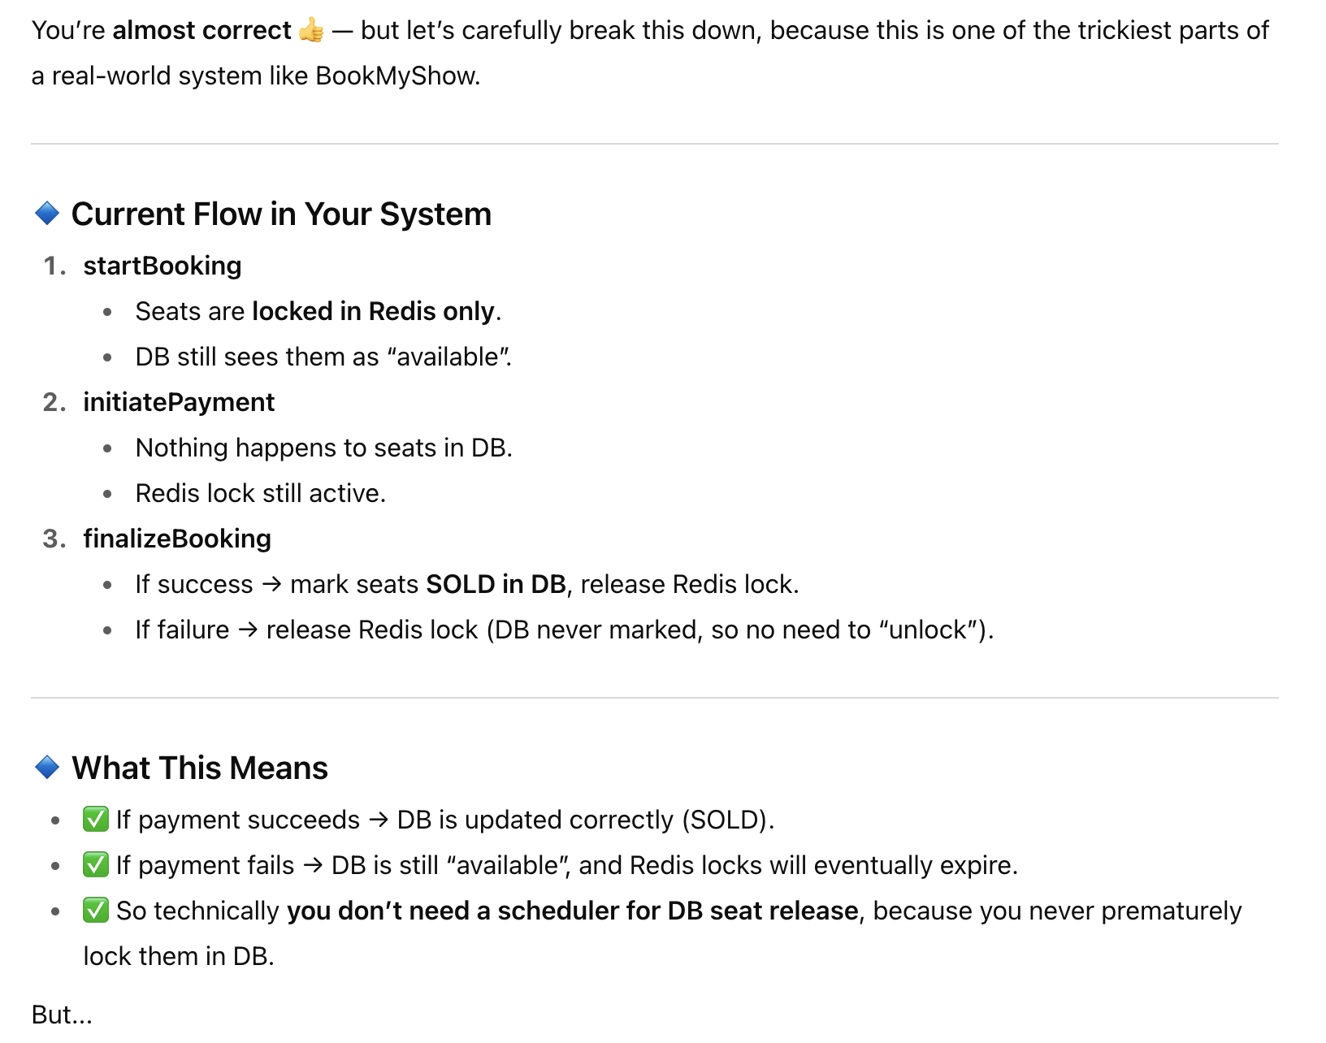
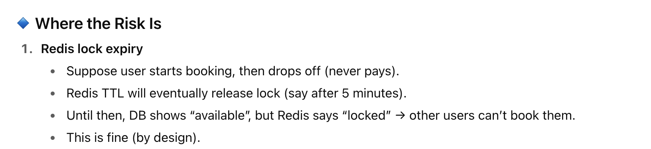

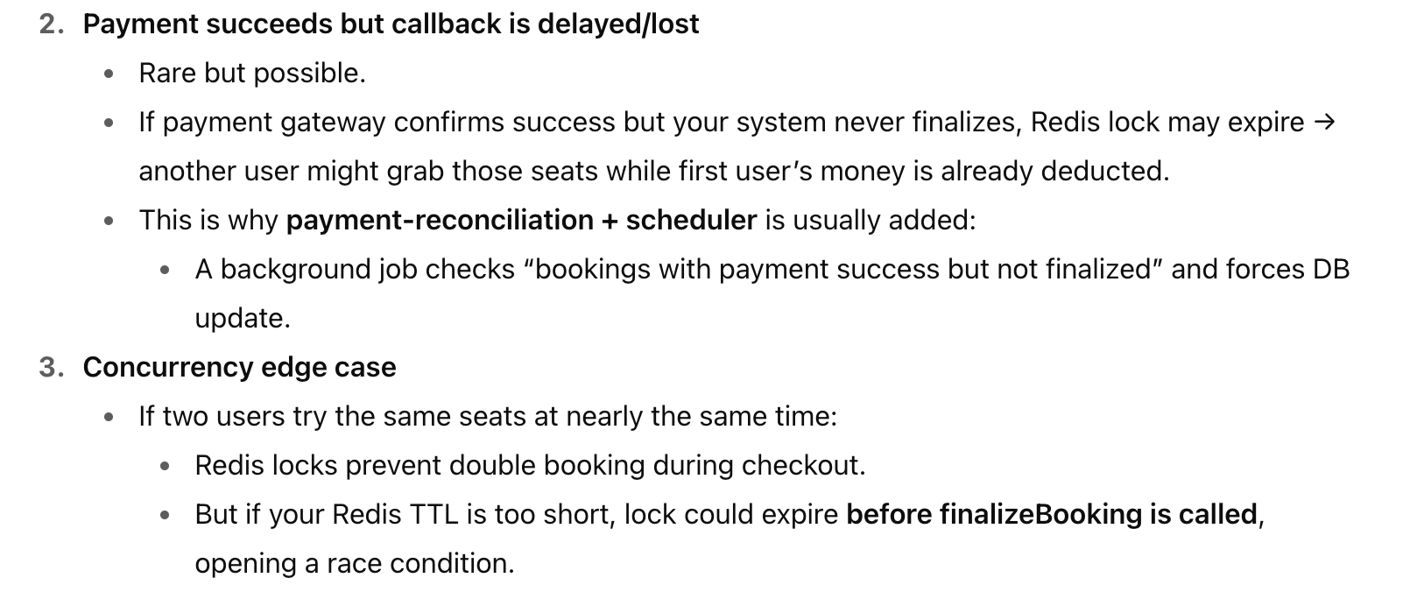
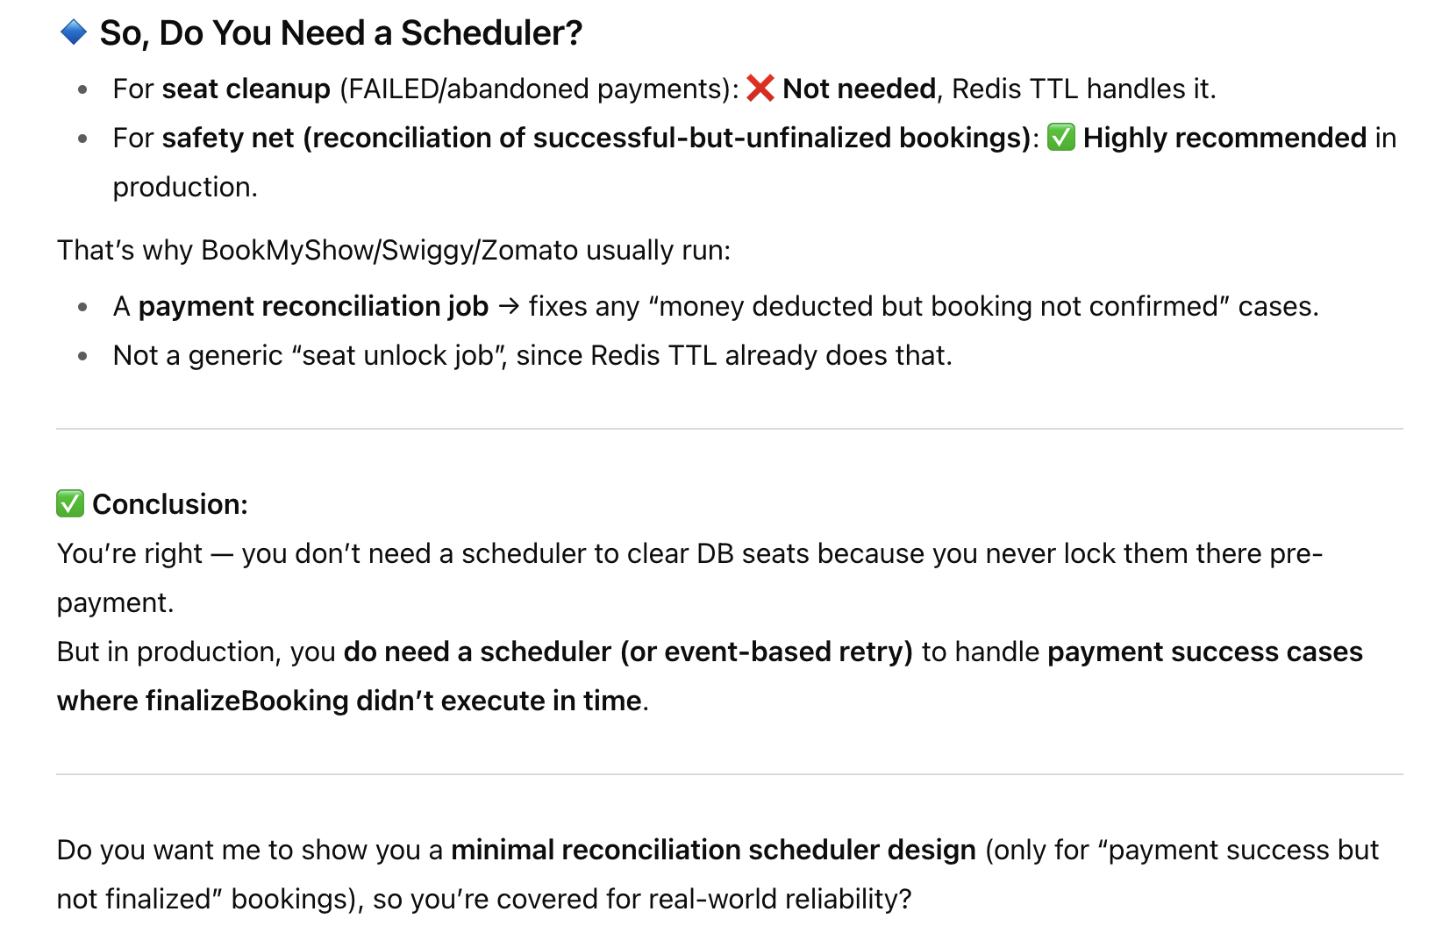

Purpose of Payment Reconciliation Scheduler
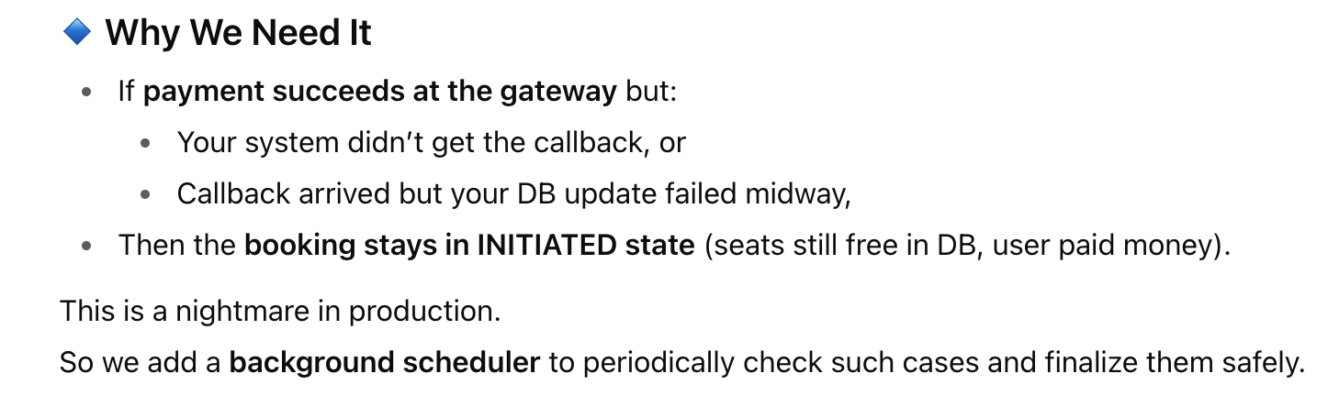
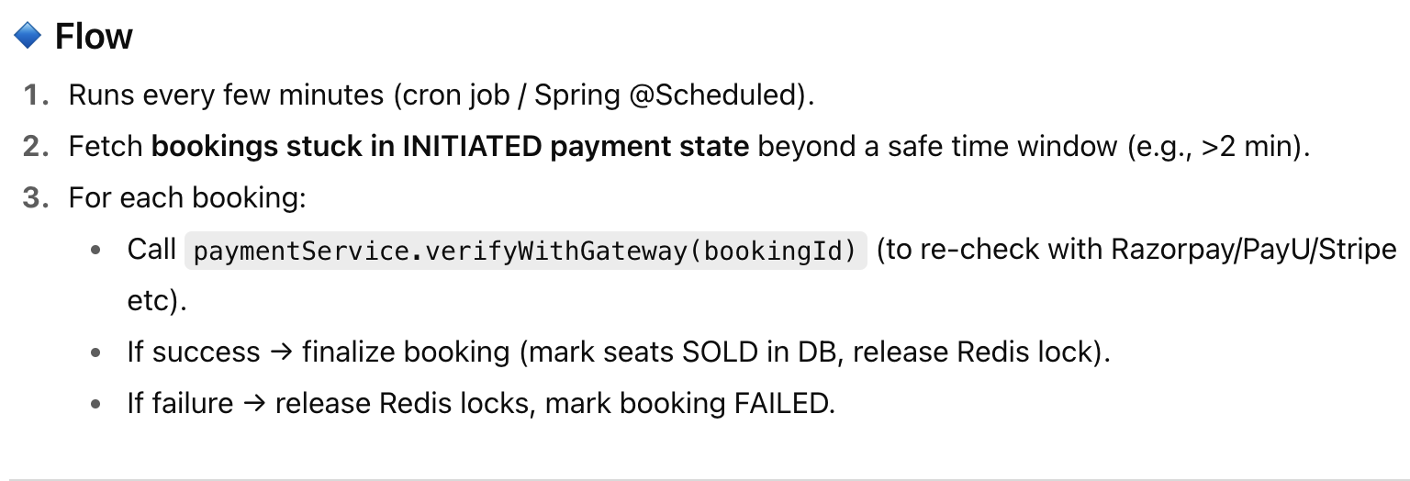

Optimistic v/s Pessimistic Locking

Pessimistic Locking Code Without DB

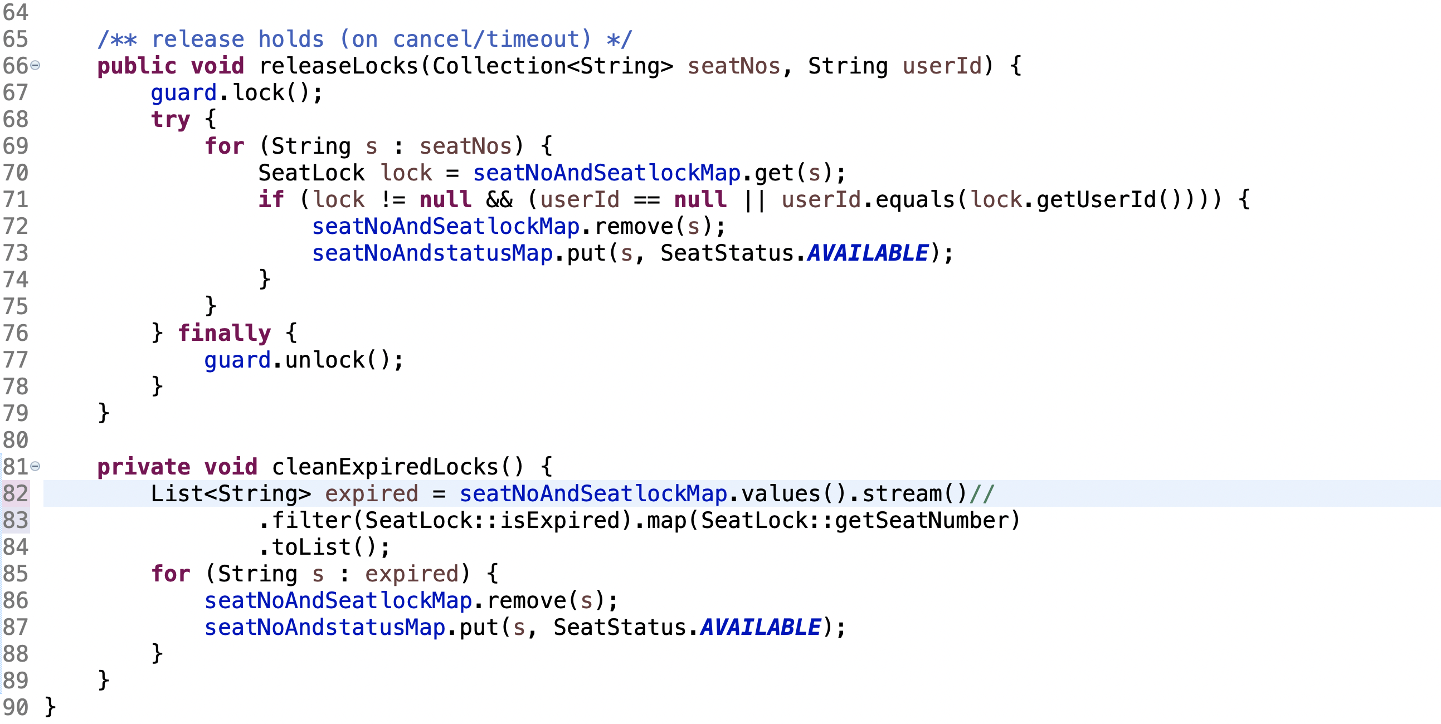

Optimistic Locking Code Without DB
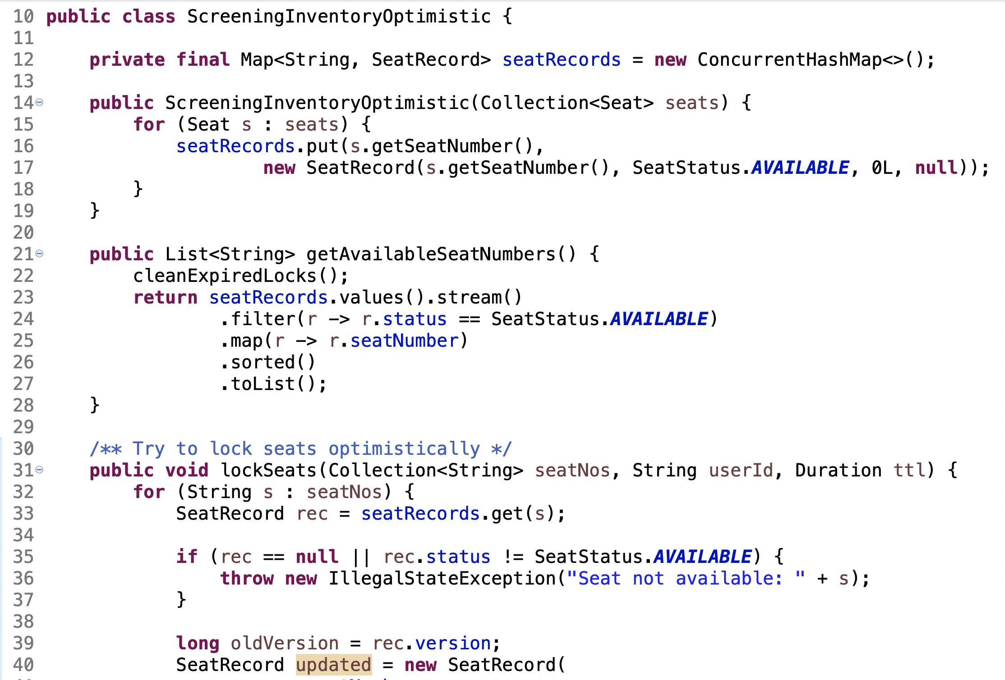
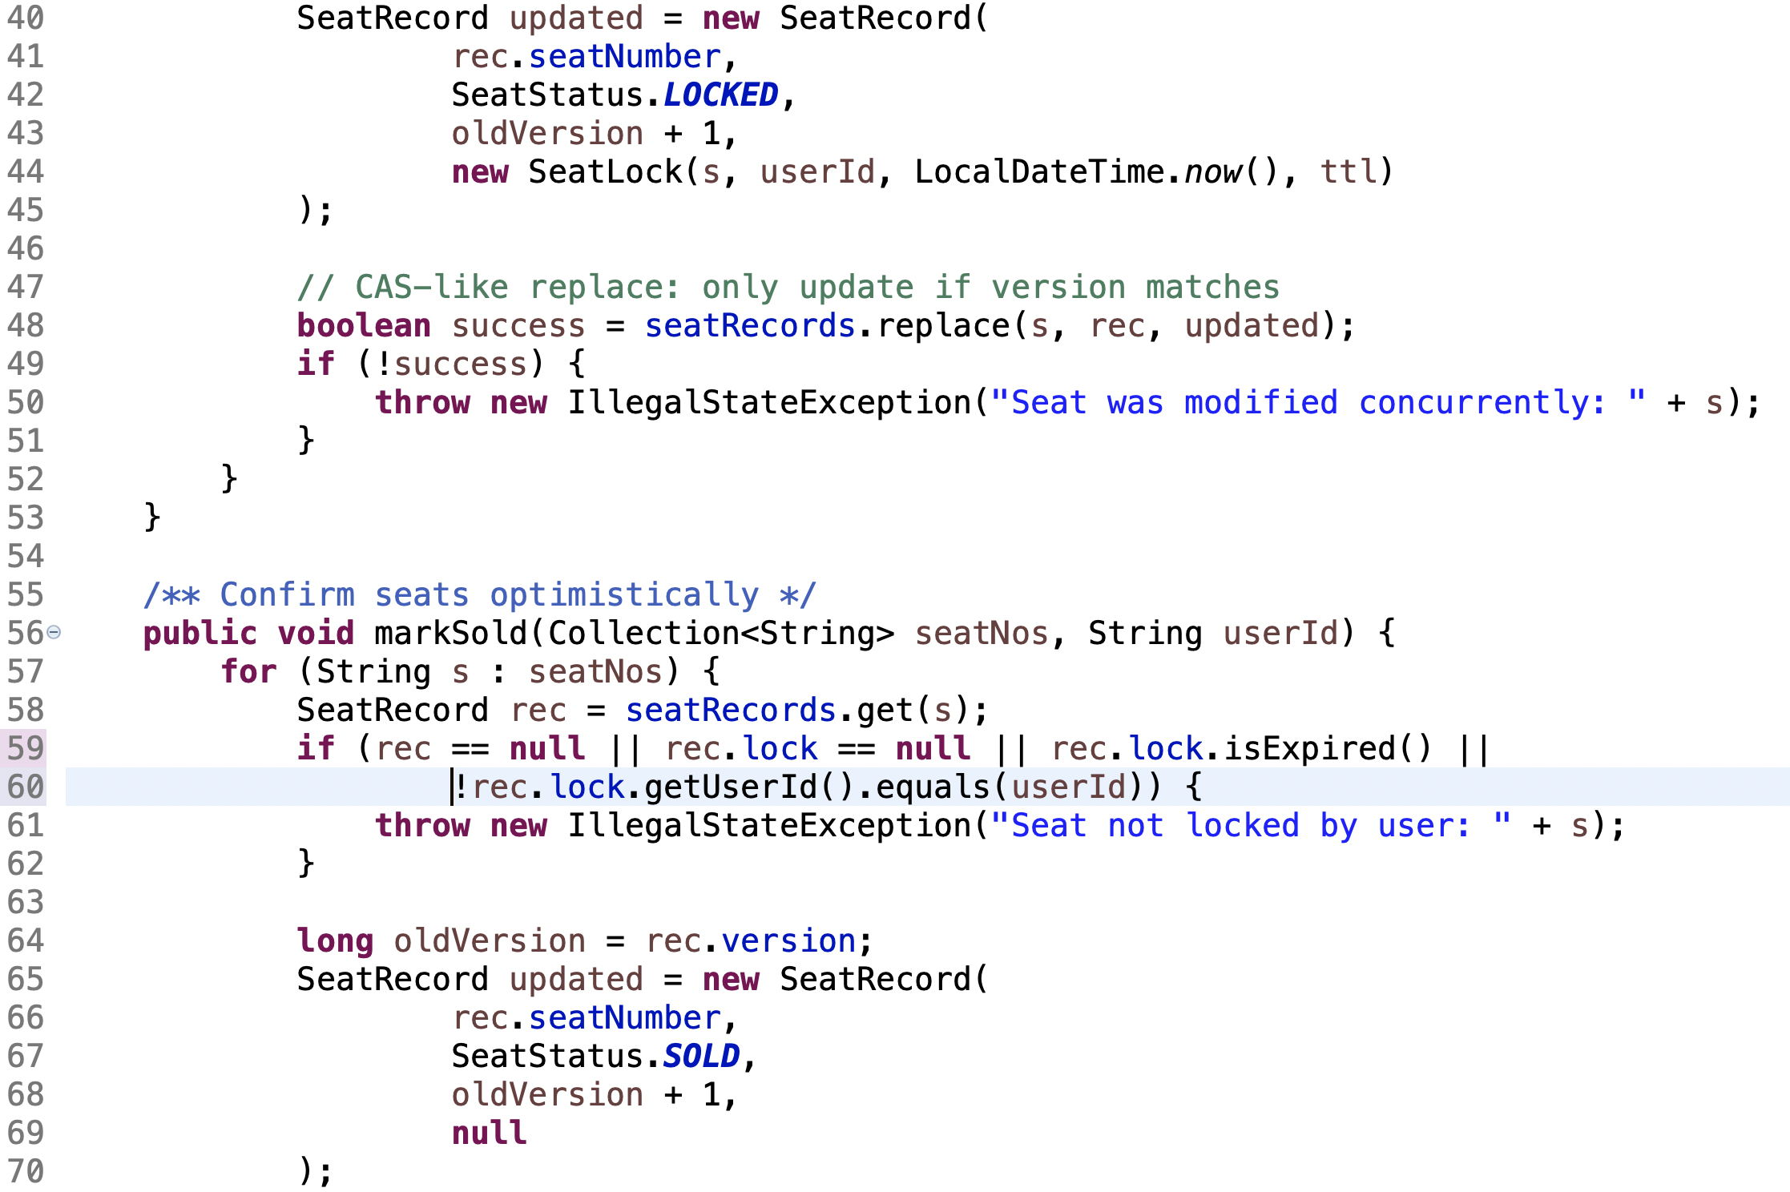
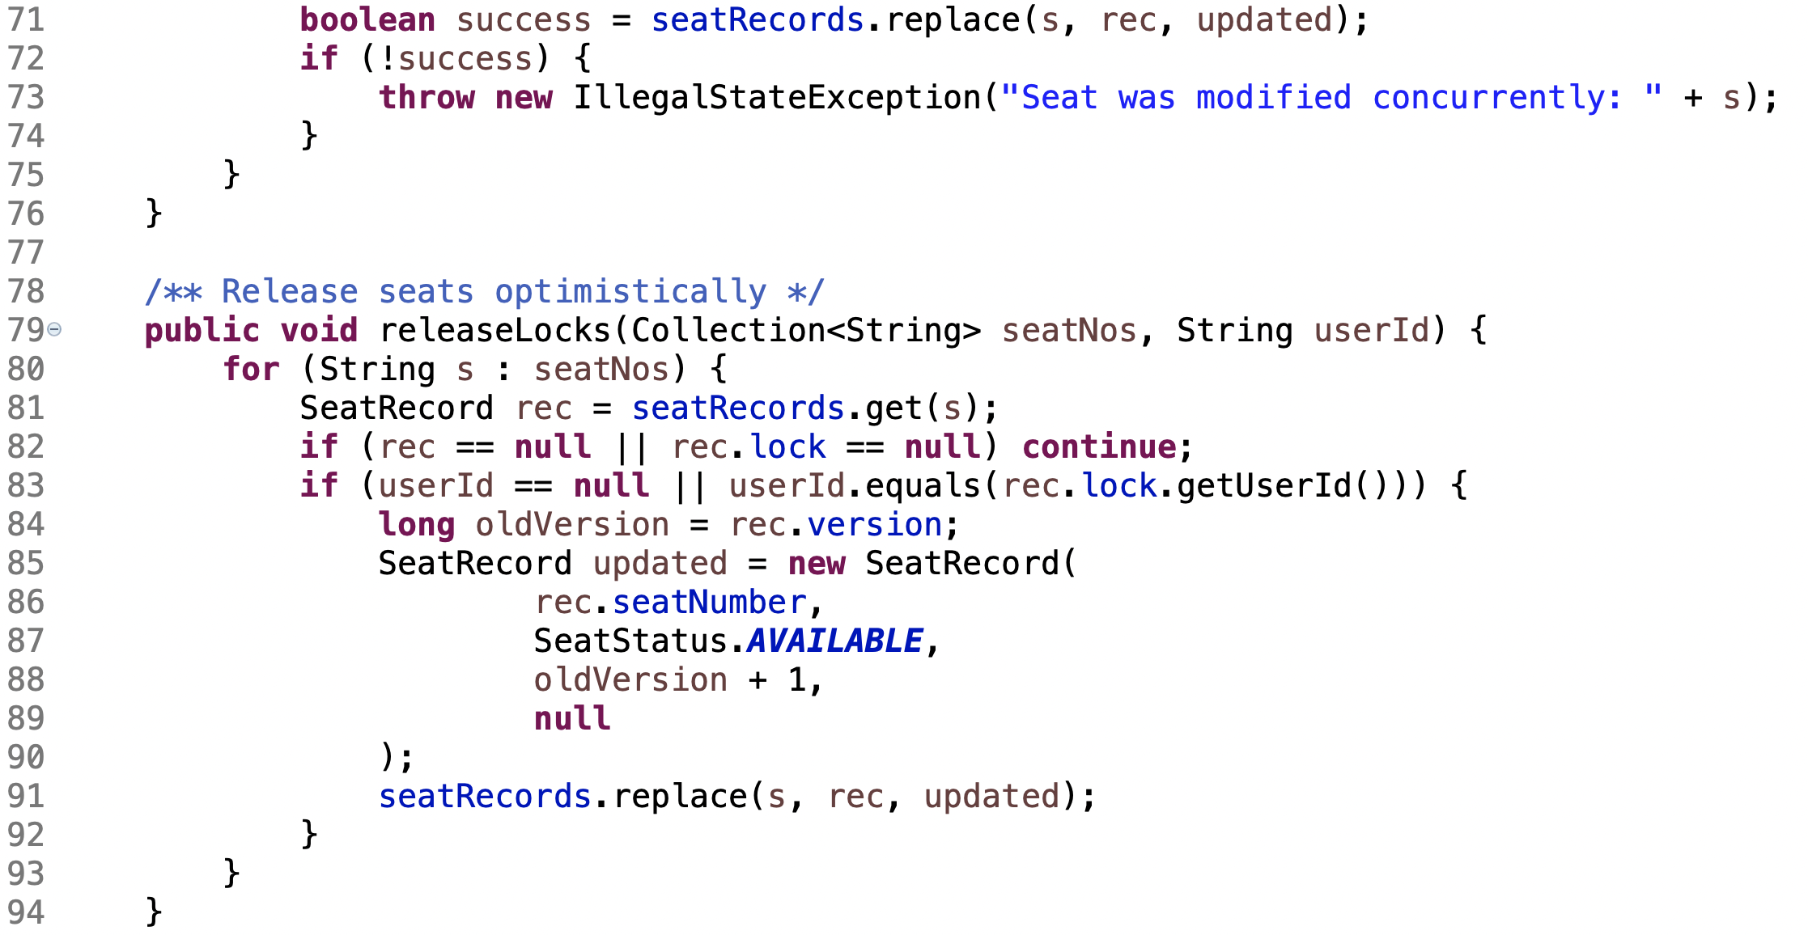

Use of @Version(Optimistic Locking) in Movie Booking System

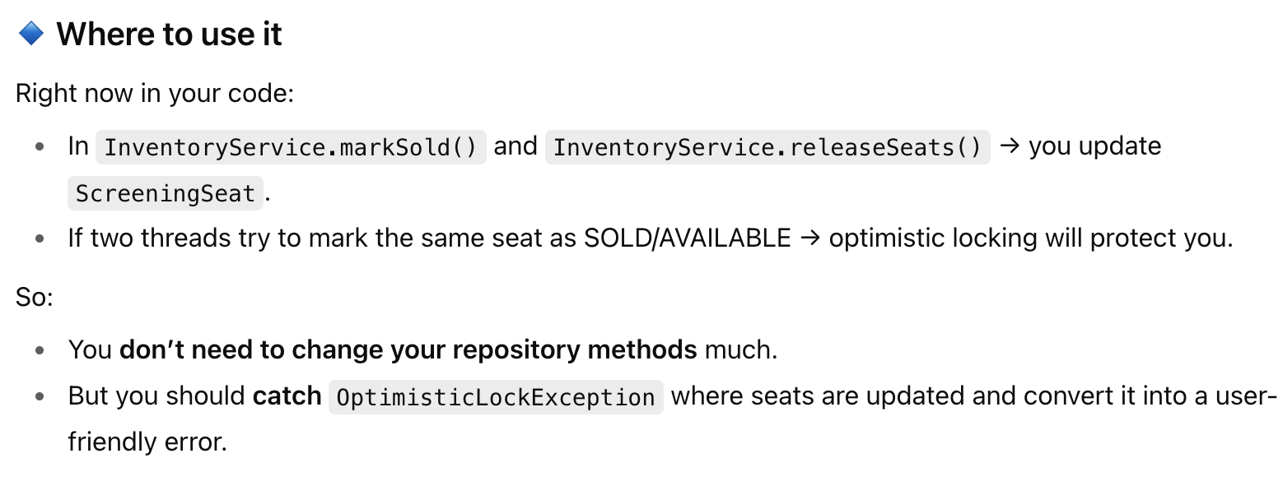

With Redis Do we Actually Need Optimistic/ Pessimistic Locking
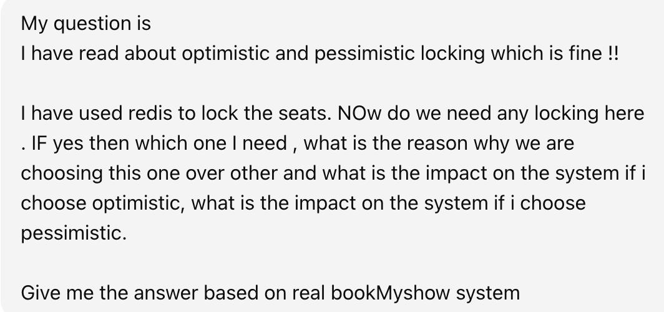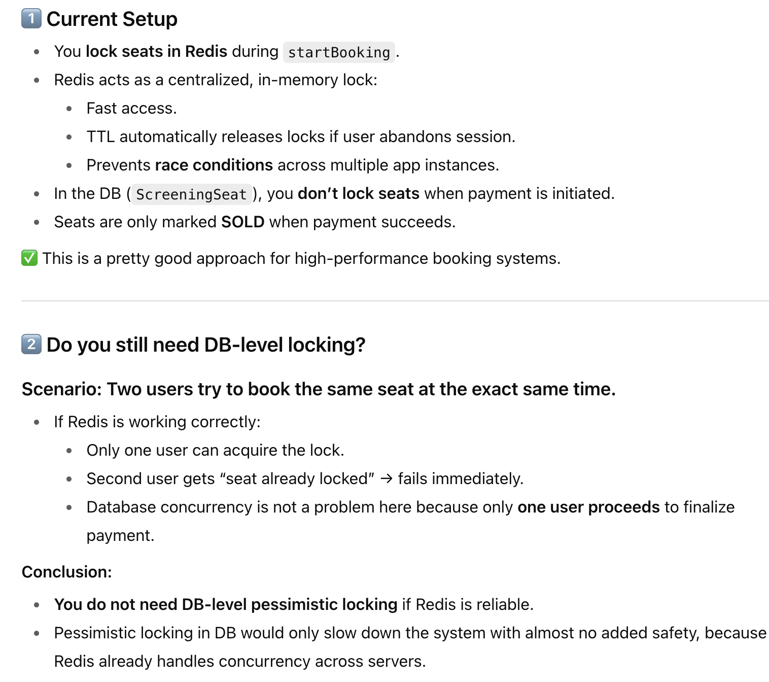
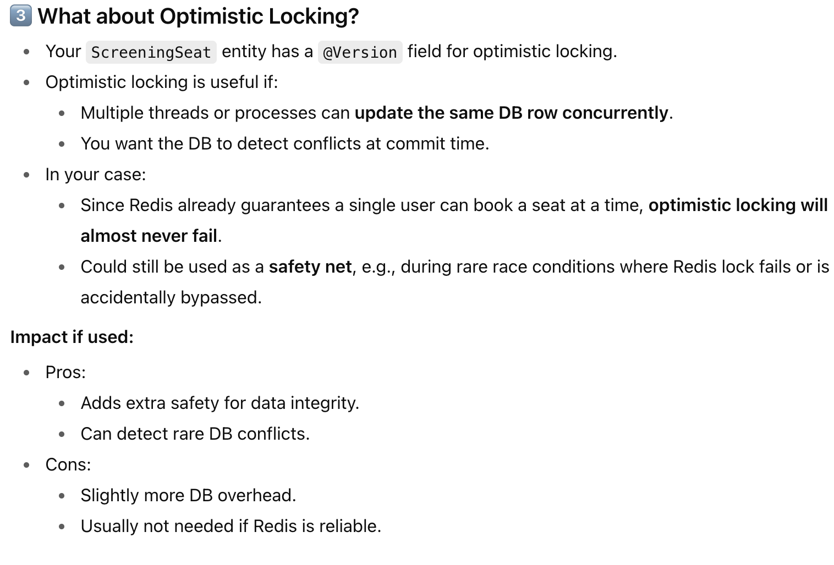
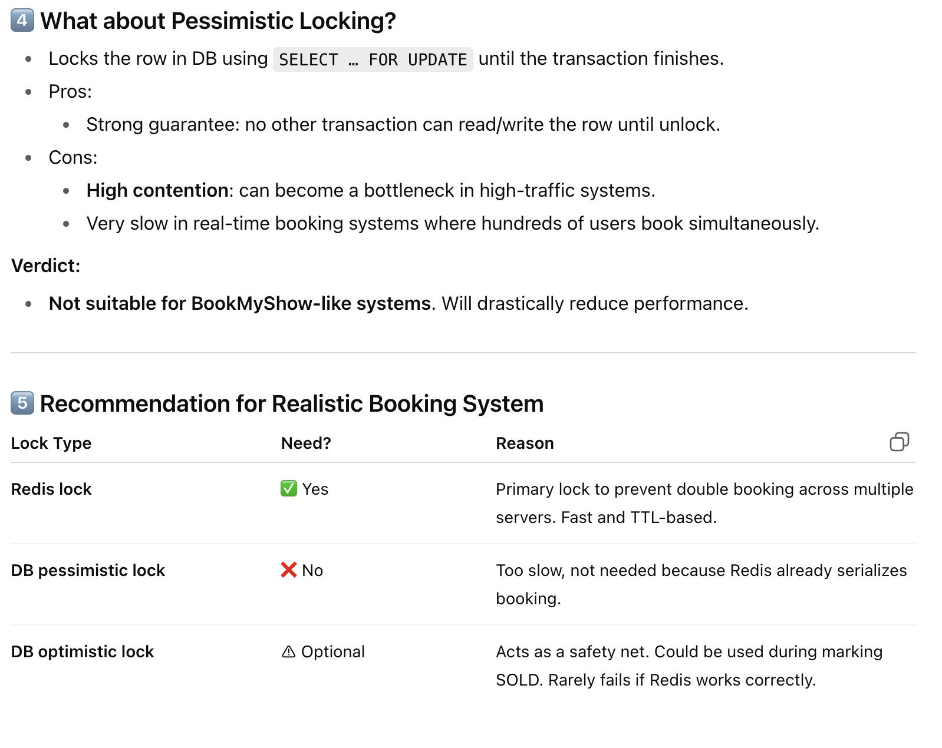
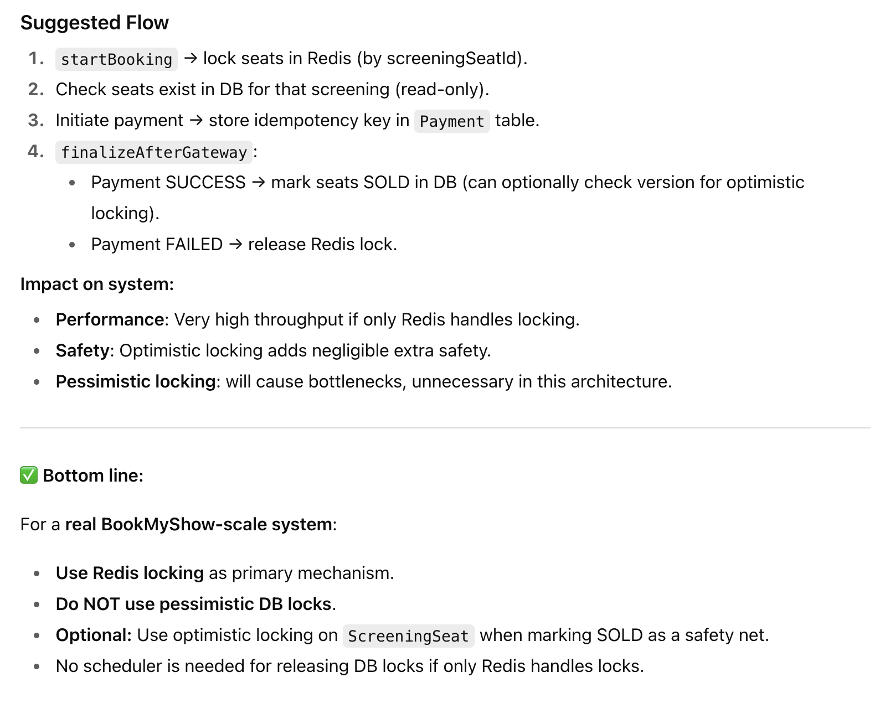

1.Best For Booking System to Handle Millions of Requests:
Refer Link : https://itnext.io/solving-double-booking-at-scale-system-design-patterns-from-top-tech-companies-4c5a3311d8ea
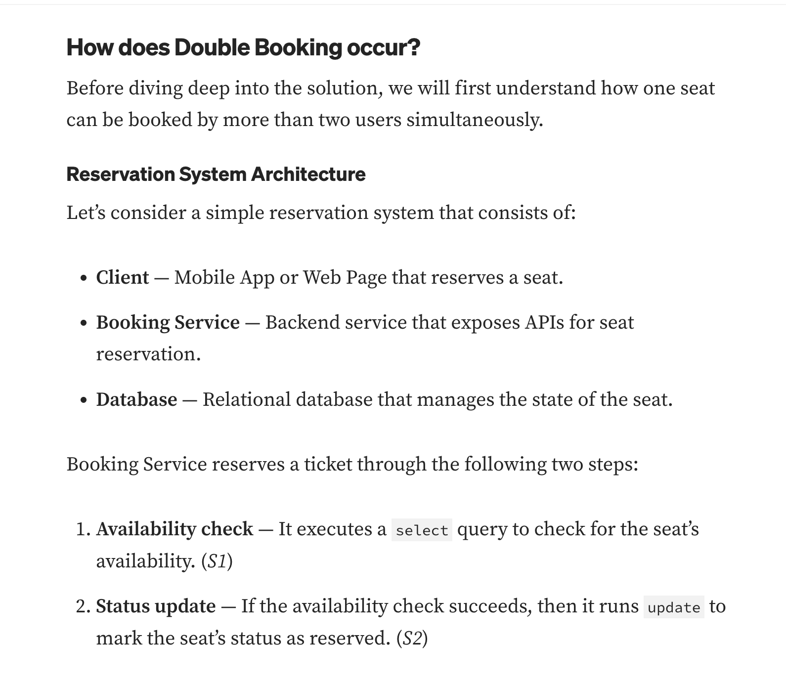
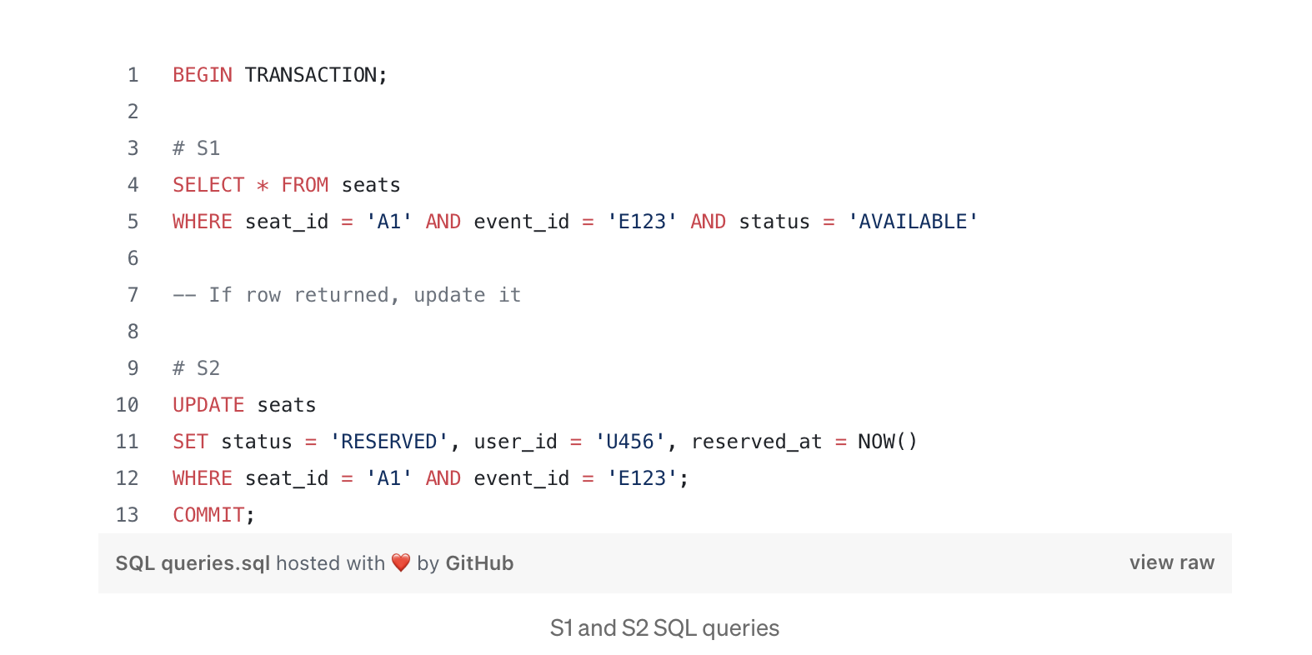
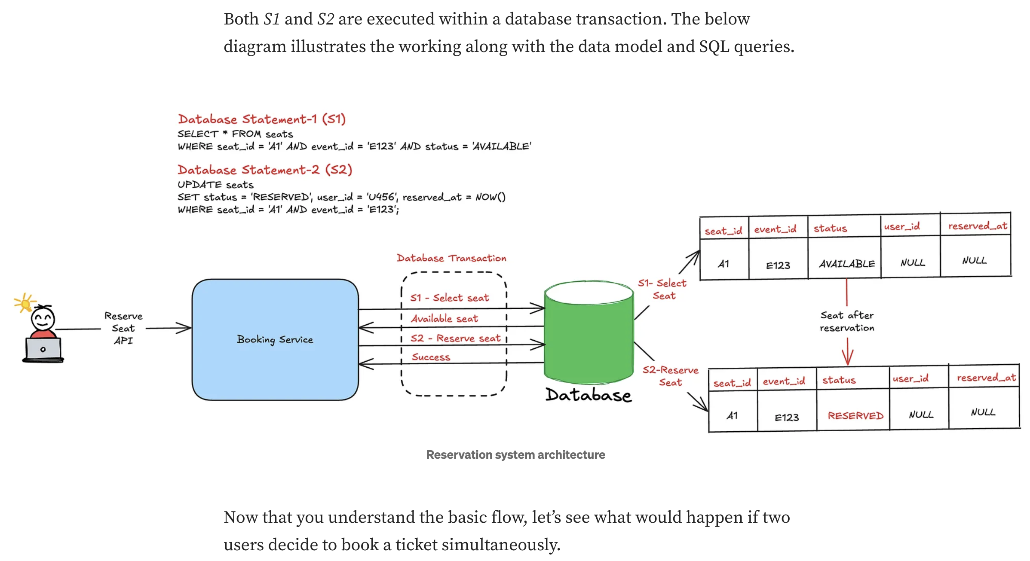
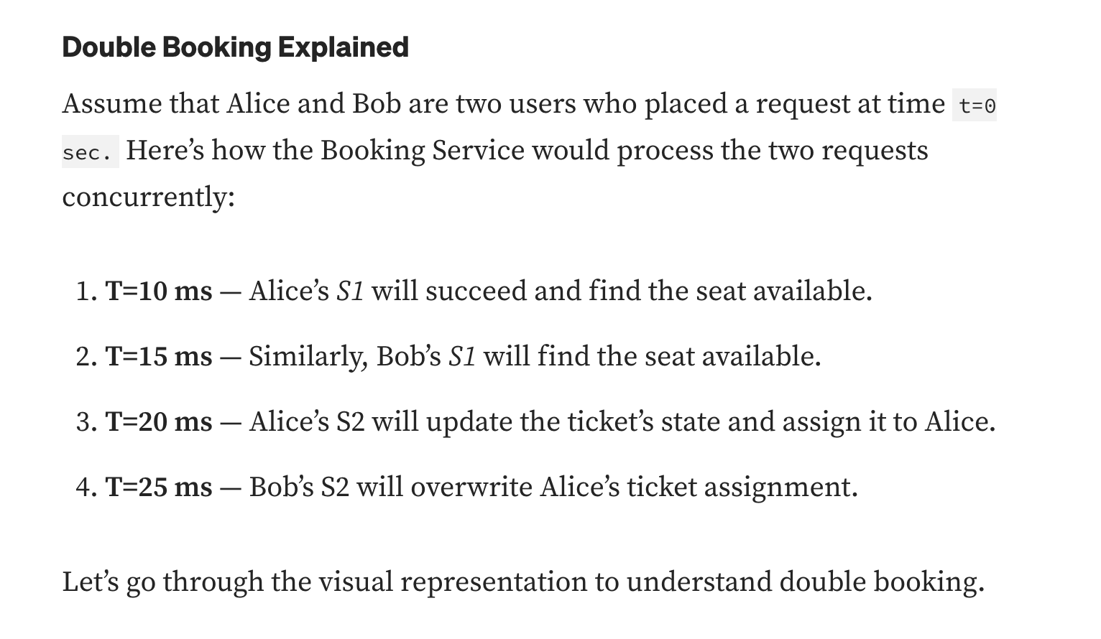
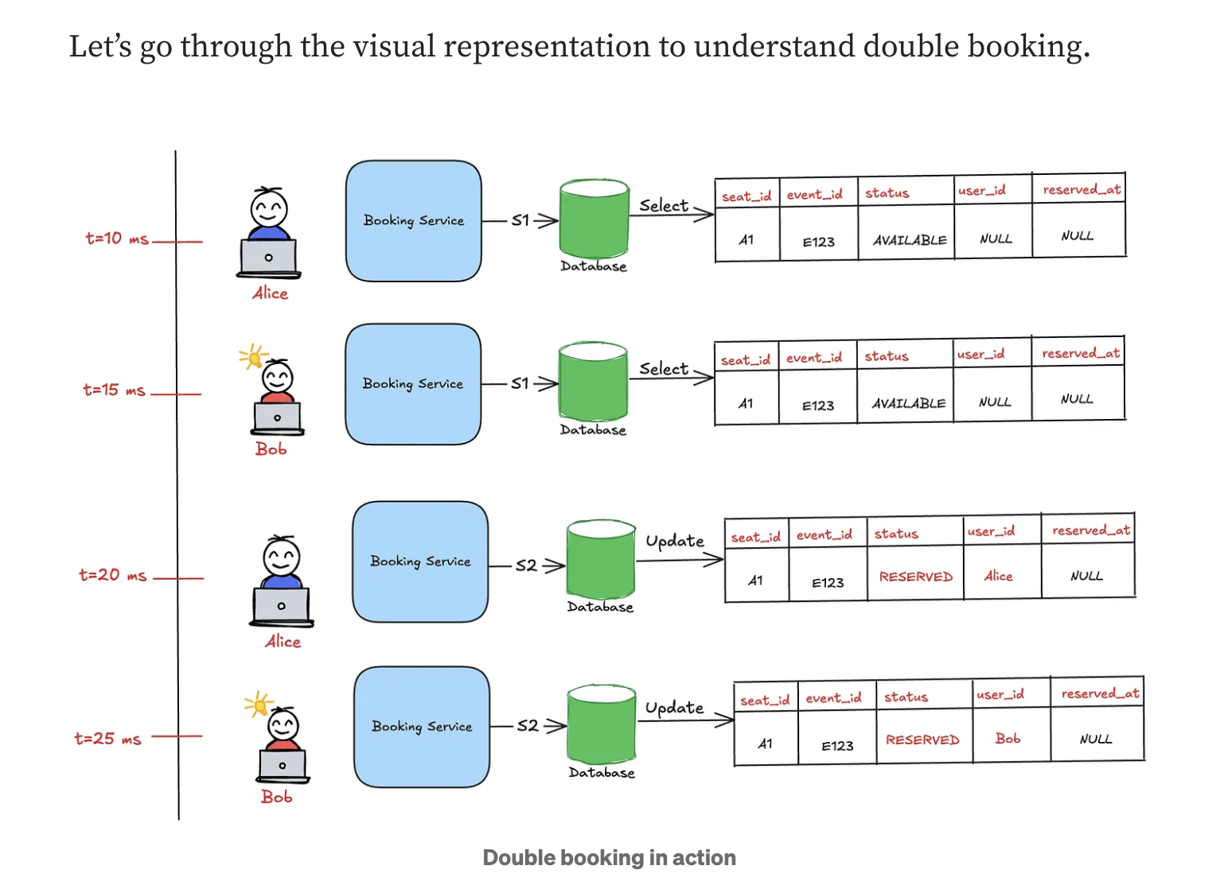
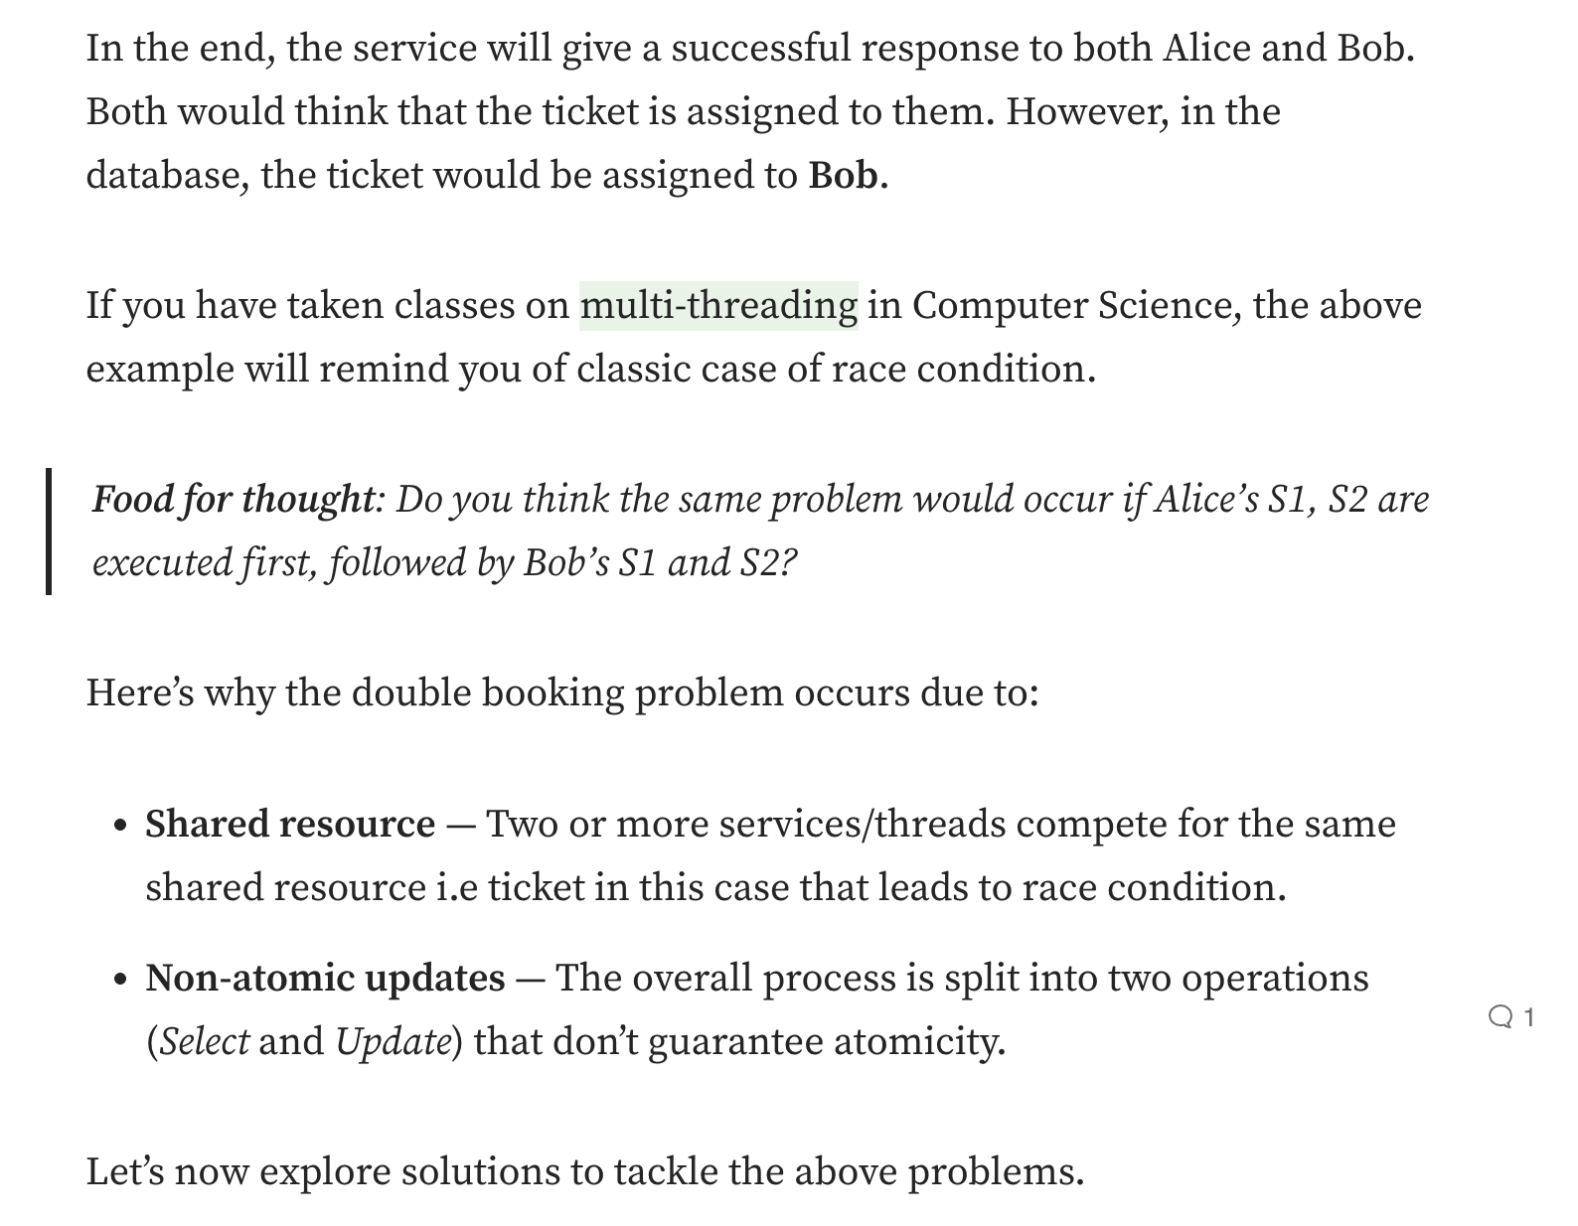
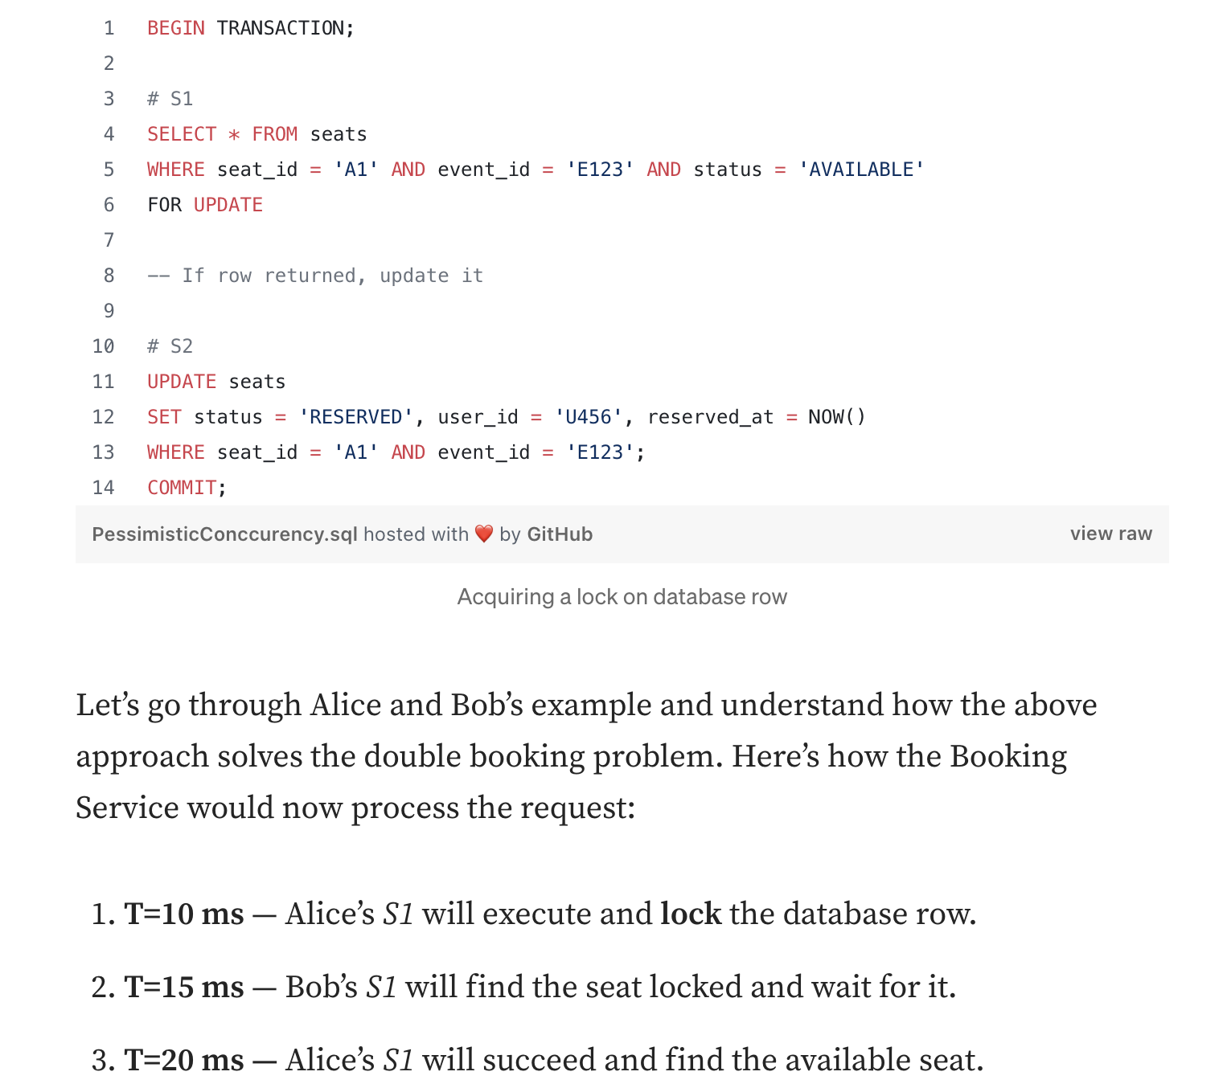
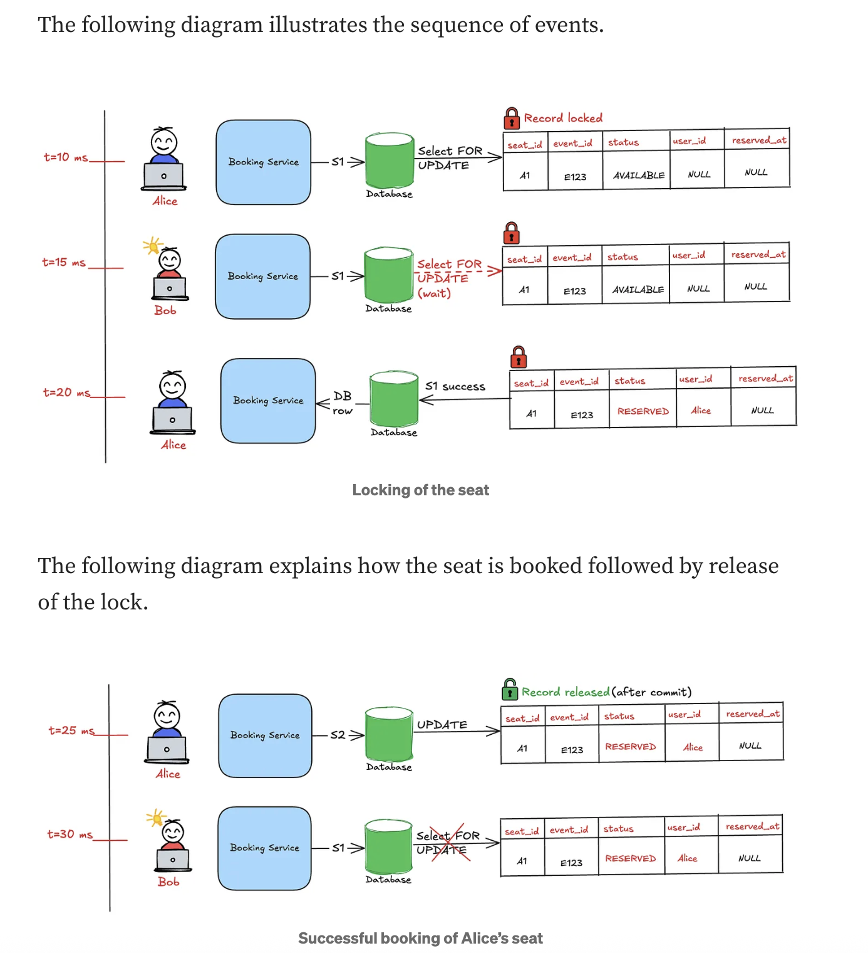
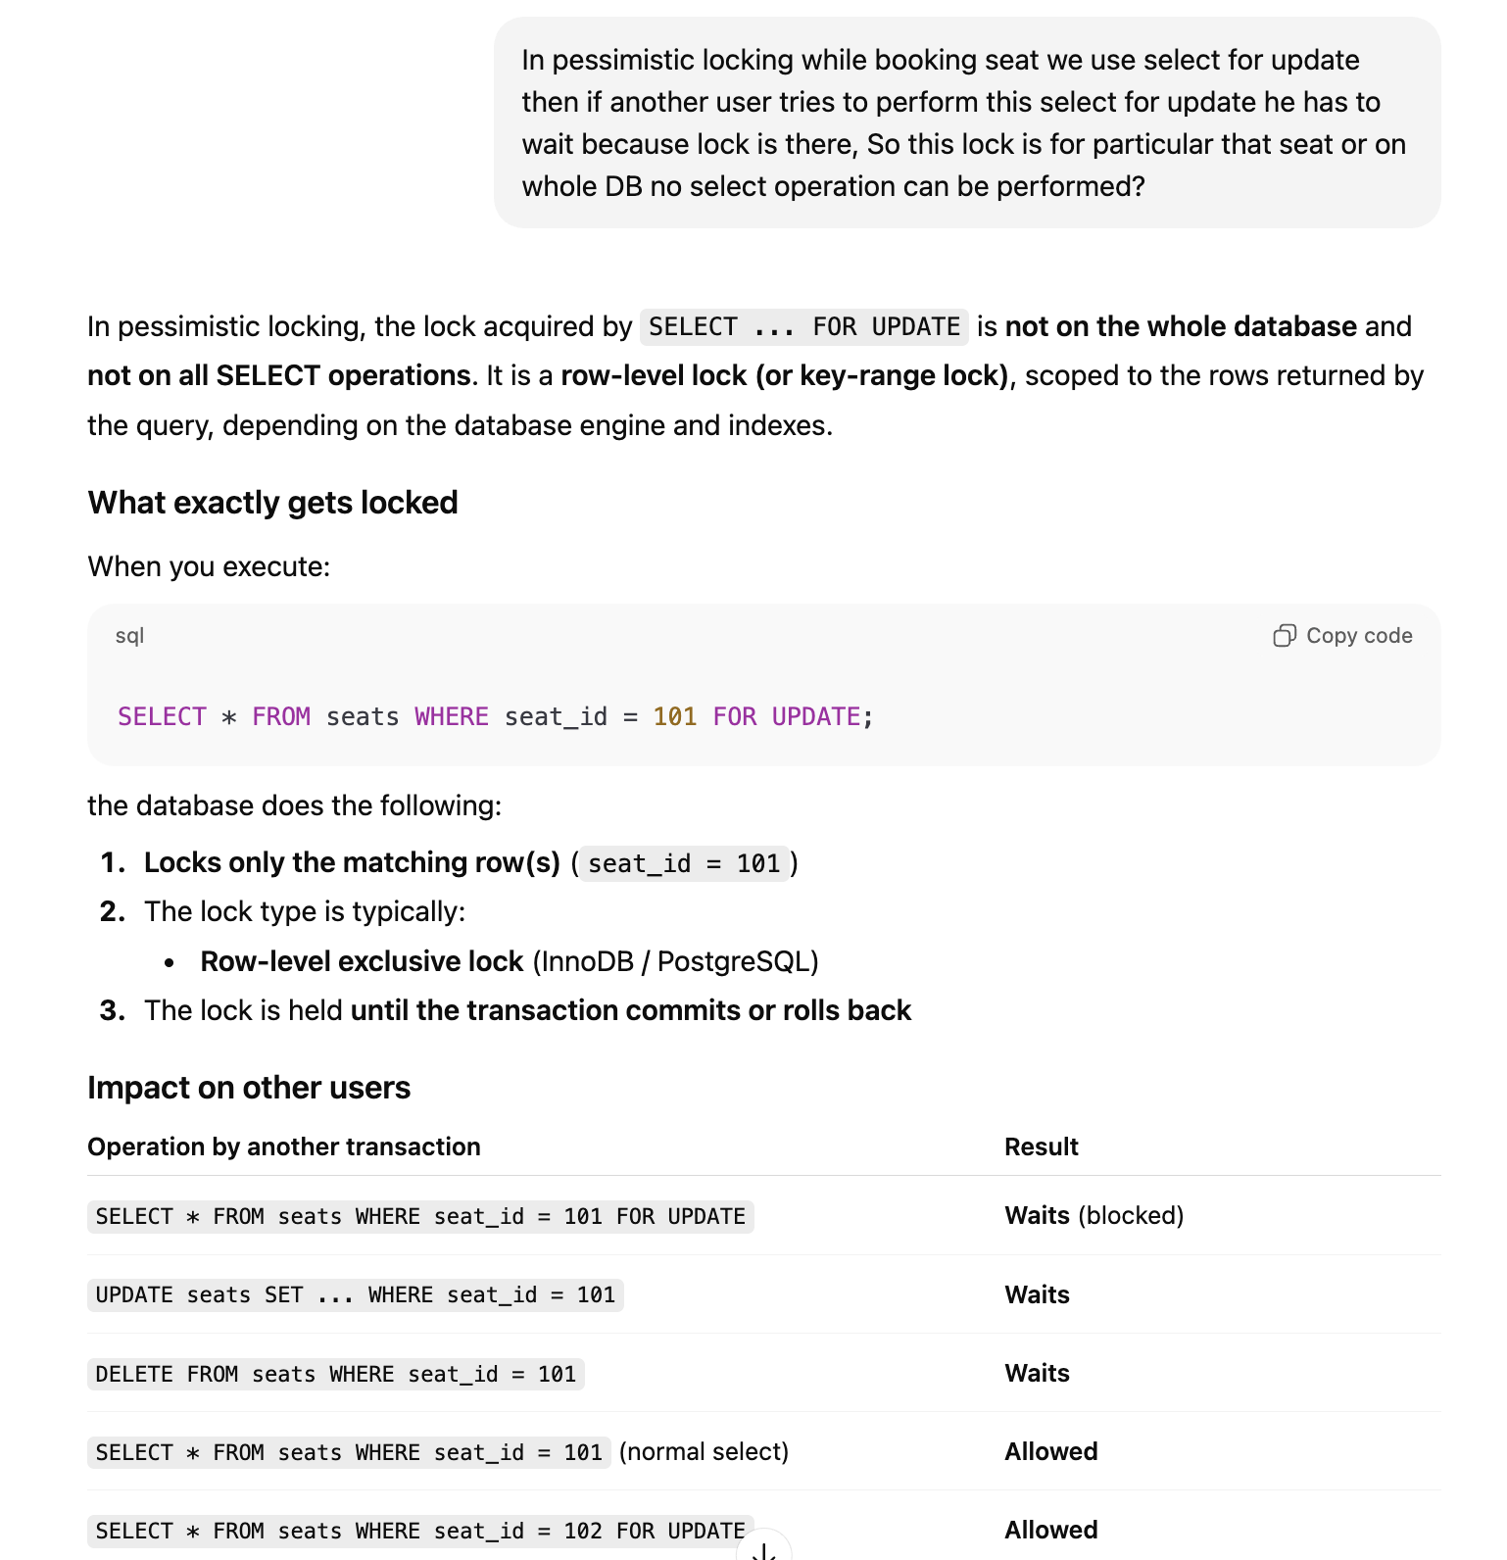
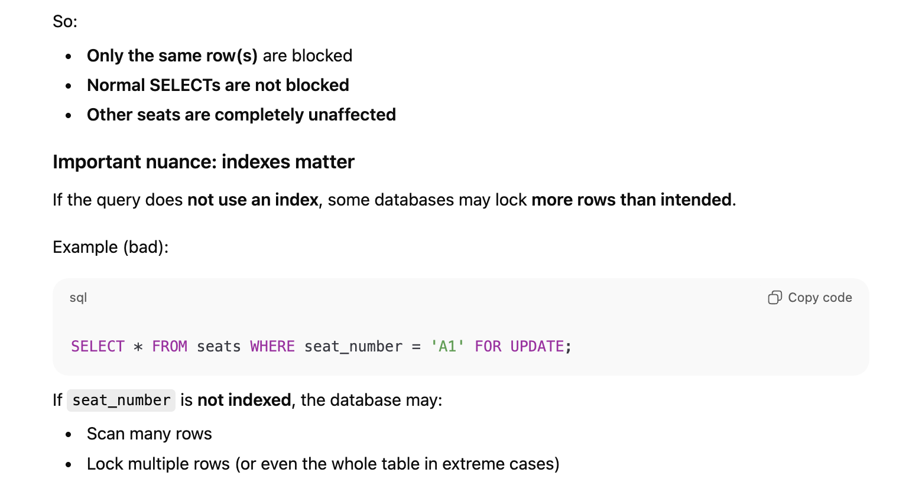
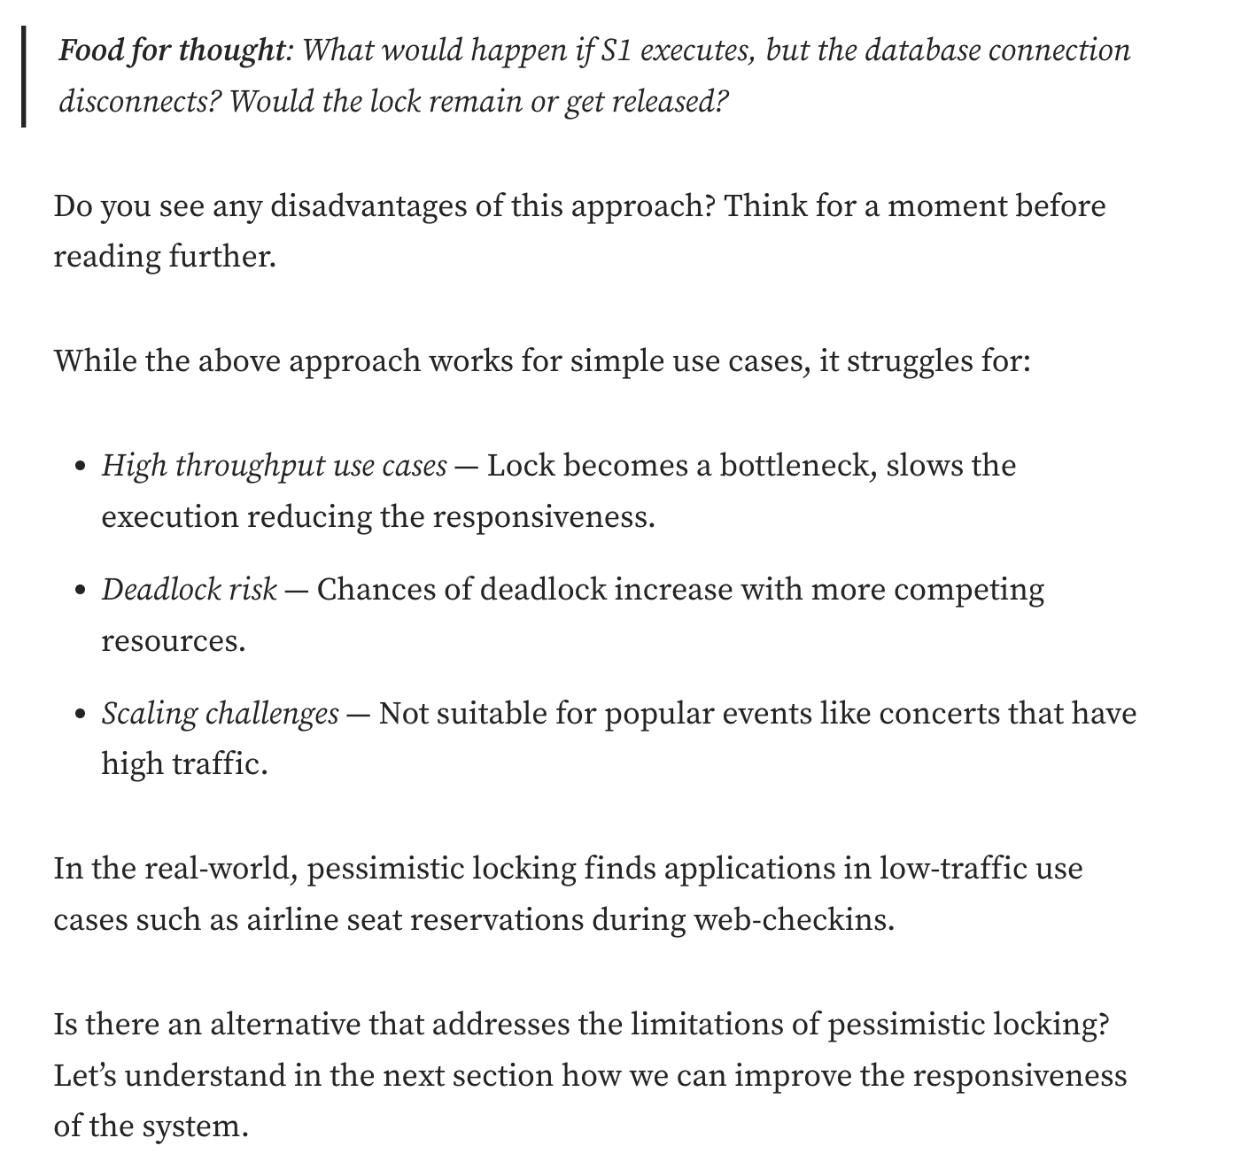
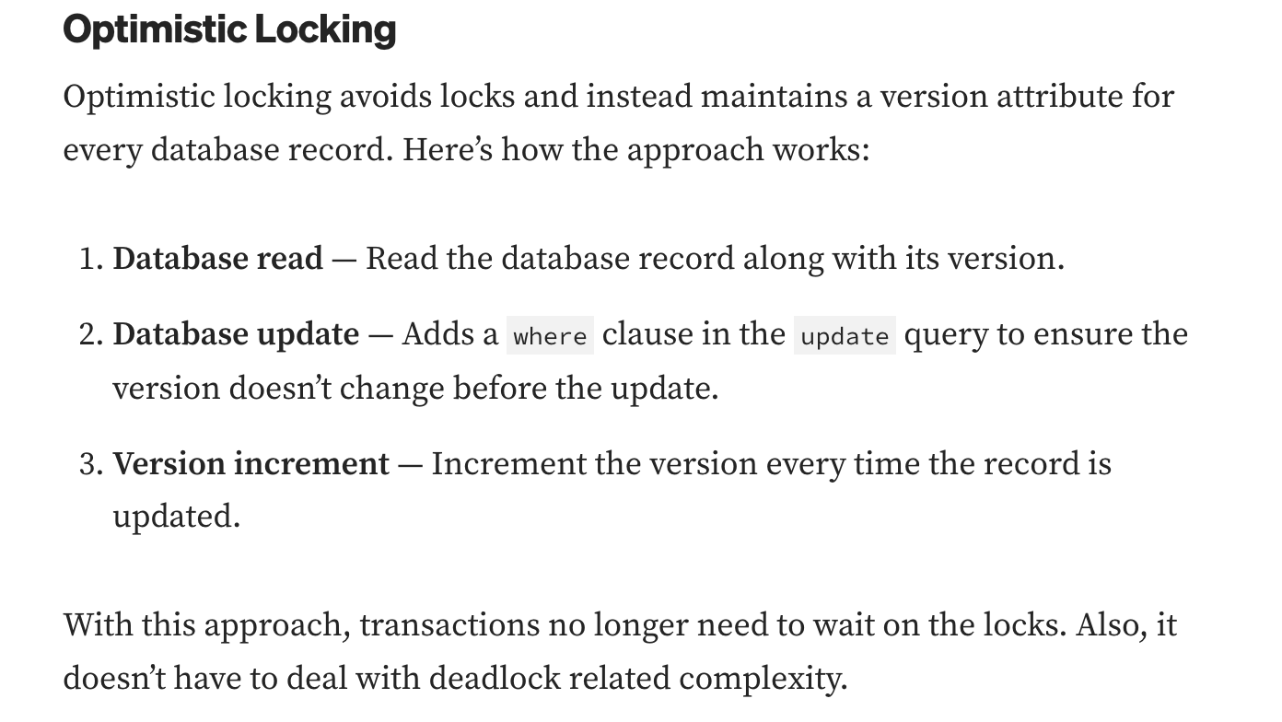
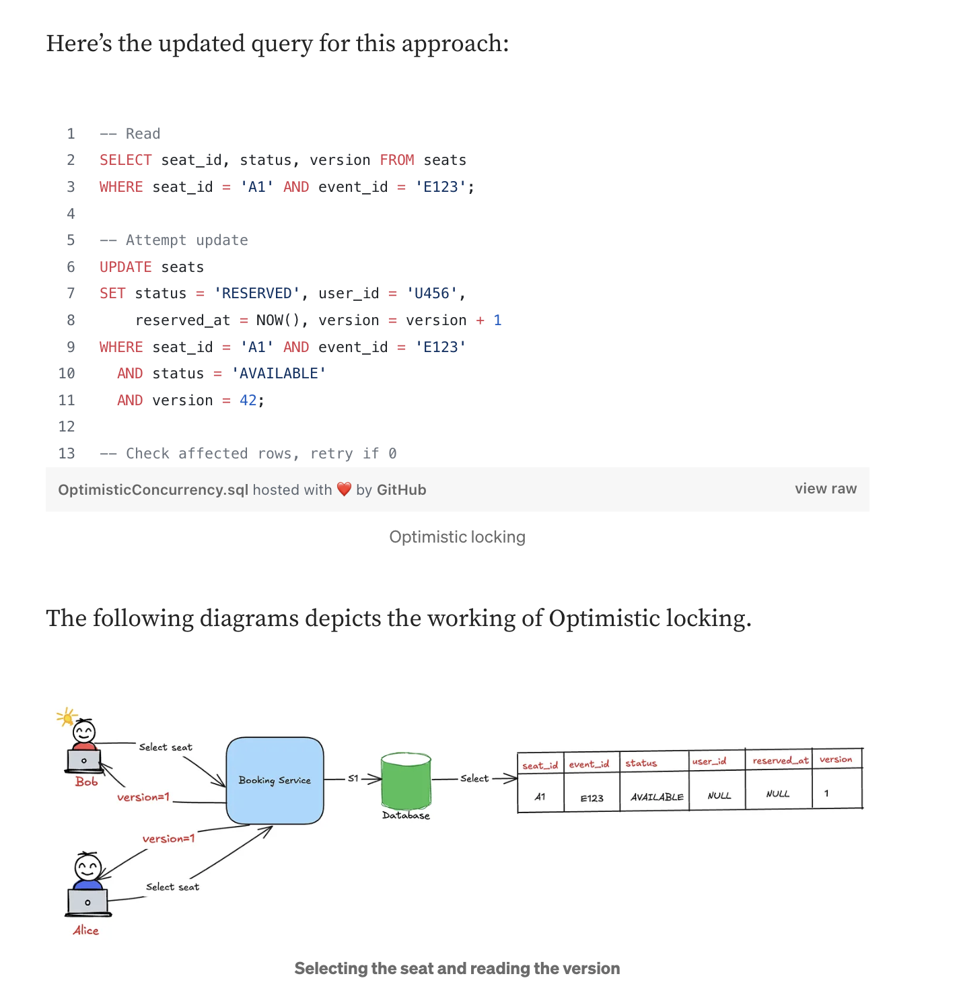
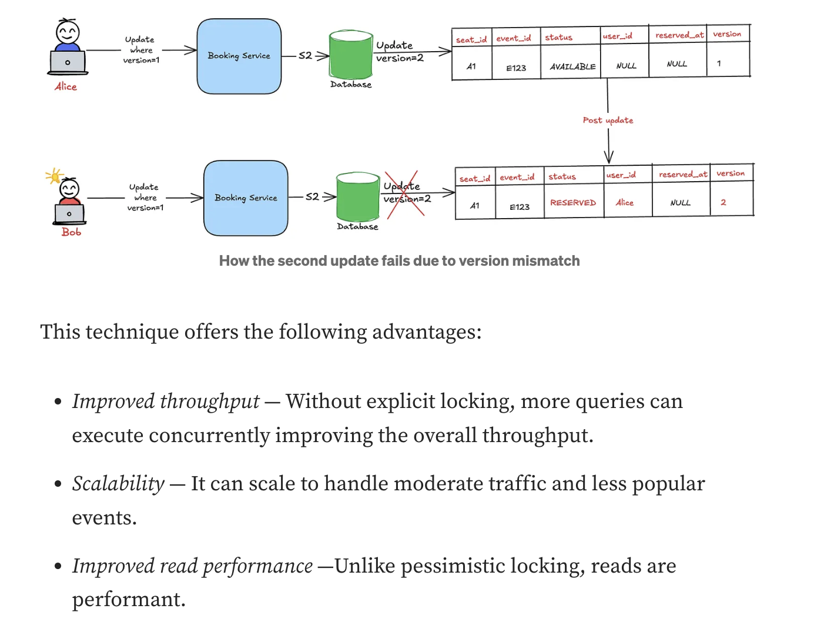

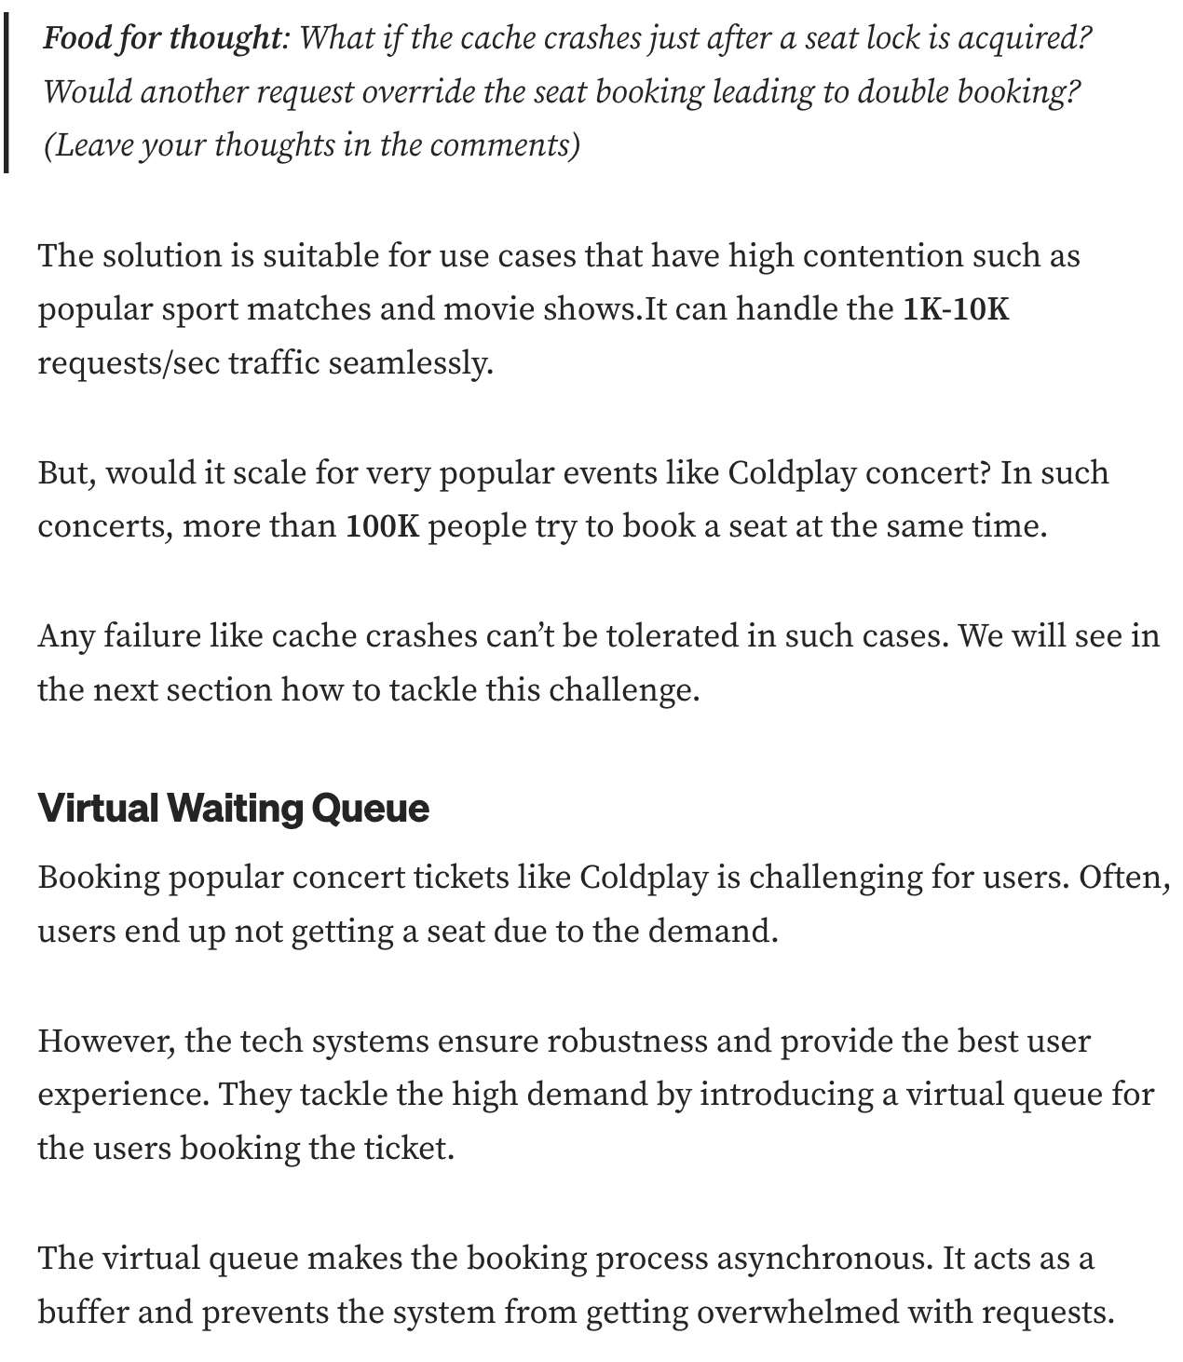
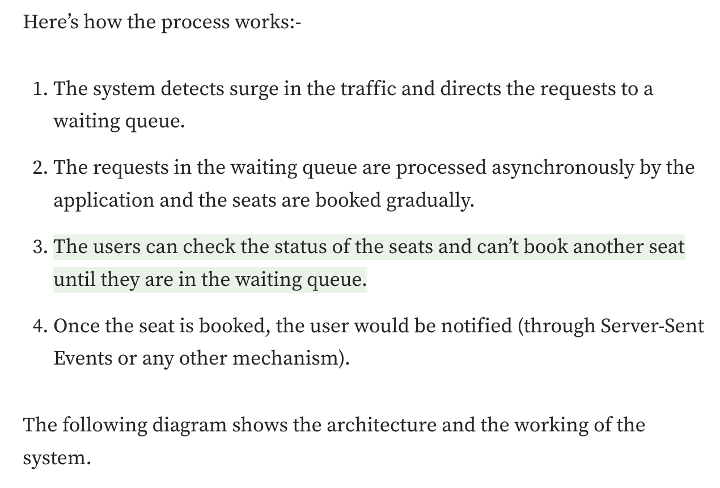
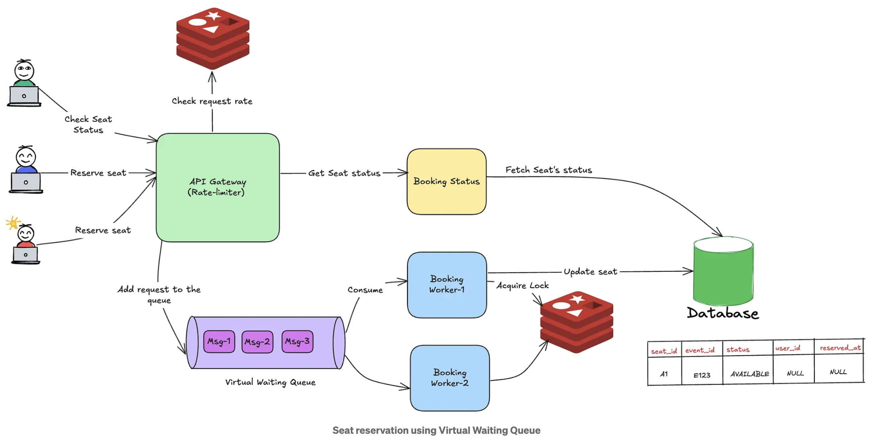
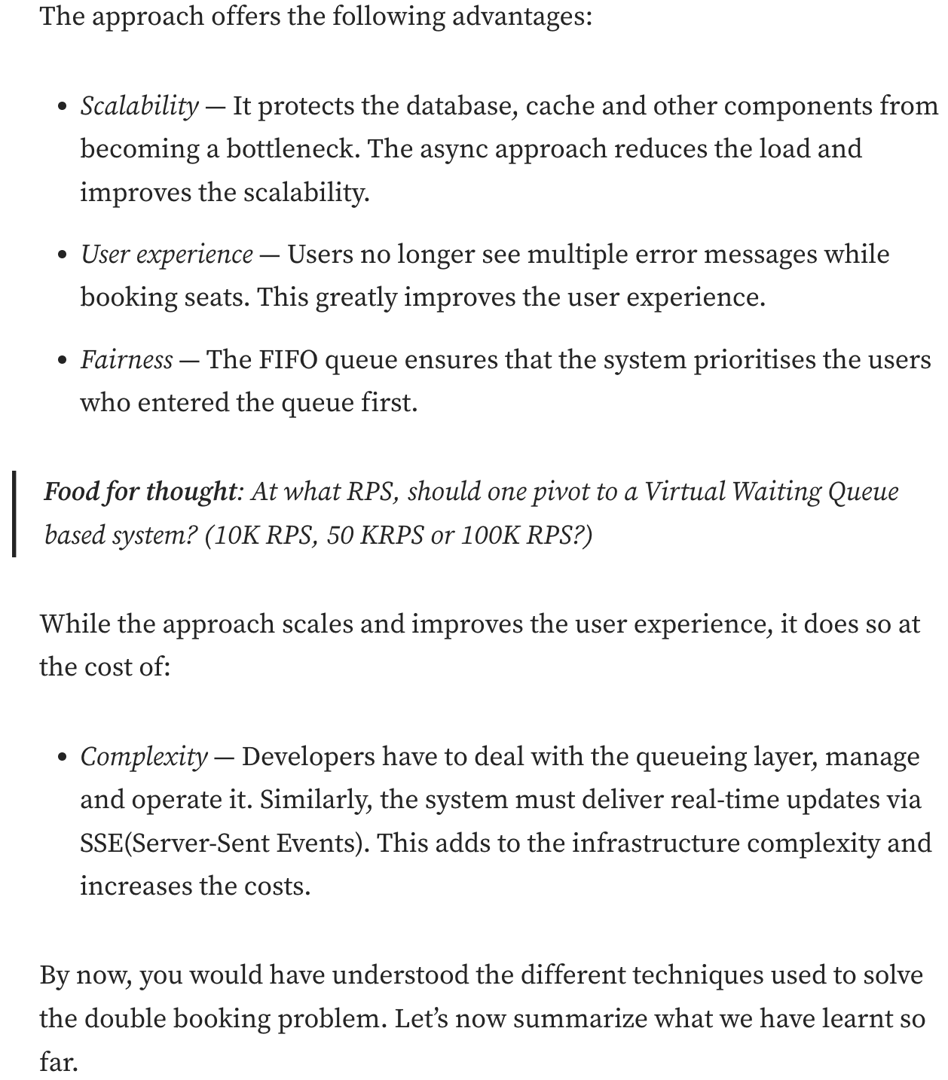
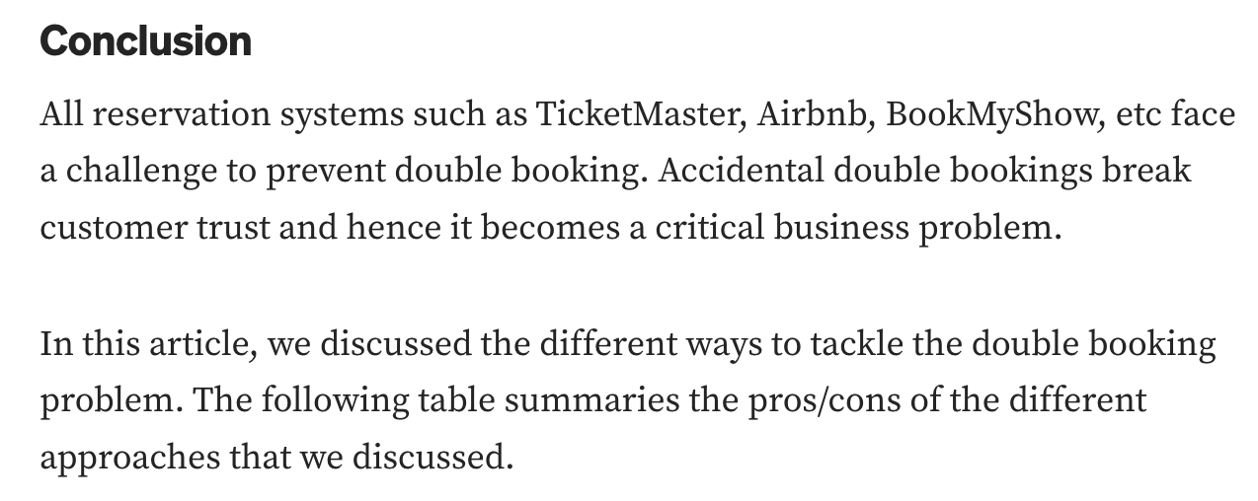
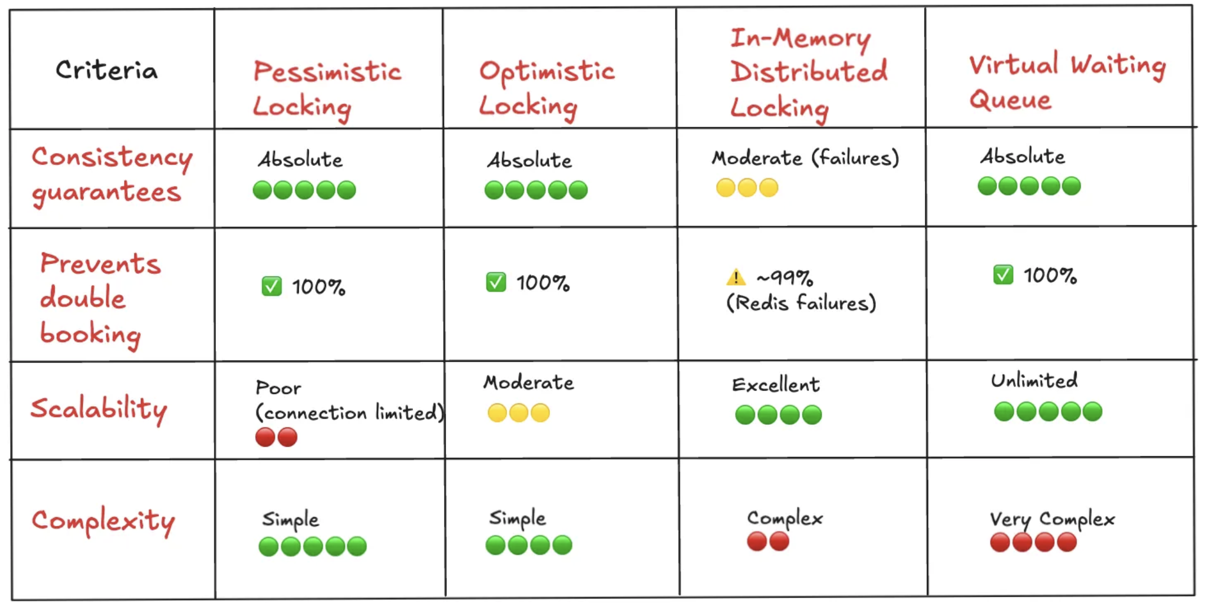
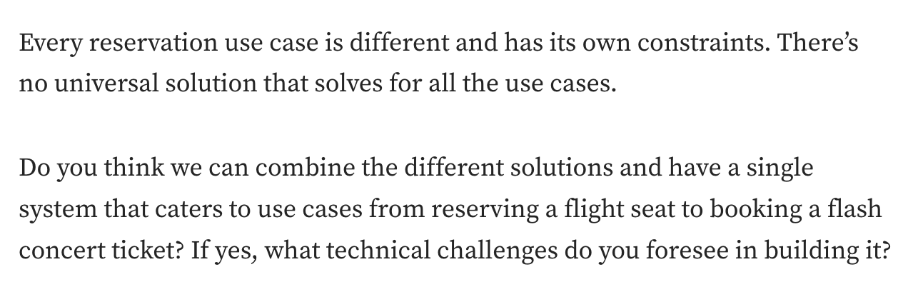
The solution described is not meant for large, high-traffic systems. It only explains how to prevent double booking in small systems where everything runs on a single database or a single cache server, with no replication delay. It works fine, but calling it “at scale” is misleading because it does not address the challenges of truly large, high-volume systems.

2.Best way Booking System to Handle Millions of Requests:
https://freedium.cfd/https://codefarm0.medium.com/building-a-ticketing-system-concurrency-locks-and-race-conditions-182e0932d962
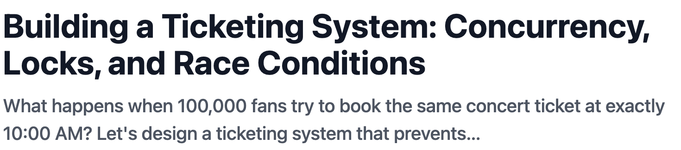
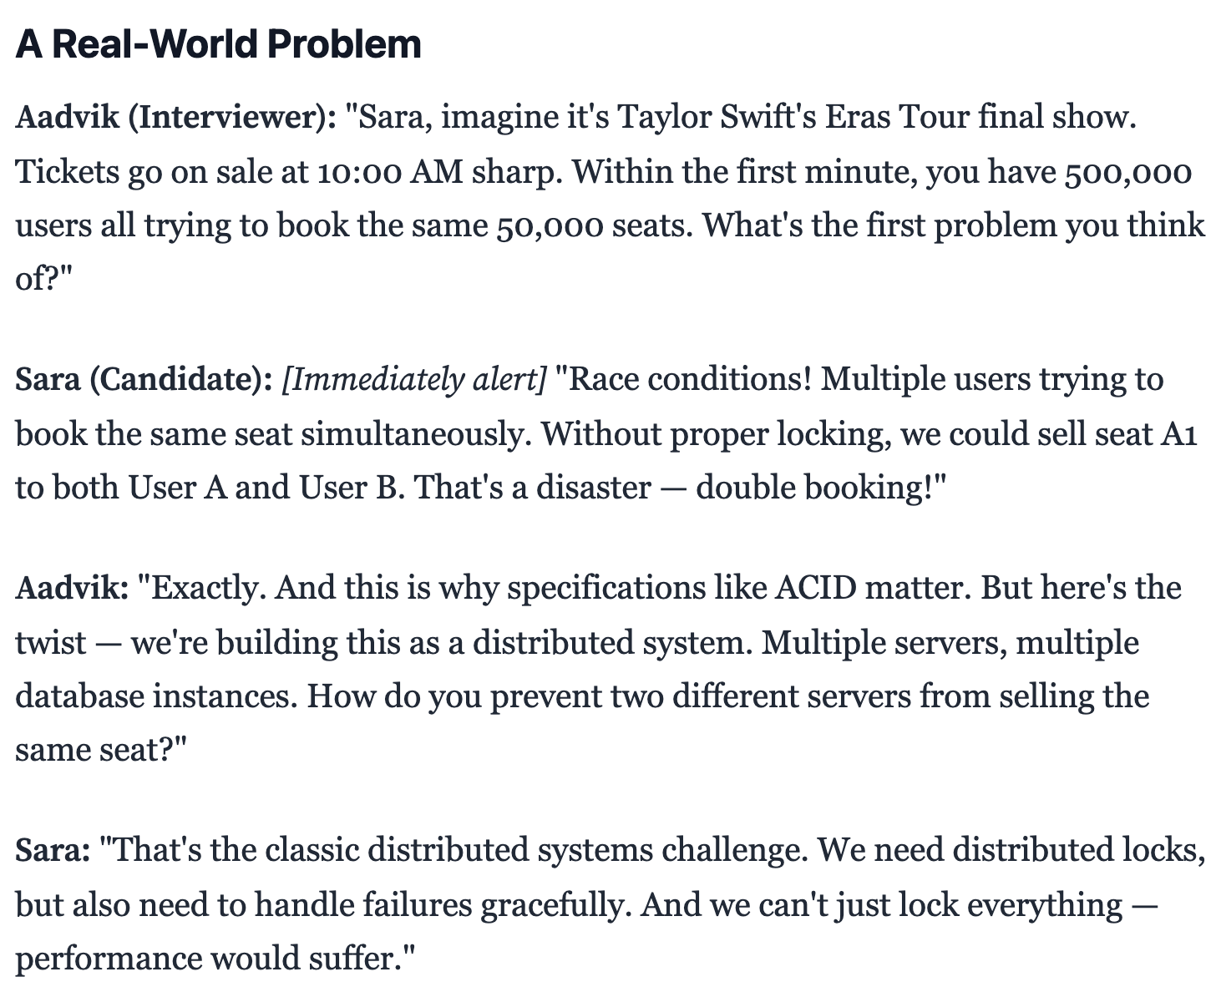
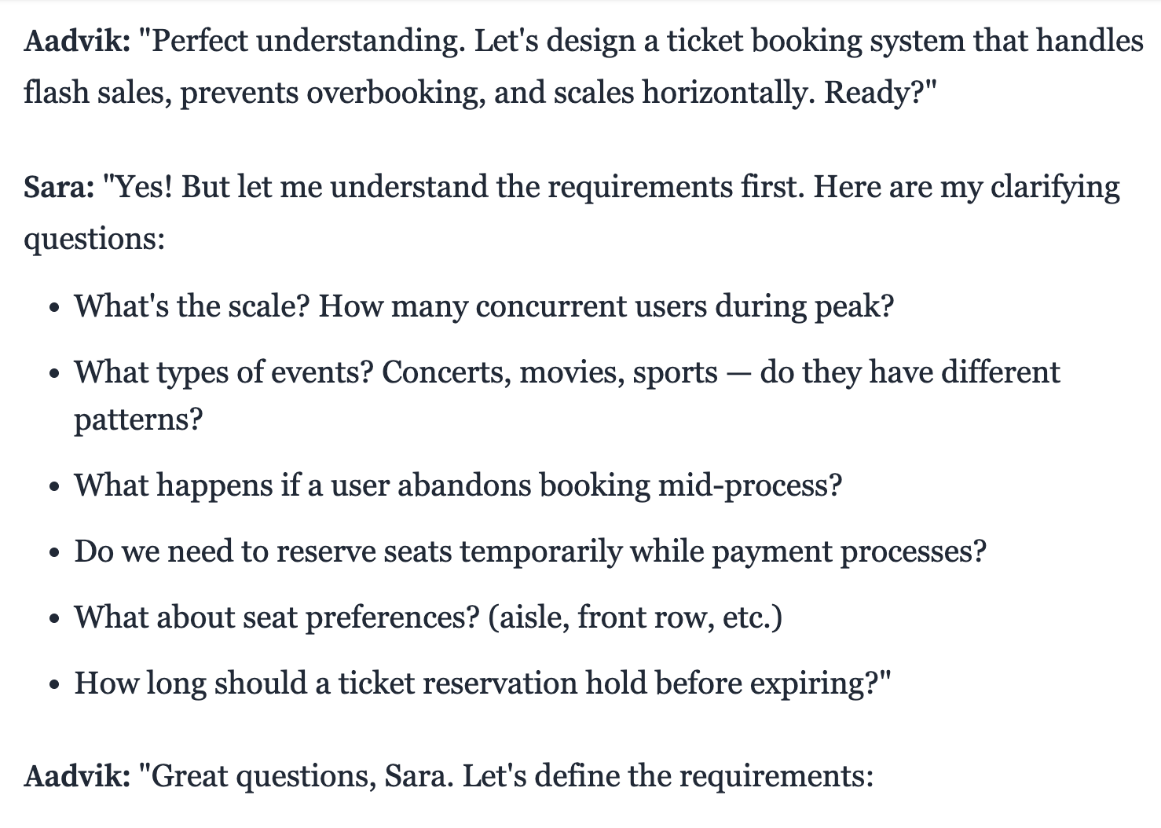
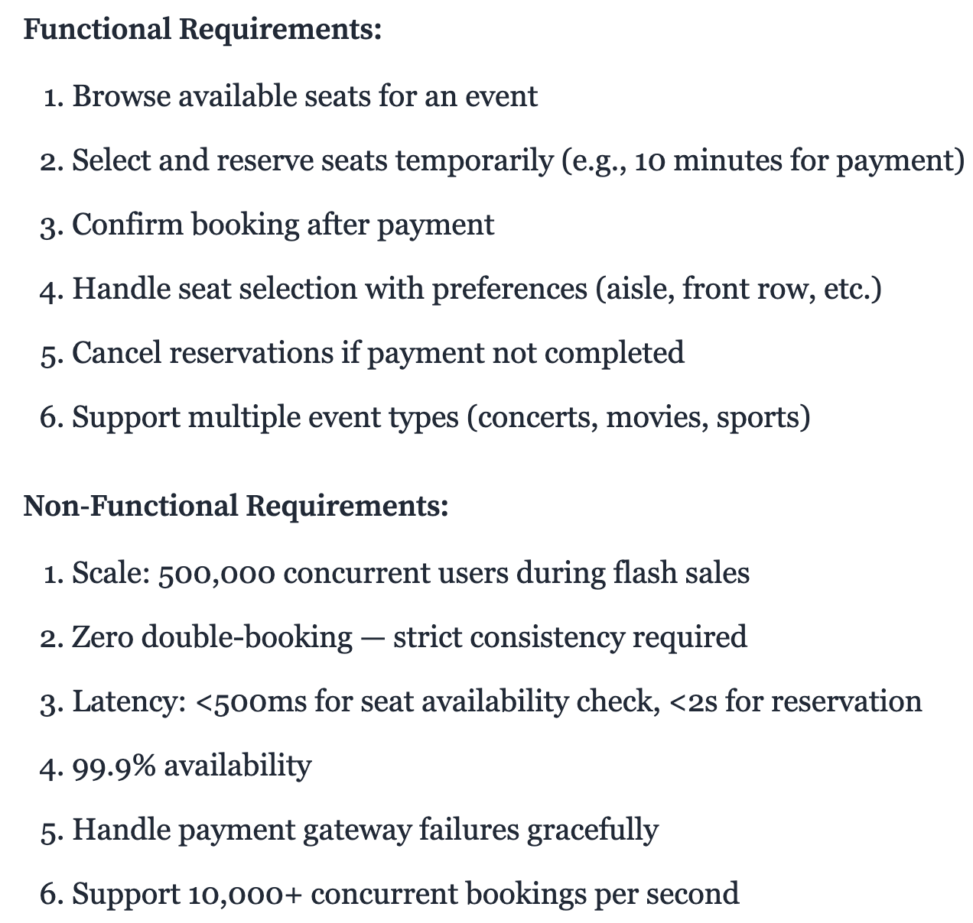
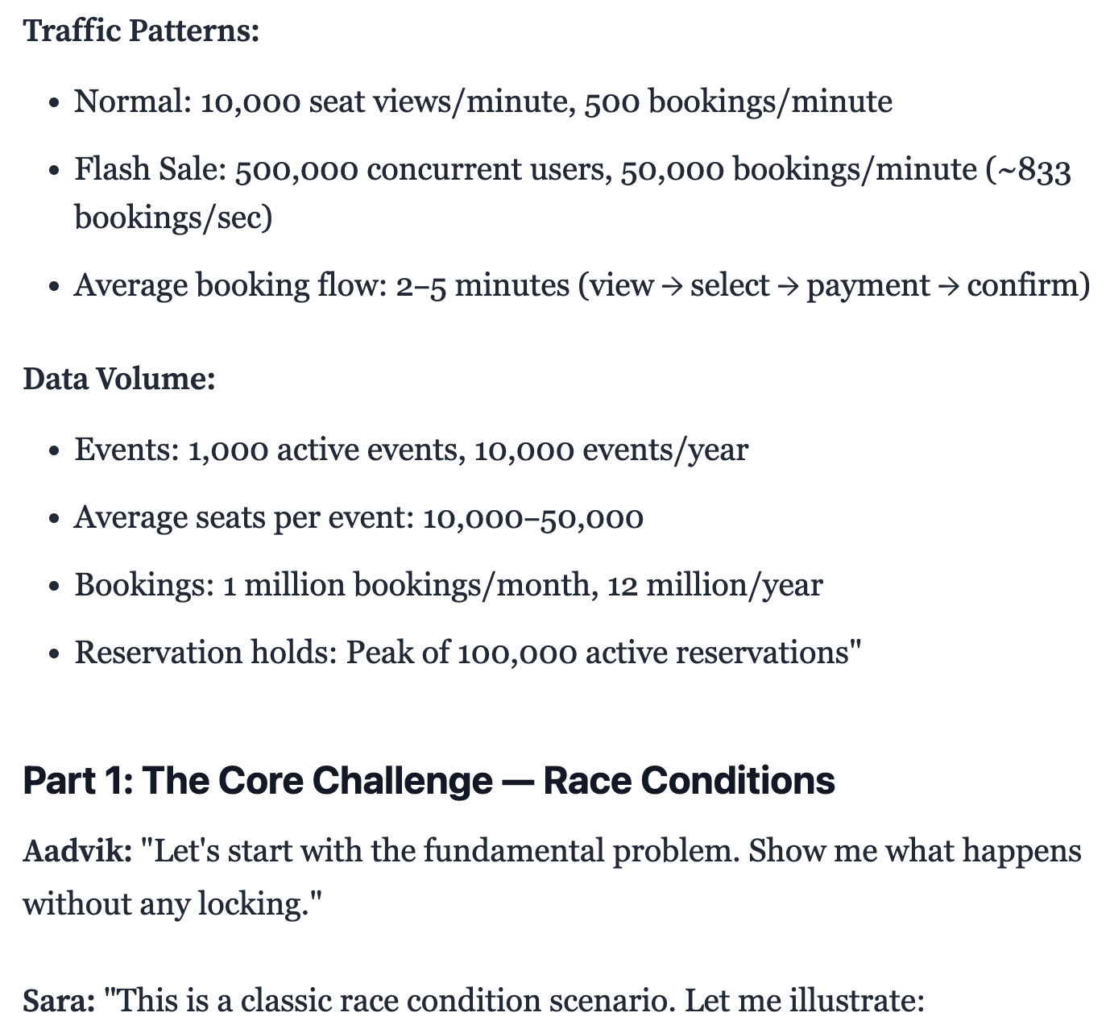
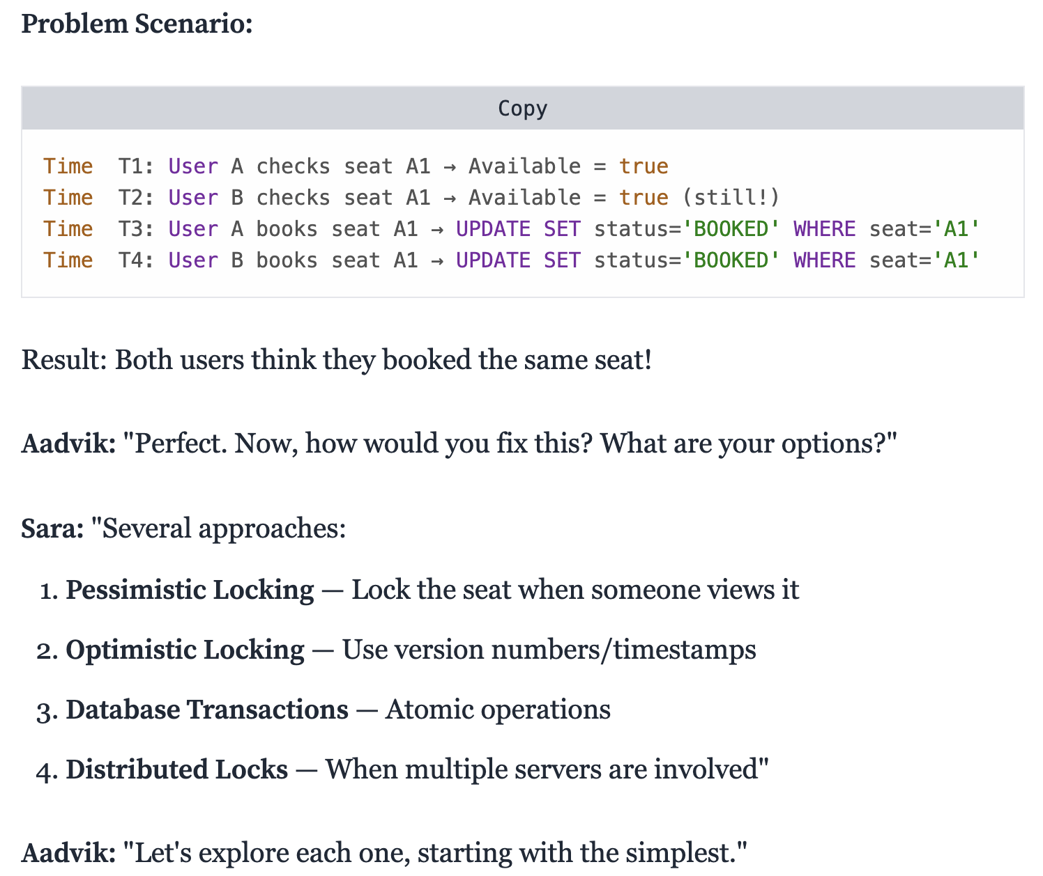
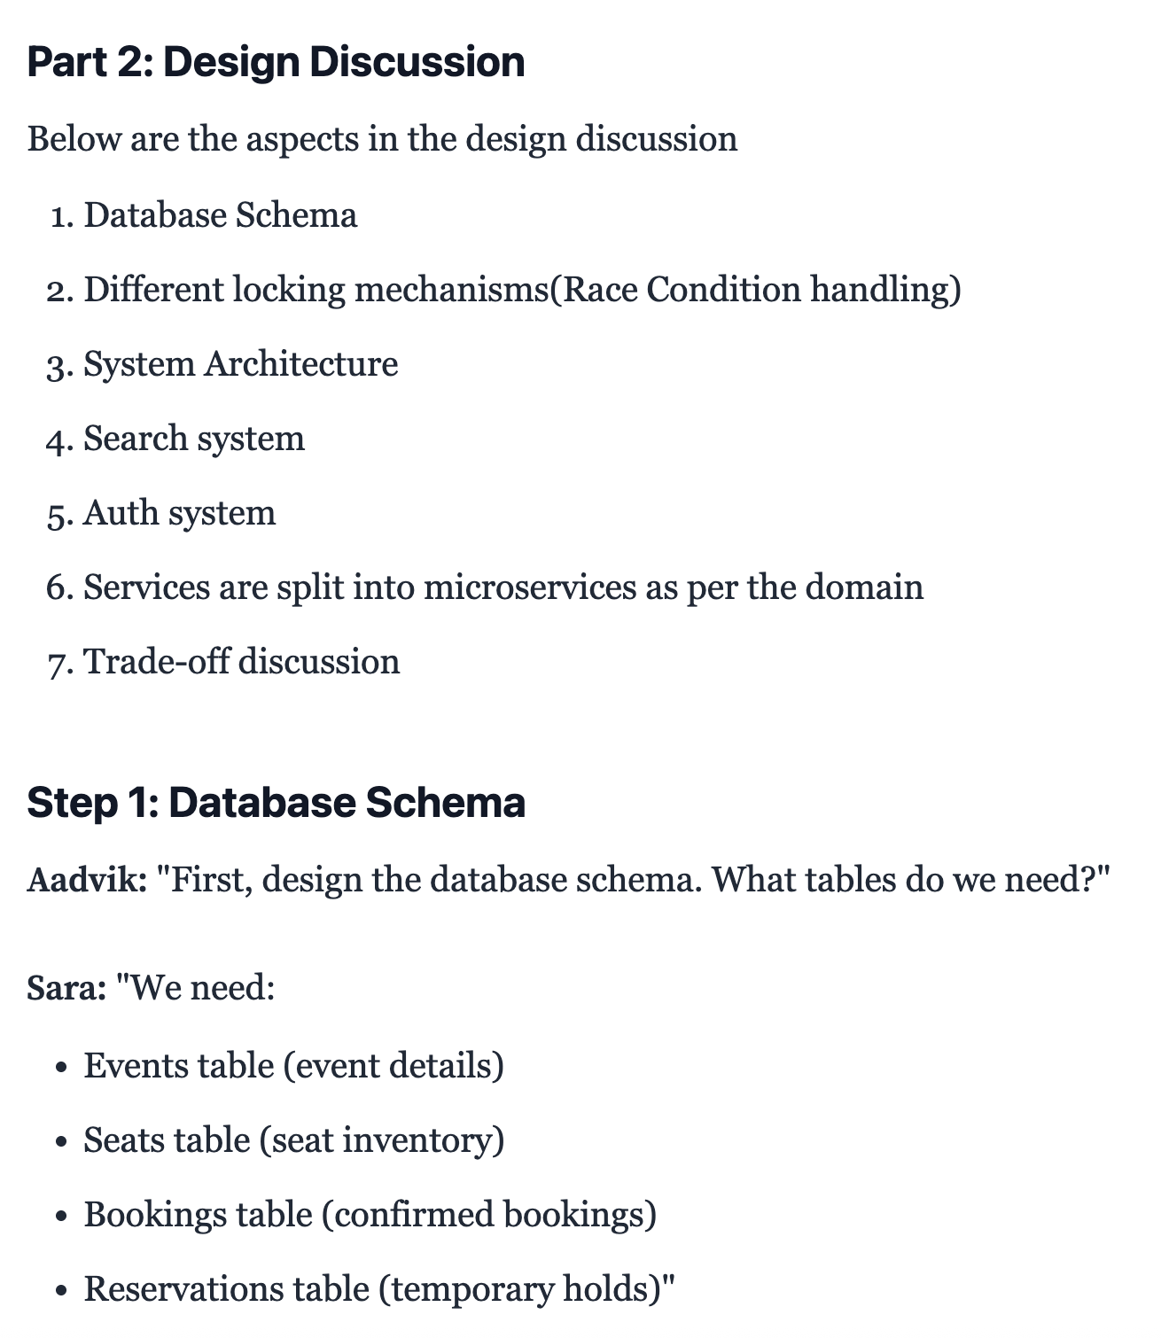
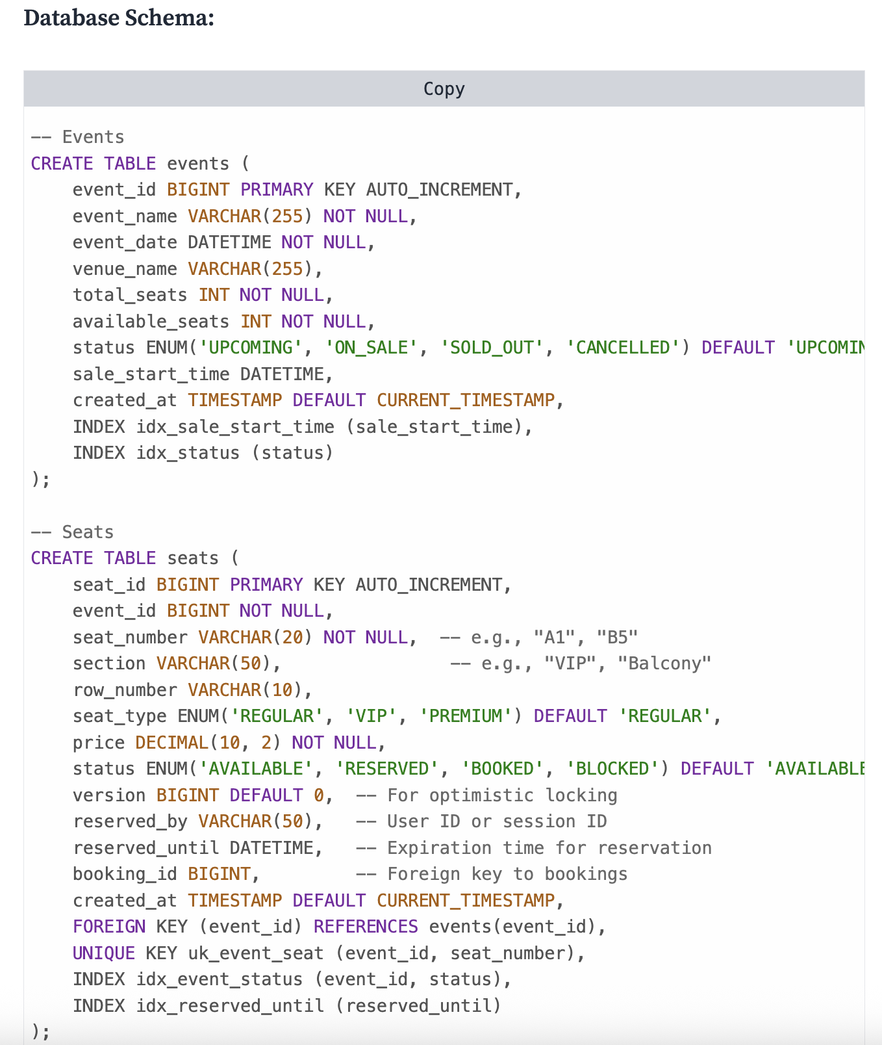
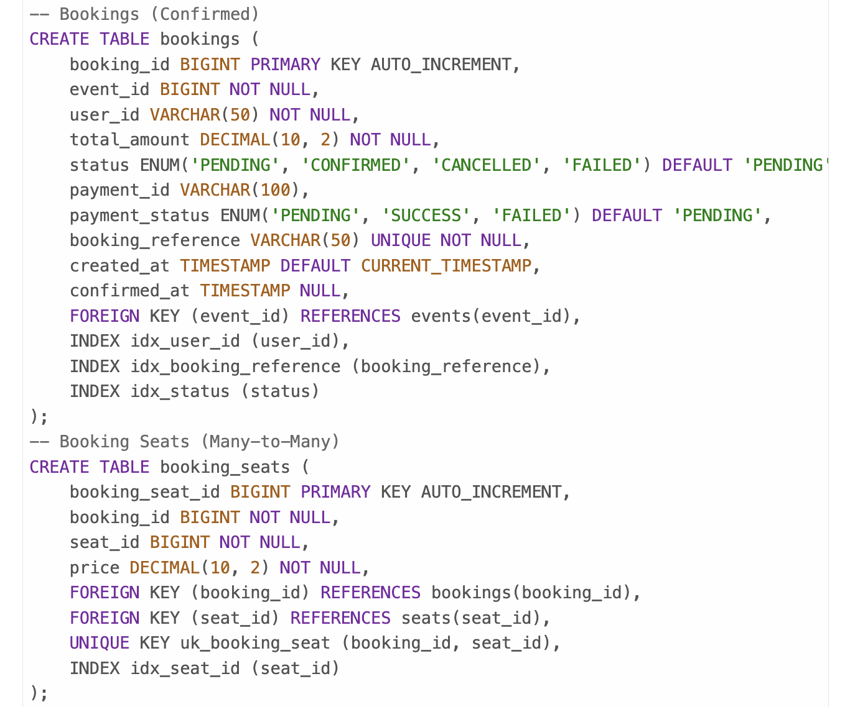
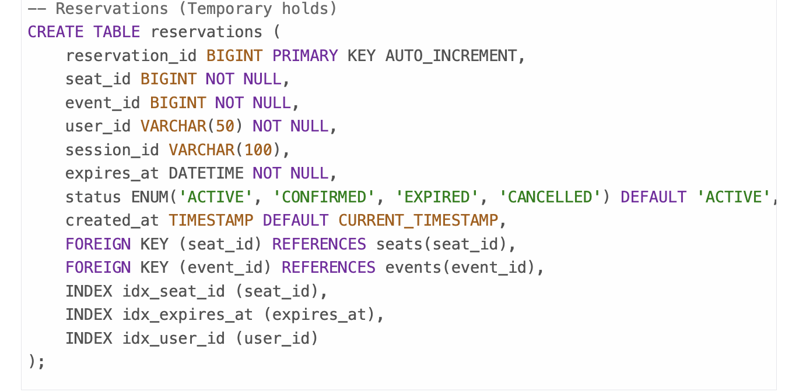
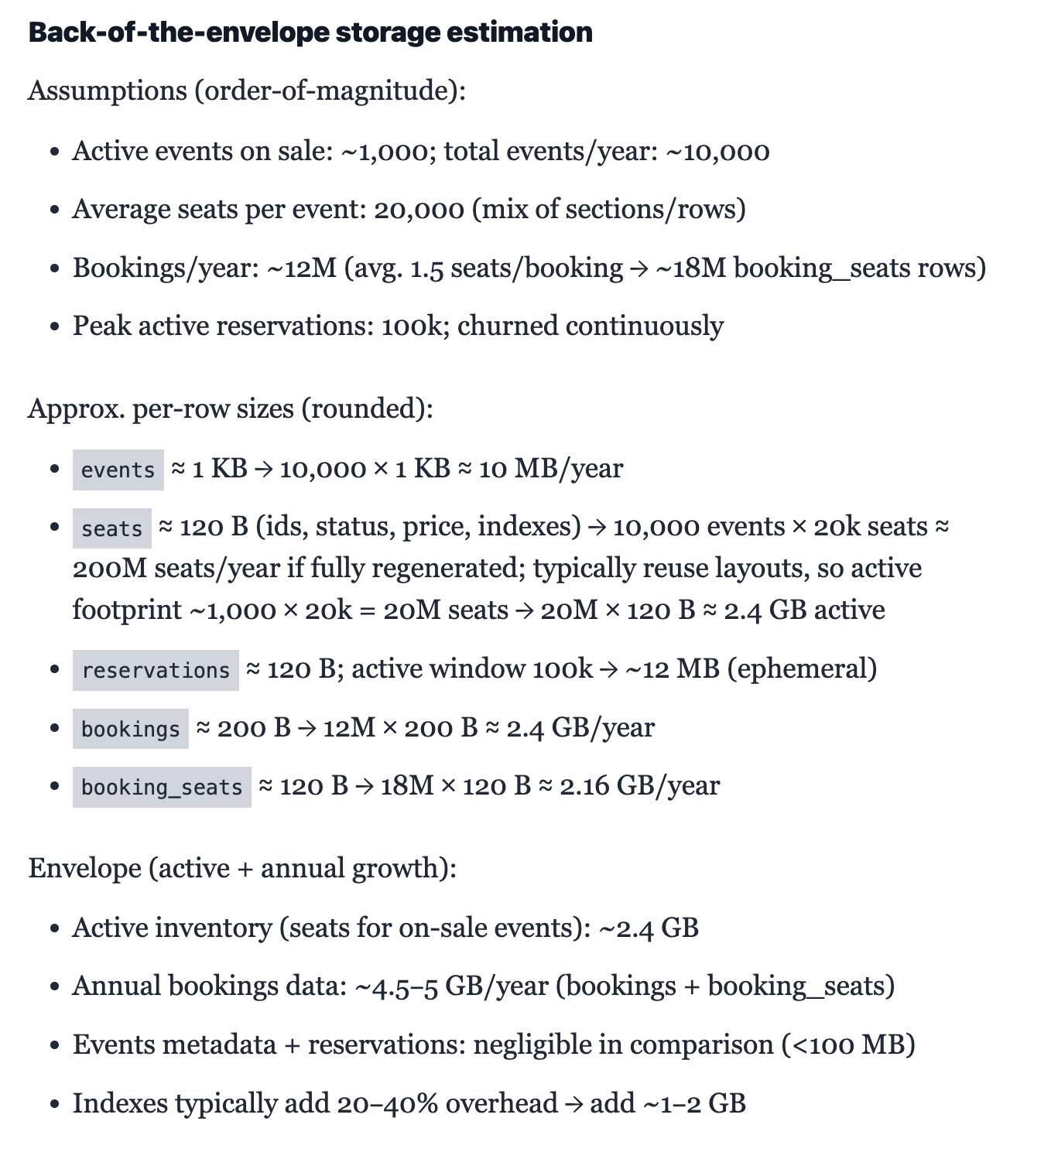
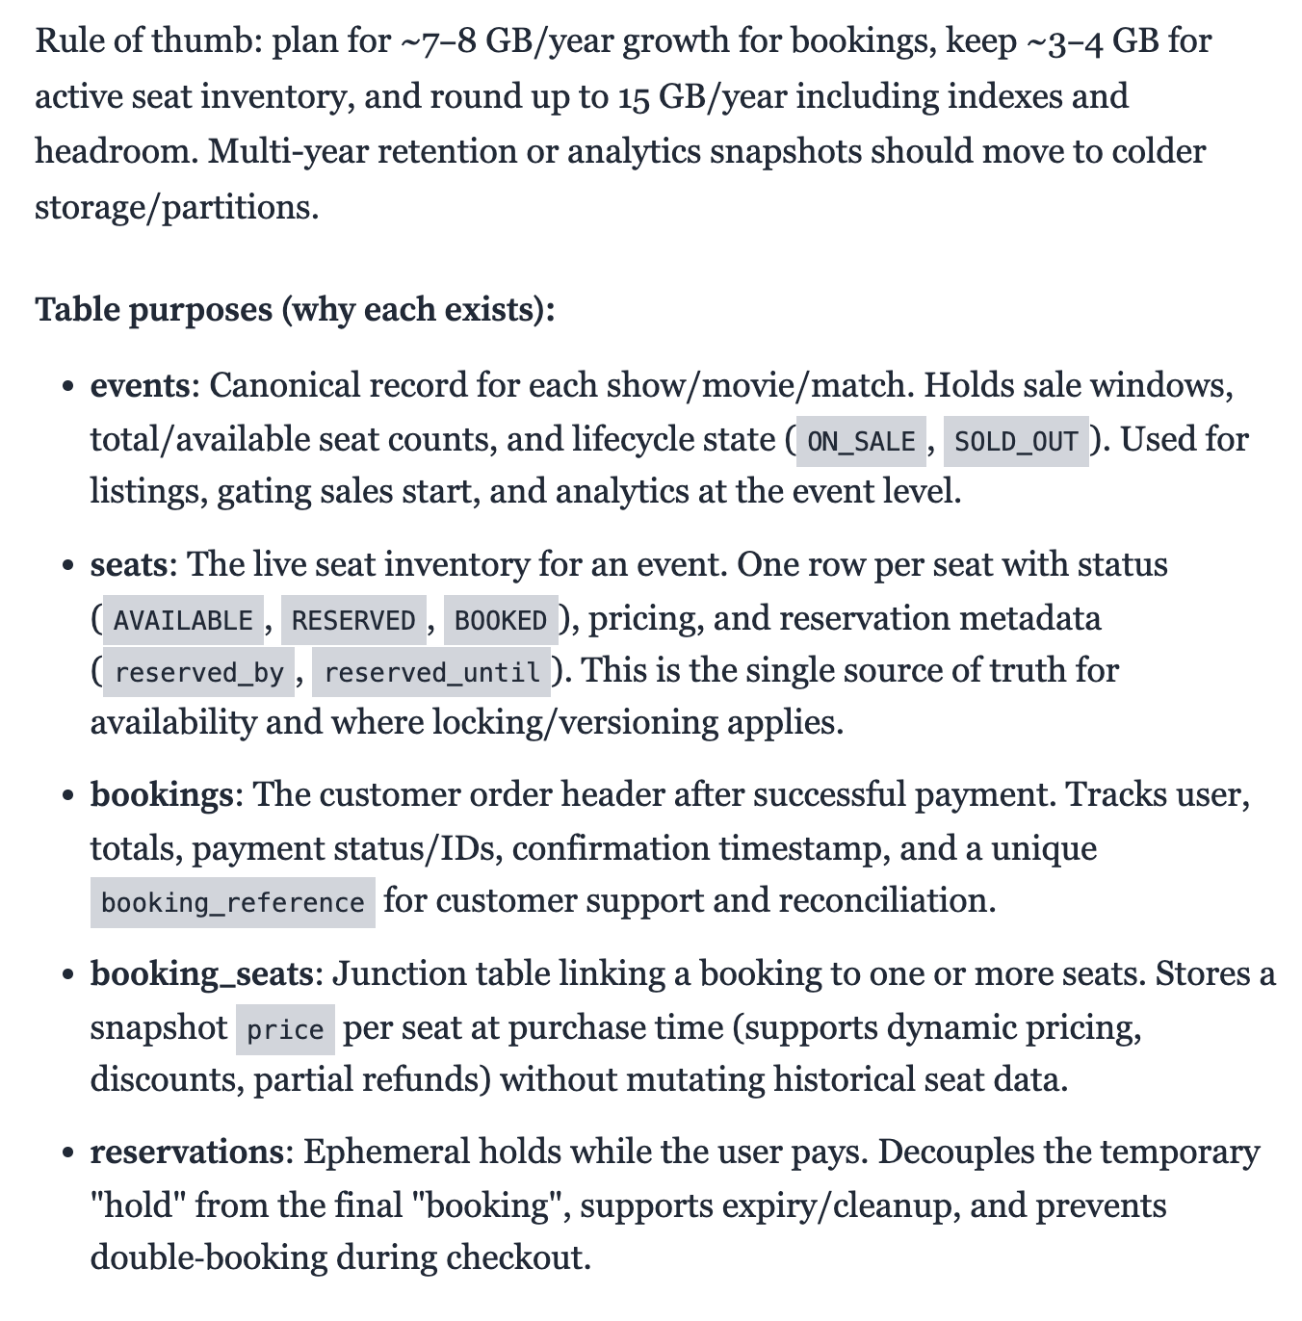
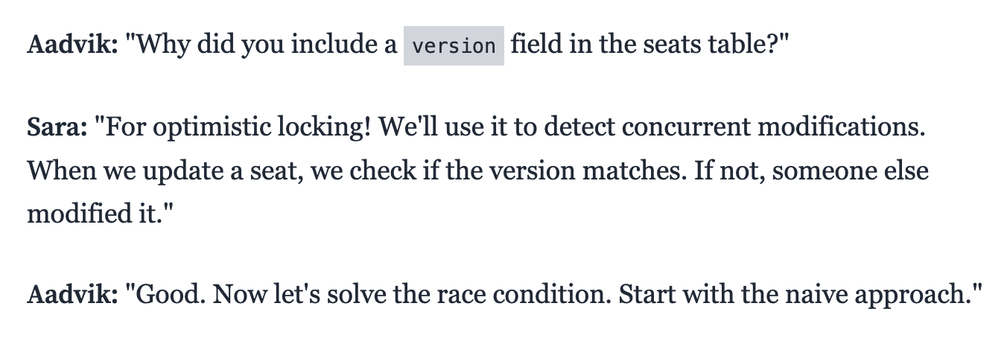
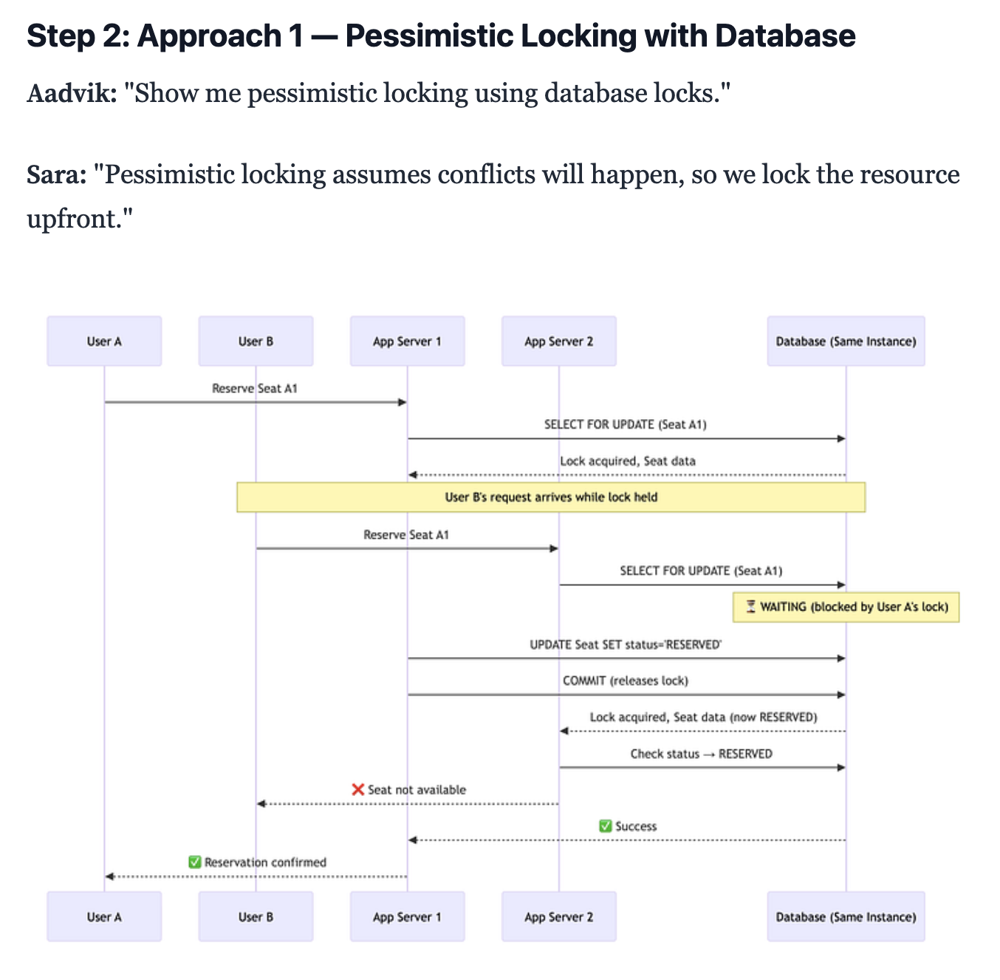
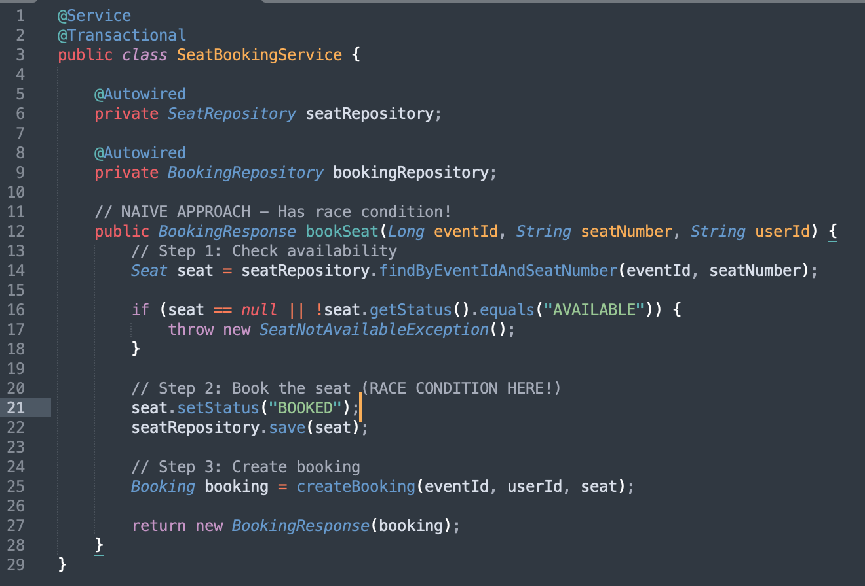
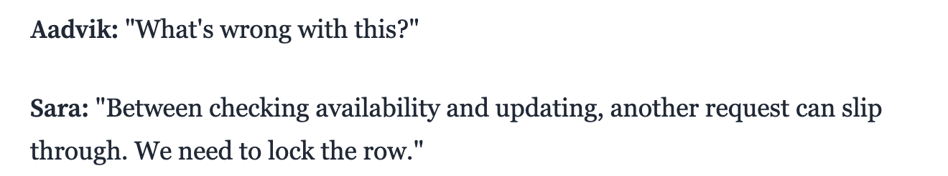
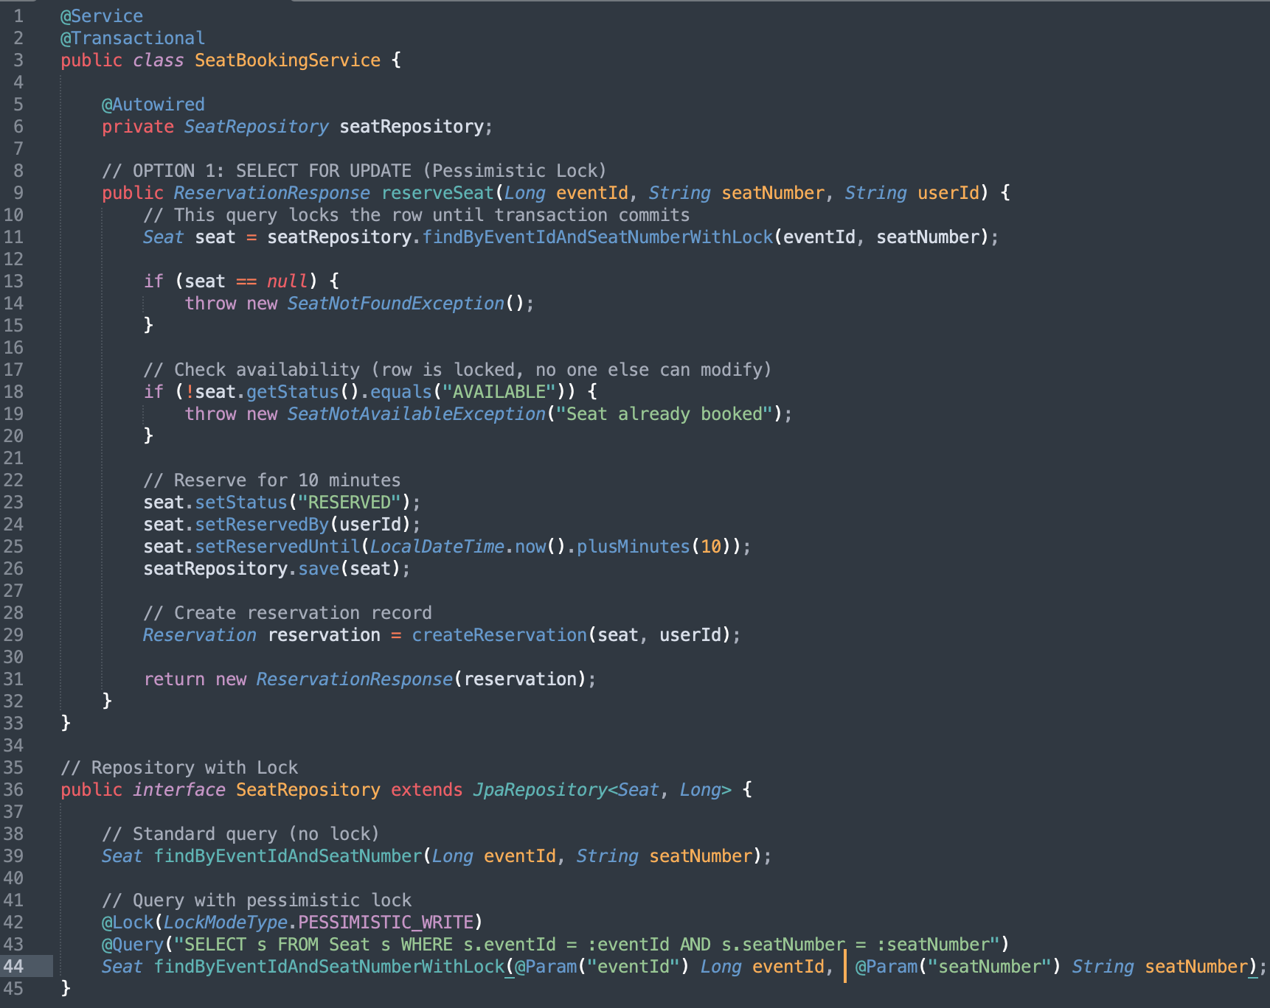
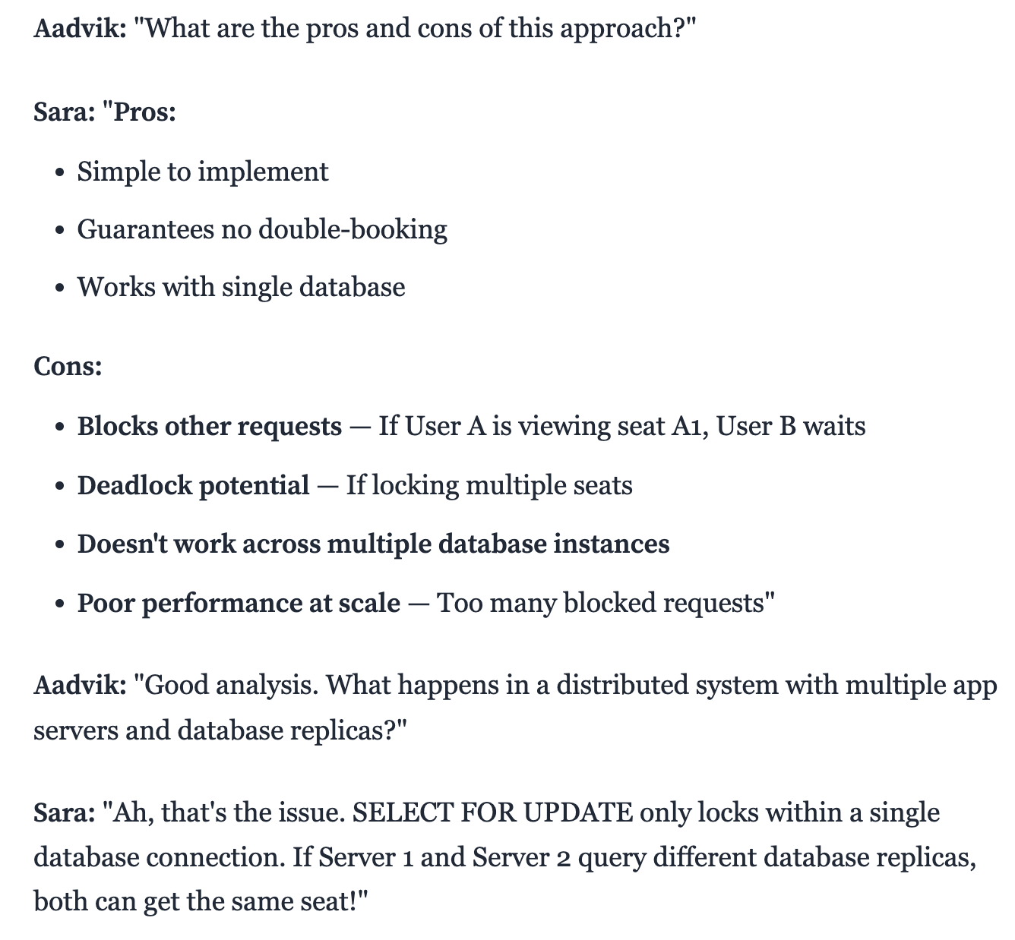
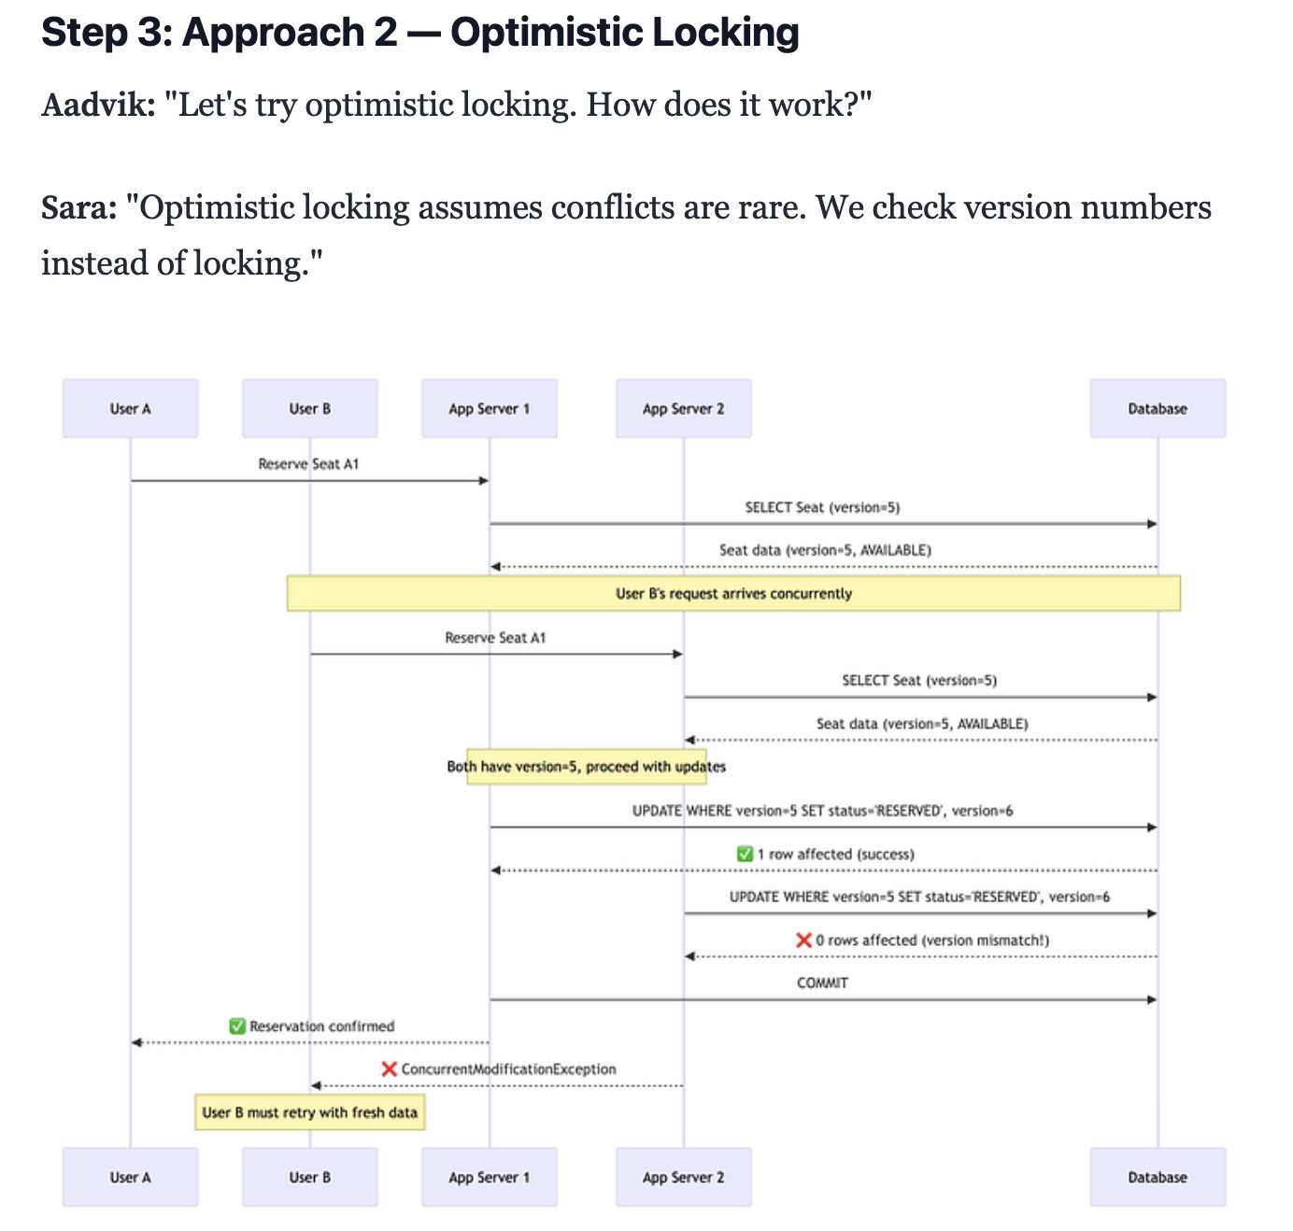

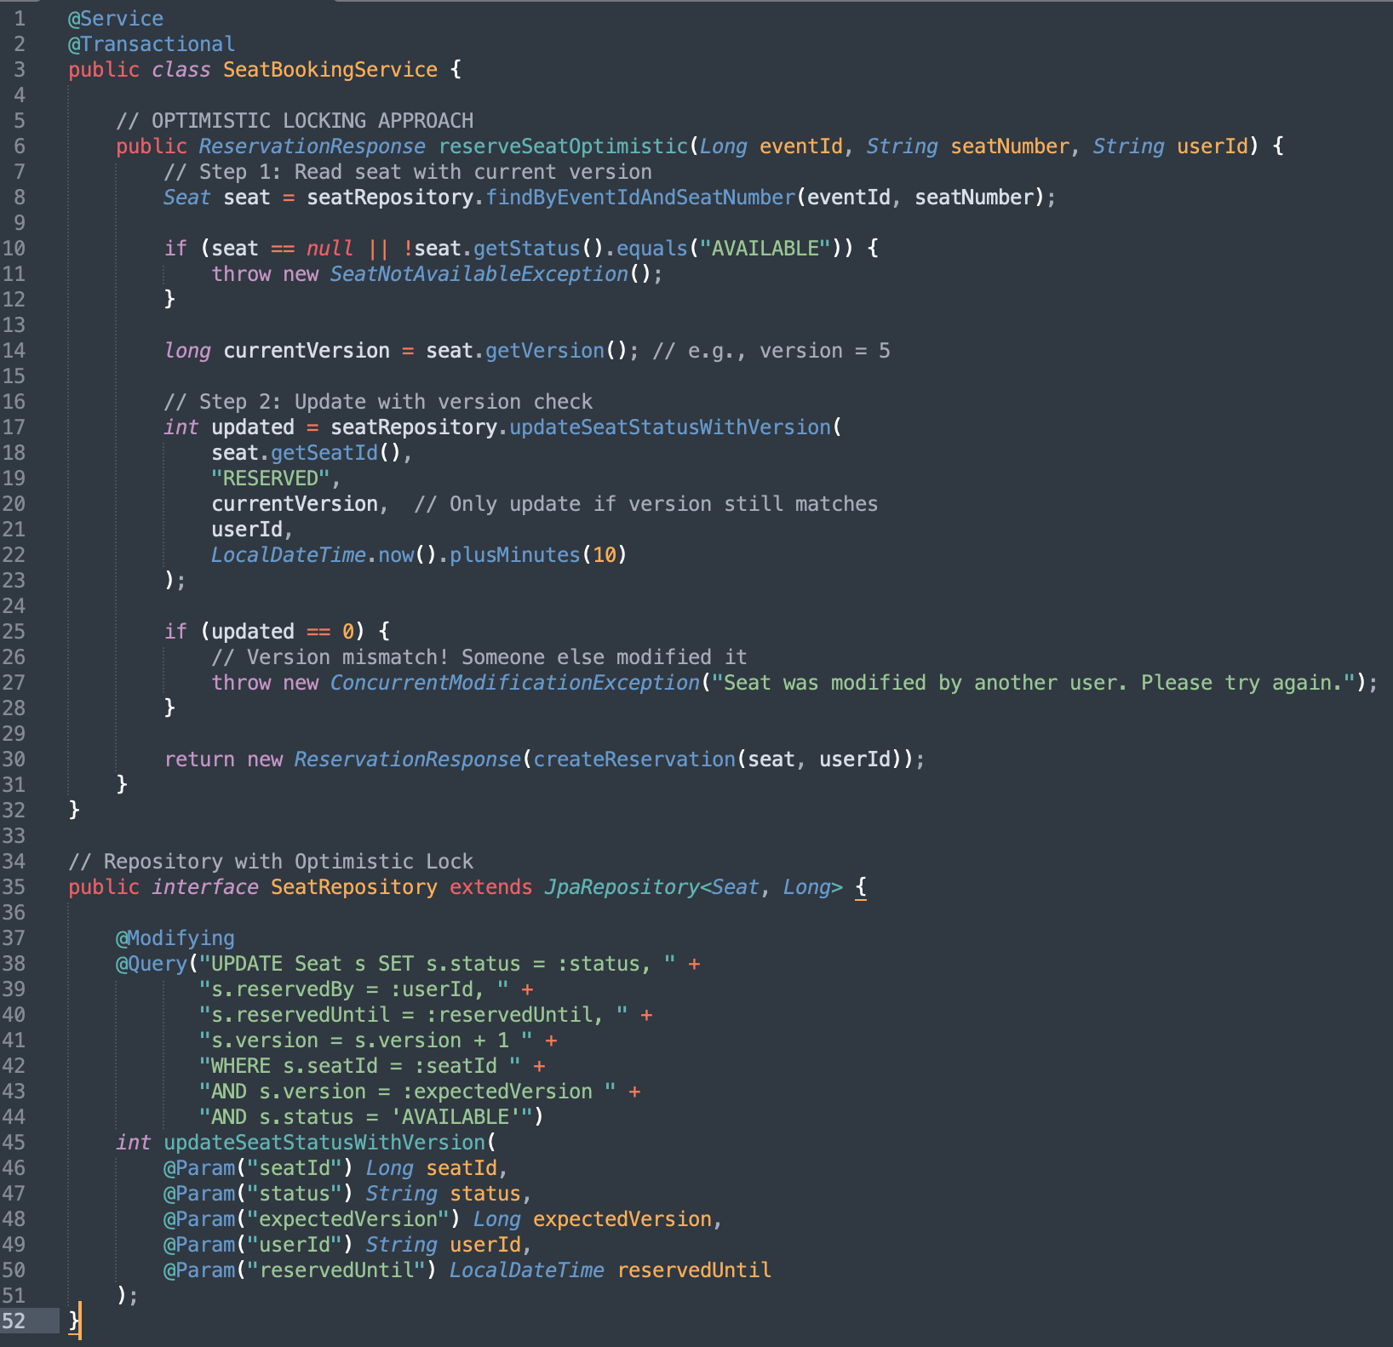
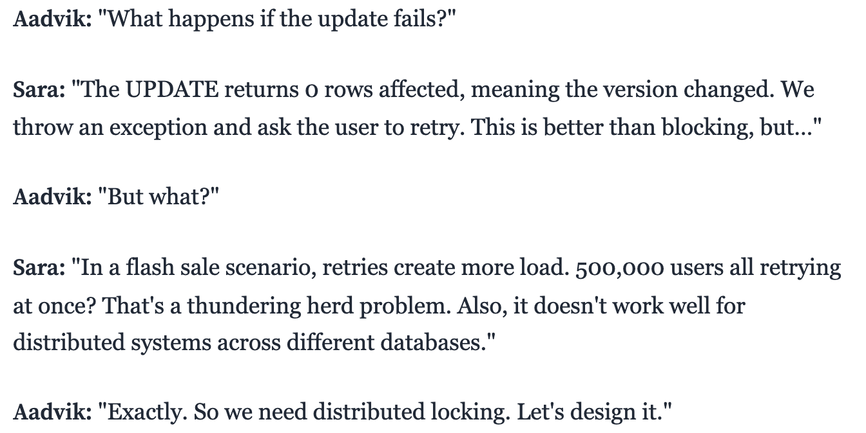
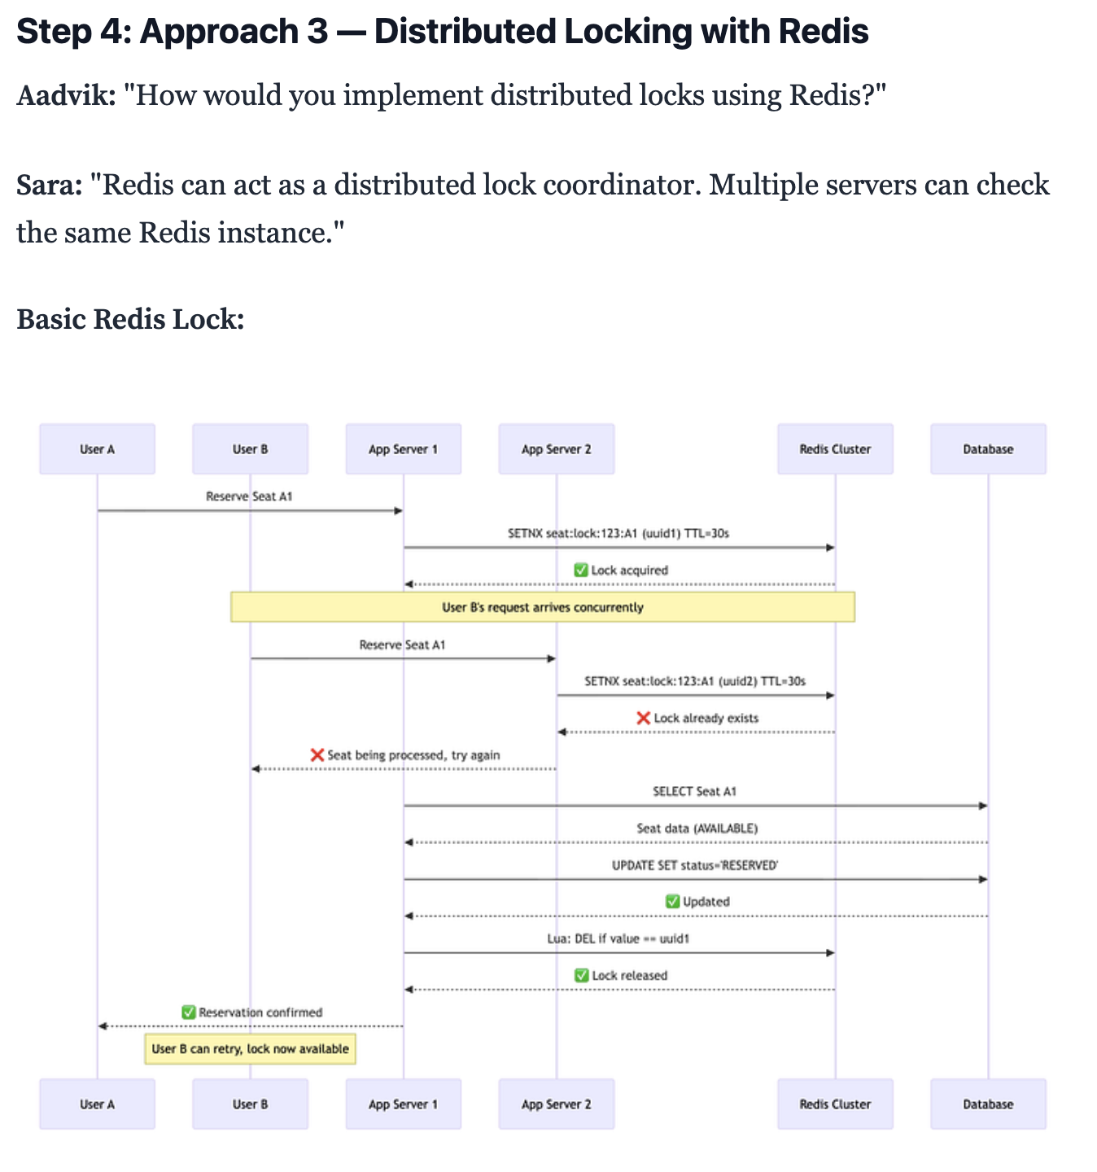
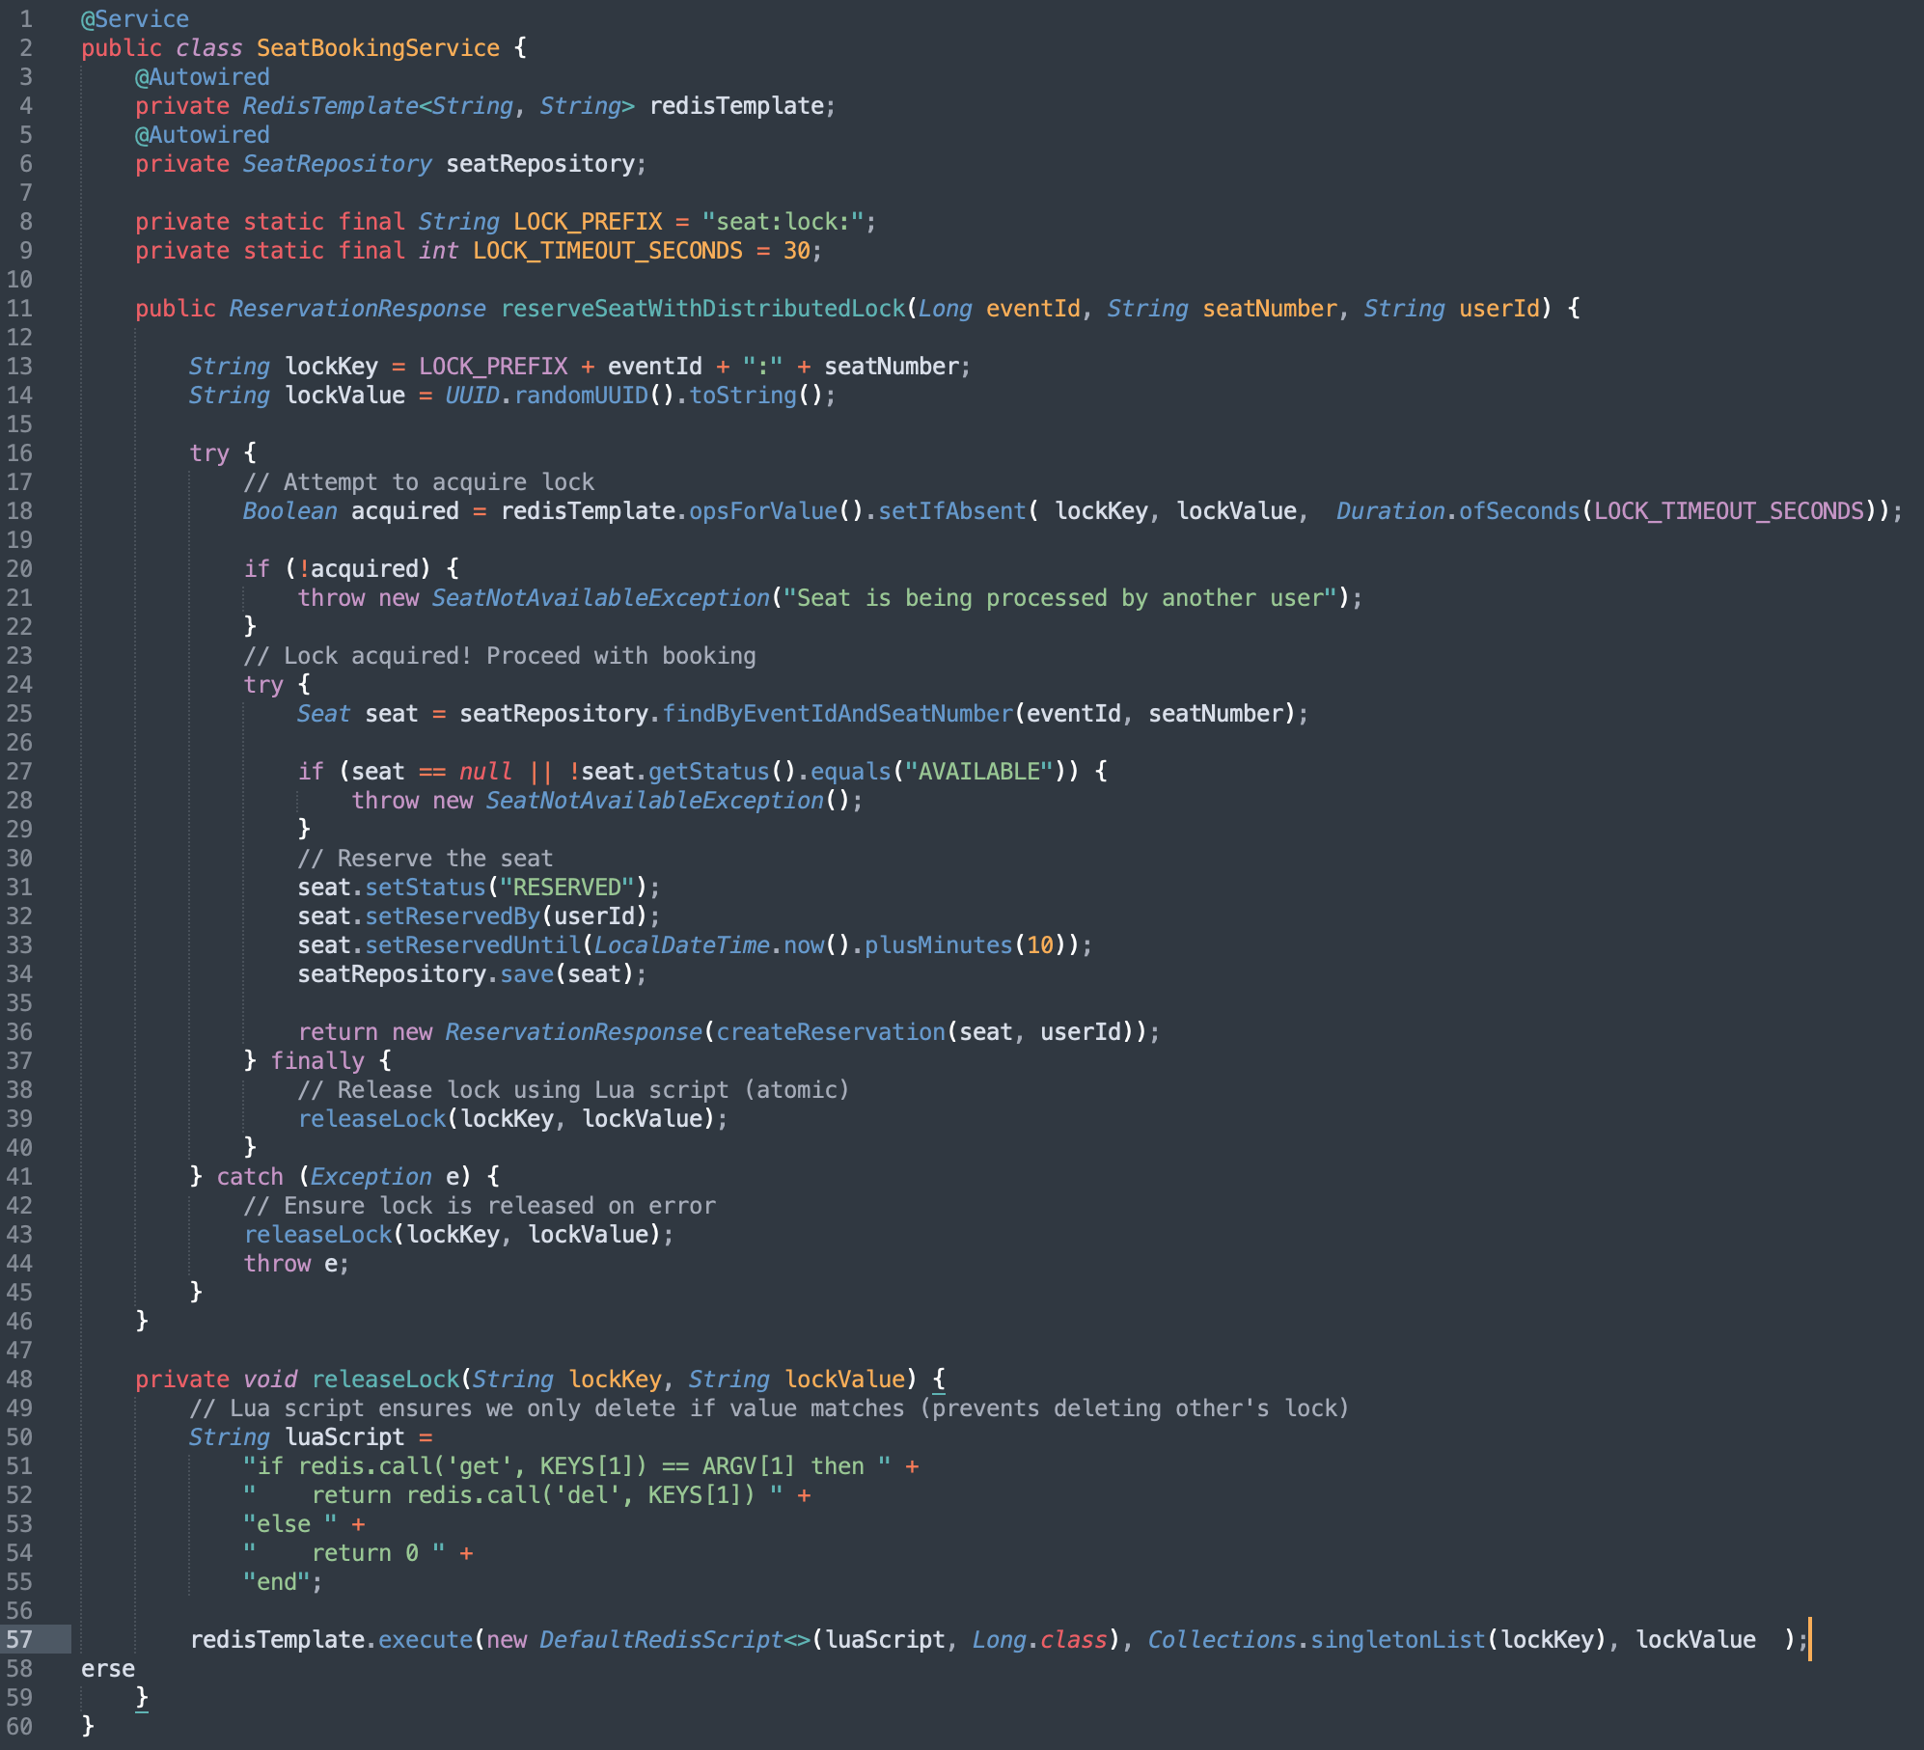
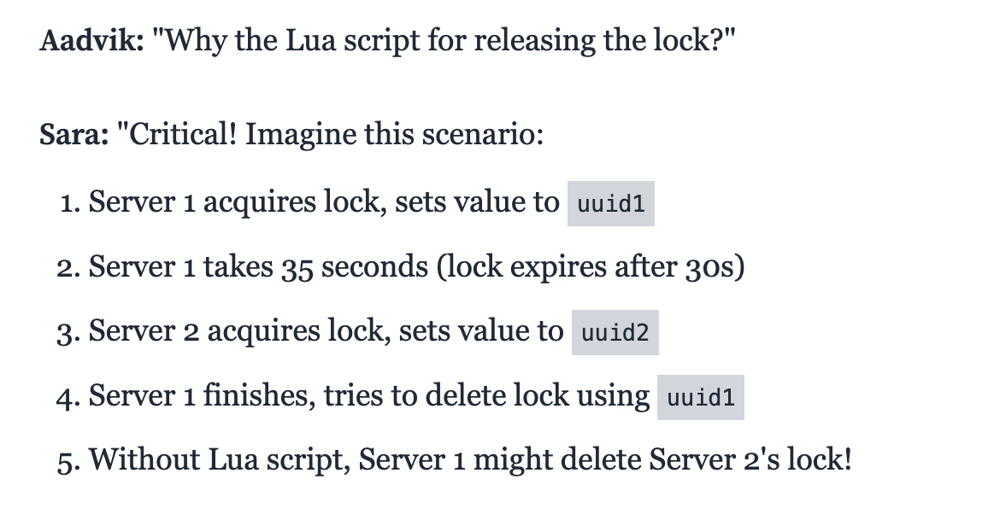
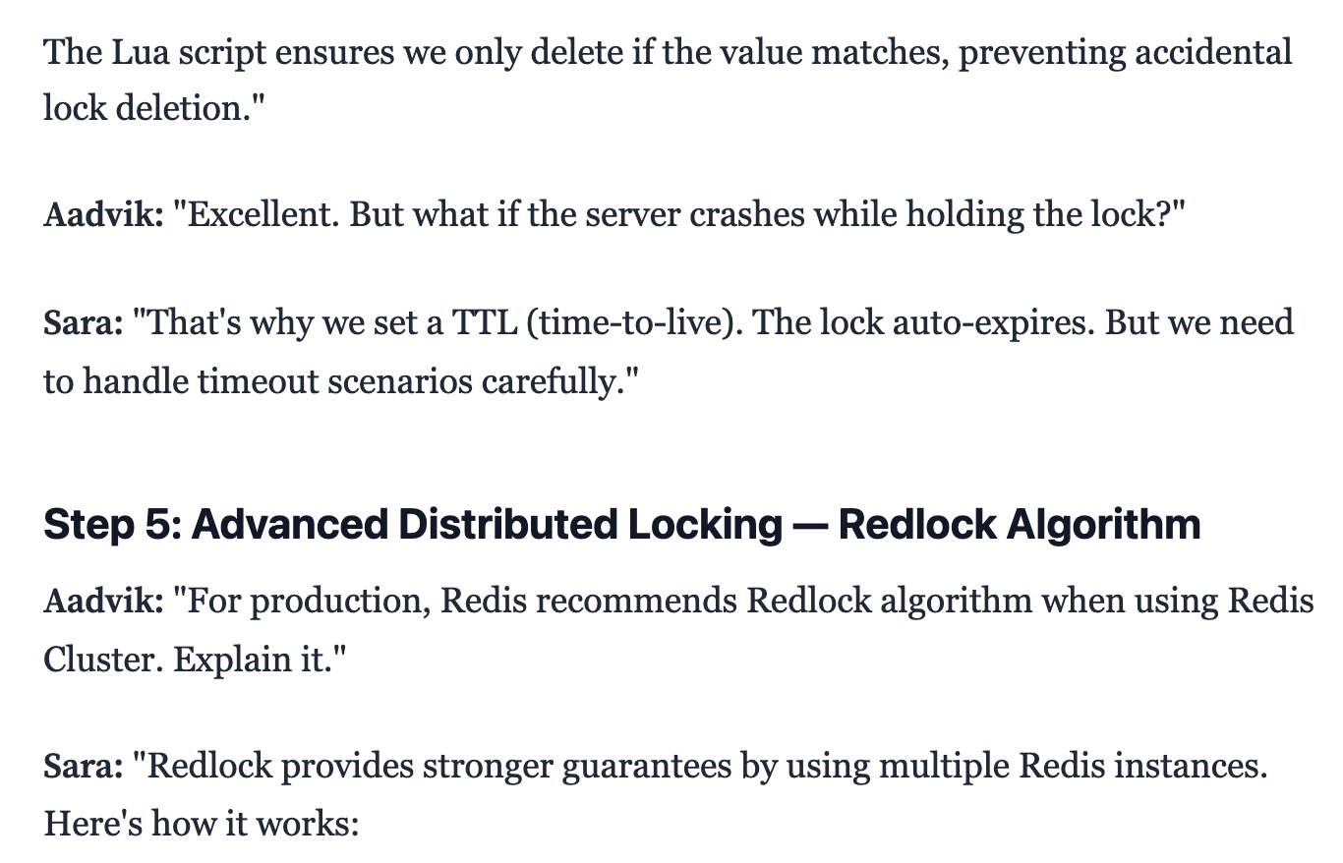
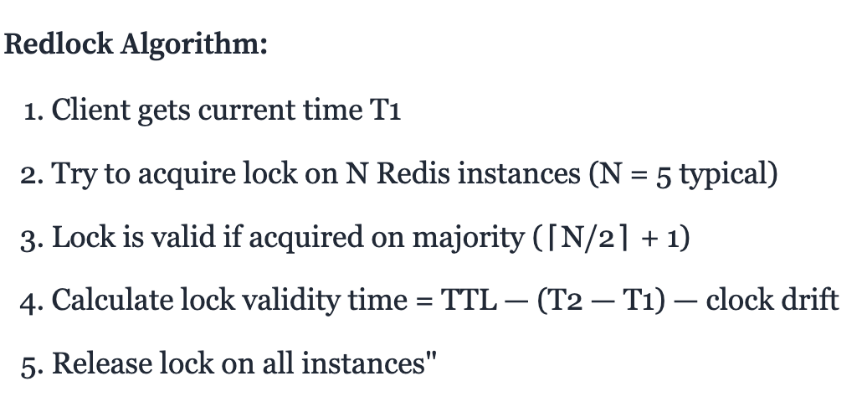
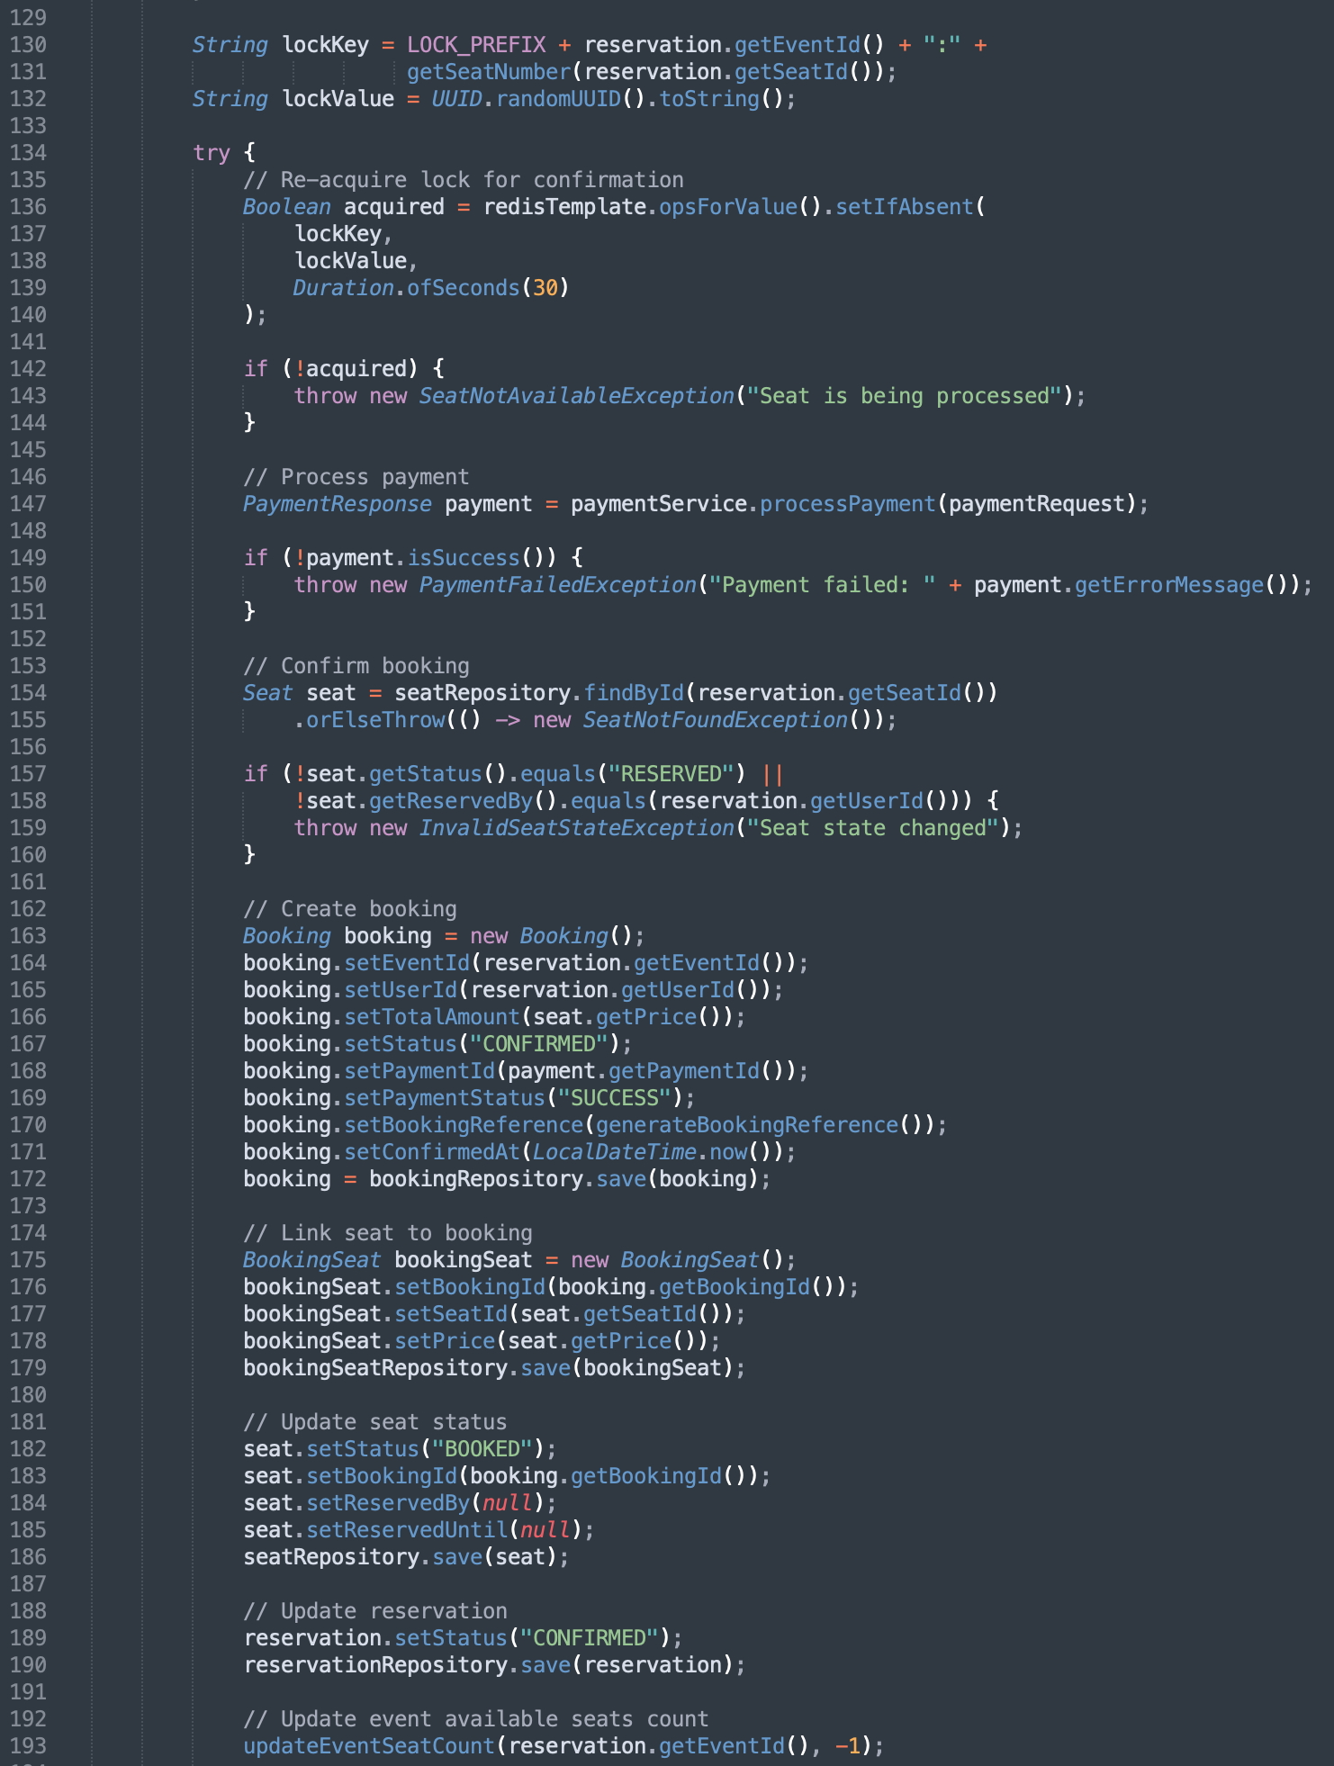
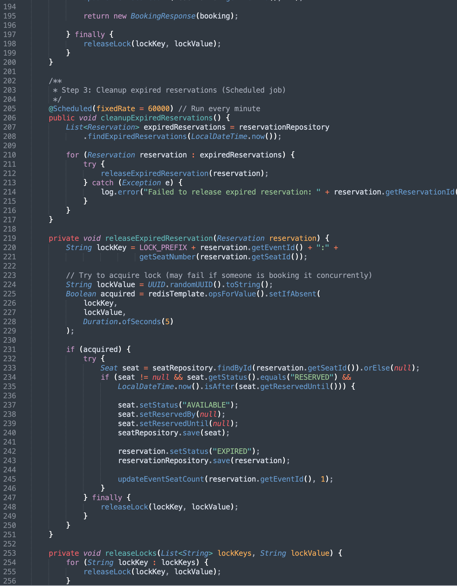
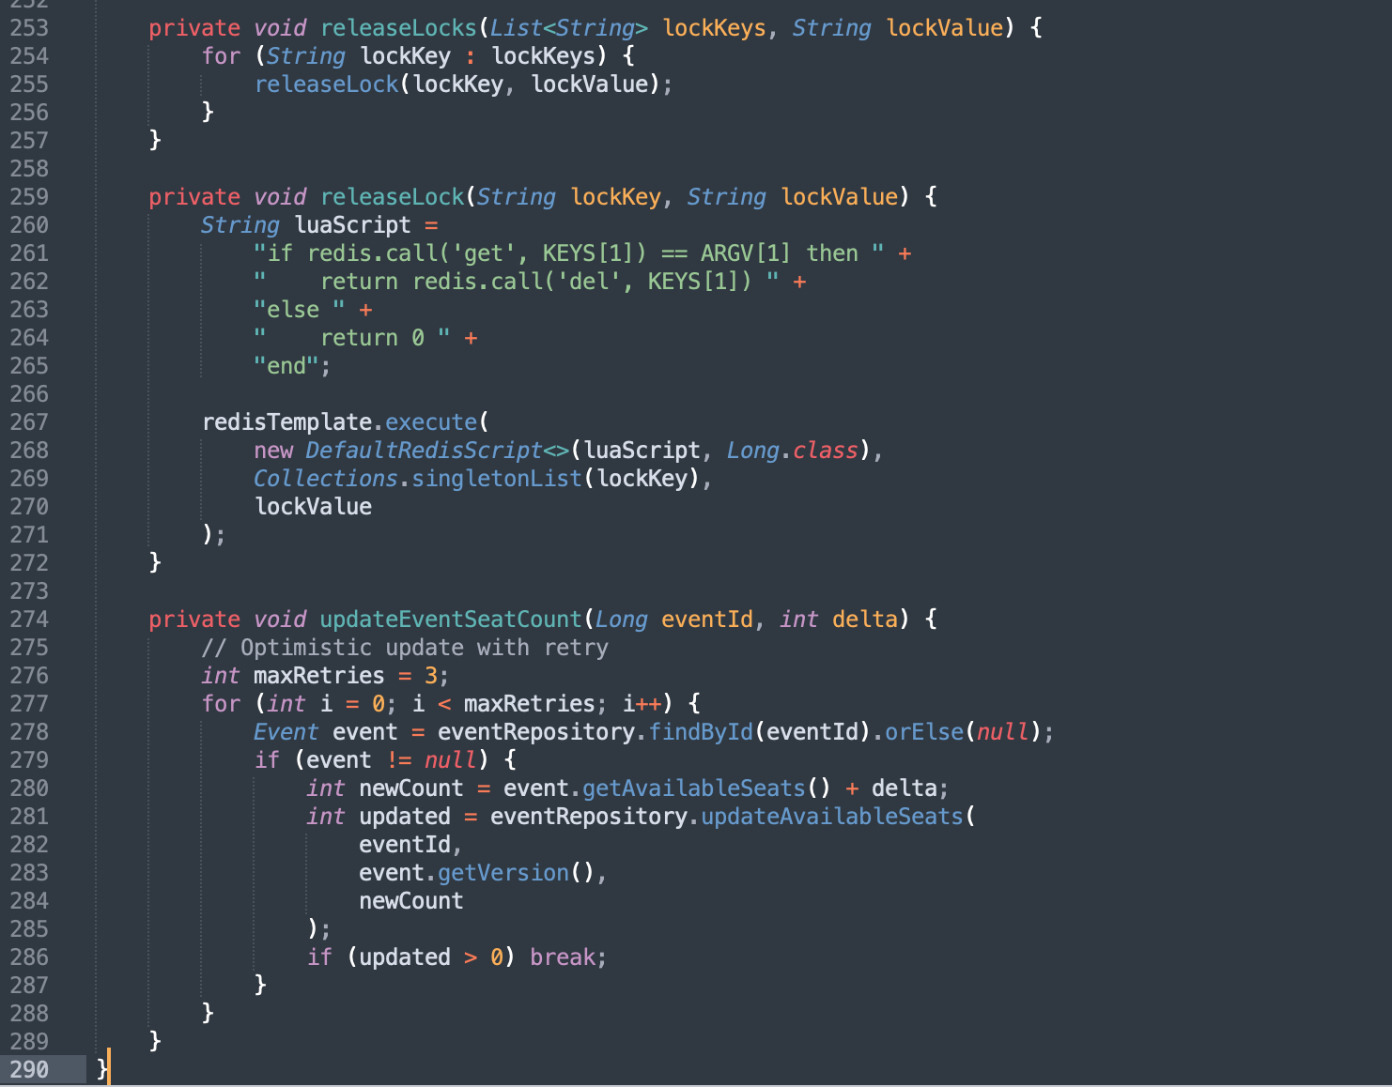
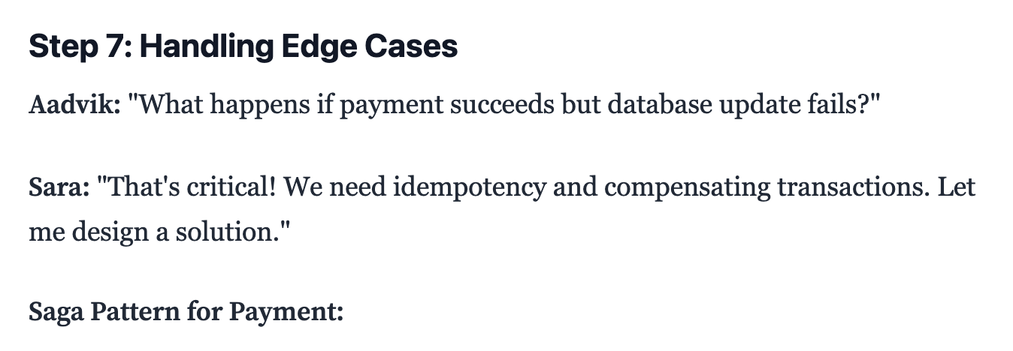
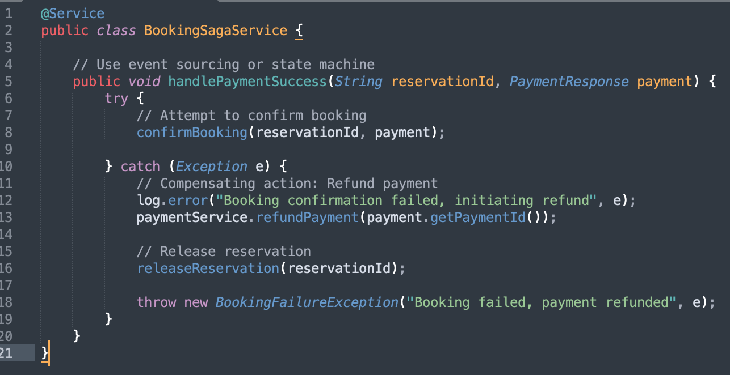
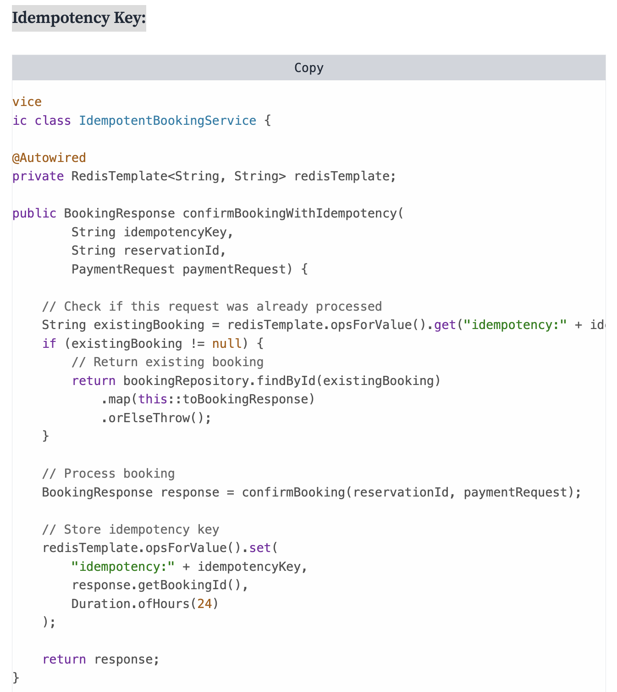

Things we can do more in Movie Booking System
- User Notifications
- Email / SMS after booking success or cancellation.
- QR code ticket delivery.
- Retry & Expiry Handling
- Scheduler to auto-expire bookings if payment not completed in TTL.
- Payment retry (e.g., failed UPI → try card).
- Audit & Logging
- Store booking events in an Audit Log or Kafka for analytics.
- Track who cancelled (user/admin/system).
- Promotions / Discounts
- Coupon system (discount on ticket price).
- Wallet / loyalty points.
- Scalability / Performance
- Sharded Redis for seat locks.
- Async booking confirmation (avoid long synchronous API calls).
- Admin Features
- Block seats (for VIP, bulk booking).
- Refund management dashboard.

Now closing this As we have limited time I hope someday I will open this PDF and deep dive in remaining topics……………
Shubham Verma

